Lecturer Dr. Ali Hadi Fahad Al-Fatlawi
B.D.S, M.Sc., Ph.D in Preventive Dentistry
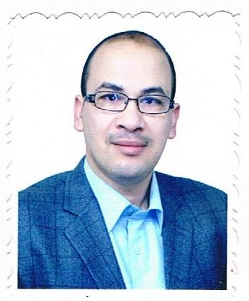
Head of POP Department in University of Kufa, College of Dentistry.
Najaf Governorate, Iraq.

+964 (0) 7808277878
Email: alih.fahad@uokufa.edu.iq

- M.Sc. from Baghdad University in Preventive Dentistry in 2010.
- Ph.D from Baghdad University in Preventive Dentistry in 2017.
- Work in Ministry of Health, Najaf from 1996-2011 and held several positions:
1. Dental Unit Officer in the Primary Health Care Sector.
2. Director of Dental Division, Najaf Health Department.
3. Associate Director at the Specialized Dental Center in Najaf.
- Work in the Ministry of Education and Scientific Research started since 2012.
Research interest:
1. Diet and oral health.
2. Community Dentistry.
3. Prevention of dental caries.
4. Genetics and oral health.
Teaching interest:
1. Community Dentistry.
2. Preventive Dentistry.
3. Pedodontics.
Selected Publication:
1. Al-Weheb, A. M., and Al-Fatlawi, A. H. F.: Effect of Zamzam water on the microhardness of initial caries-like lesion of permanent teeth, compared to Casein Phosphopeptide-Amorphous Calcium Phosphate agents. (2012).
J Bagh College Dentistry 2012; 24(2): 128-132.
2. Effect of casein phosphopeptide-amorphous calcium phosphate on the microhardness and microscopic features of the sound enamel and initial caries-like lesion of permanent teeth, compared to fluoridated agents. (2012).
J Bagh Coll Dentistry 2012; 24(4): 114-120.
3. Oral health status in relation to nutritional status among institutionalized autistic children and adolescents in Baghdad city, Iraq. (2017).
J Bagh Coll Dentistry 2017; 29(1): 117-124.
4. Salivary Physicochemical Characteristics in Relation to Oral Health Status Among Institutionalized Autistic Adolescents in Baghdad/Iraq. (2017).
J Bagh Coll Dentistry 2017; 29(3): 68-74.
5. Dental Trauma in Relation to Malocclusion among Primary School Children in Najaf City, Iraq. (2018).
Journal of Research in Medical and Dental Science 2018; 6(1): 236-242.
6. Prevalence of oral lesions in Al-Muthannagovernorate, Iraq: (Clinicopathological study). (2018).
International Journal of Enhanced Research in Science, Technology & Engineering 2018; 7(1): 8-12.
7. Salivary pH, Flow Rate and Streptococcus mutans Count in Relation to Oral Health Statusamong Colored Eyes Adolescentsin Baghdad/Iraq. (2018).
Biomedical & Pharmacology Journal, December 2018. Vol. 11(4): 2085-2089.

