**السيرة الذاتية**

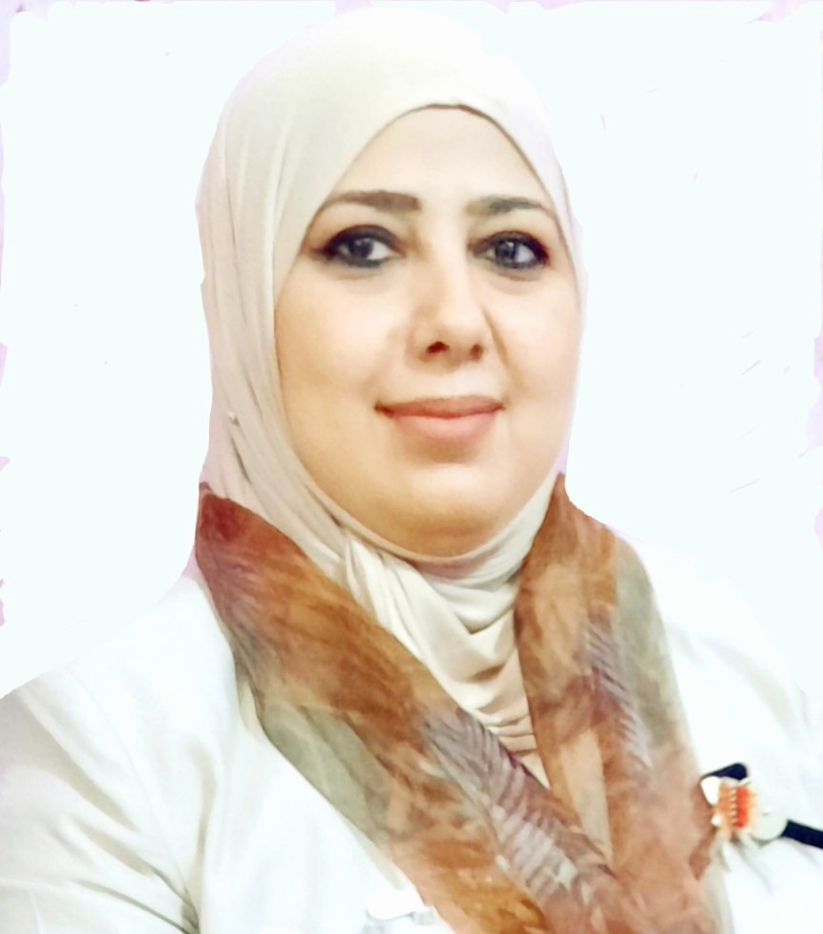

**البطاقة الشخصية**

* **الاسم : رنا أبراهيم خليل**
* **الـجـنــســيــة : عراقي**
* **تاريخ ومكان الميلاد : 01 / 01 / 1983 بغداد**
* **مكان الإقامة : صلاح الدين**
* **البريد الالكتروني :** [**rana.ibrahim@uosamarra.edu.iq**](mailto:rana.ibrahim@uosamarra.edu.iq)
* **بوابة البحث :**
* [**https://www.researchgate.net/profile/Rana_Khaleel**](https://www.researchgate.net/profile/Rana_Khaleel)
* **ORCID**
* [**https://orcid.org/0000-0002-6551-8295**](https://orcid.org/0000-0002-6551-8295)
* **Google scholar**
* [**https://scholar.google.com/citations?user=cnCS8FwAAAAJ&hl**](https://scholar.google.com/citations?user=cnCS8FwAAAAJ&hl)**=**
* **ar**

**الشهادات**

* **بكالوريوس هندسة وعلوم زراعية – جامعة تكريت (2005 )**
* **ماجستير هندسة وعلوم زراعية ( بيئة ) – جامعة تكريت ( 2008 )**
* **دكتوراه تقنيات بيئية – جامعة العلوم الماليزية (2014)**

**الخبرات العملية والأدارية**

* **محاضرة في جامعة العلوم الماليزية للفترة 2011-2015**
* **محاضرة في جامعة تكريت للفترة من 2005-2006**
* **تدريسية في جامعة سامراء ( كلية الهندسة / قسم هندسة العمارة ) من 2016 ومستمرة**
* **مدير قسم البعثات والعلاقات الثقافية – جامعة سامراء من 2020/9/7 ومستمرة**

**المهارات**

* **اللغة العربية - اللغة الأم .**
* **اللغة الإنكليزية الثانوية**

**الأبحاث المنشورة**

1. Rana .I. Khaleel , Ismail N, Ibrahim M. Responses on Growth of Ladyfinger Abelmoschus esculentus L. (Ladyfinger) by different treatments methods of dairy wastewater. Ann Agric Environ Med. 2014; 21(1): 42 48. www.aaem.pl AAEM, I SI Journal IF = 3.060.

2. Rana .I. Khaleel , Norli Ismail, Mahamad. H. Ibrahim. THE IMPACT OF WASTEWATER TREATMENTS ON SEED GERMINATION AND BIOCHEMICAL PARAMETER OF Abelmoschus esculentus L. Science Direct --Procedia - Social and Behavioral Sciences. Impact 0.162

3. Rana Ibrahim Dulaimi, Norli Bt Ismail, Mahamad Hakimi , The effect of Industrial wastewater in seed Growth published at: "International Journal of Scientific and Research Publications, Volume 2, Issue 3, March 2012 Edition".

5. Amer Abdul Aziz and Rana Ibrahim (2009). The effect of two soil types and different quantities of organic fertilizers on the growth of senna. Cassia angustifolia . Published at Journal of agricultural science \\ University of Tikrit Volume 9, Issue 3, 2009.

7. Rana. IbrahimRana. Ibrahim and Abdul Razak Shaari. (2011). Overview of Medicinal Plants spread and their uses in AsiaMedicinal Plants spread and their uses in Asia\\ IPCEIPCE-- University Perlis International Postgraduate Conference on Engineering (IPCE2011). 22--23rd Oct

8. Al Shaheen. M, Rana Ibrahim Al Dulaimi , Ghassan Faris Atiyah. Effect of irrigation schedules and potassium fertilization on the production and yield of (Vigna mungo. L).2017 29 30 مؤتمر تربية

بنات

9. Ghassan Al Samarai, Rana. I. Khaleel ( 2017), Haroon.H. Al Mazroee. 2017. “Nanoparticles: Scope and Application as Potential Alternative of Agriculture Pesticides,,. RICCCE 2017 20th Romanian International Conference on Chemistry and Chemical Engineering 6- 9 September 2017, Poiana Brasov, Romania.

10. R. I Khaleel. (2017). ( Efficacy of Some Plant Extracts and Biodegradables Wrapping Materials as an Alternative to Fungicides in Increasing Shelf Life Citrus Fruits . Open Journal of Ecology 7 (12), 621

11. RI Khaleel ( Diagnosis of the Bio Compound as an Anti Fungal from Populus euphratica L. Plant Using Chromatographic Technology . Open Journal of Ecology 9 (5), 145 156 2019

**2011.Perlis.Malaysia.**23rd Oct 2011.Perlis.Malaysia.

**8.**

8. **Al**Al**-**-**Shaheen. M,** Shaheen. M, **Rana Ibrahim AlRana Ibrahim Al--DulaimiDulaimi, Ghassan Faris** , Ghassan Faris **Atiyah. Effect of irrigation schedules and potassium fertilization on** Atiyah. Effect of irrigation schedules and potassium fertilization on **the production and yield of (Vigna mungo. L).2017**the production and yield of (Vigna mungo. L).2017**-**- **29**29**-**-**30** 30 مؤتمر تربية

بنات

**9.**

9. **Ghassan Al**Ghassan Al**-**-**Samarai,** Samarai, **Rana. I. KhaleelRana. I. Khaleel (2017)(2017), Haroon.H. Al**, Haroon.H. Al**-**-**Mazroee. 2017. “Nanoparticles: Scope and Application as Potential** Mazroee. 2017. “Nanoparticles: Scope and Application as Potential **Alternative of Agriculture Pesticides,,. RICCCE 2017 20th Romanian** Alternative of Agriculture Pesticides,,. RICCCE 2017 20th Romanian **International Conference on Chemistry and Chemical Engineer**International Conference on Chemistry and Chemical Engineer**ing** ing **-**- **6**6**-**-**9 September 2017, Poiana Brasov, Romania.**9 September 2017, Poiana Brasov, Romania.

**10.**

10. **RI KhaleelRI Khaleel (2017).(2017). Efficacy of Some Plant Extracts and** Efficacy of Some Plant Extracts and **Biodegradables Wrapping Materials as an Alternative to Fungicides in** Biodegradables Wrapping Materials as an Alternative to Fungicides in **Increasing Shelf Life Citrus Fruits**Increasing Shelf Life Citrus Fruits **.** . **Open Journal of Ecology 7 (12),** Open Journal of Ecology 7 (12), **621**621**.**.

**11**

11**.** . **RI KhaleelRI Khaleel ( 2019)( 2019).. Diagnosis of the Bio**Diagnosis of the Bio**-**-**Compound as an** Compound as an **Anti**Anti**-**-**Fungal from Populus euphratica L. Plant Using Chromatographic** Fungal from Populus euphratica L. Plant Using Chromatographic **Technology**Technology**.** . **Open Journal of Ecology 9 (5),**Open Journal of Ecology 9 (5), **145**145**-**-**156** 156 **2019**2019

**الأبحاث المنشورة**

12. RI Khaleel, Ghassan F Al-Samarrai, AM Mohammed, (2019). [Coating of Orange Fruit With Nano-Silver Particles to Minimizing Harmful Environmental Pollution by Chemical Fungicide](http://jcoagri.uobaghdad.edu.iq/index.php/intro/article/view/858). University of Baghdad, College of Agriculture Engineering Sciences. [Vol 50 No 6 (2019)](https://jcoagri.uobaghdad.edu.iq/index.php/intro/issue/view/30)

|  |
| --- |
| 13. GF Al-Samarrai, RI Khaleel‏, (2020). [Groundwater Impact of Samarra city agriculture areas‏](javascript:void(0))  IOP Conference Series: Materials Science and Engineering 928 (2), 022076‏ |
|  |  | 2020 |
| 14. GFA Samarrai, RI Khaleel‏, (2020). Activity of some natural products and their toxicity in  controlling Colletotrichum gloeosporioid[es Penz‏](javascript:void(0)). IOP Conference Series: Materials Science  and Engineering 928 (6), 062018‏ |  | 2020 |
| 15. Tayob, RI Khaleel, WM Mahdi, (2020) . Evaluation of nanostructures for wastewater in  removing heavy elements and their effect on pea plant growth (Pisum sativum)‏. IOP  Conference Series: Materials Science and Engineering 928 (6), 062022‏ |  | 2020 |
| 16. RI Khaleel‏, (2019). [BIO-TOXICITY STUDY OF SOME SELECTED PLANT BY ARTEMIA SALINA (LEACH) TEST‏](javascript:void(0)). Plant Archives 19 (2), 2847_2850 |  |  |