PERSONAL INFORMATION Suhail Ahmad
Akabe Mah. Eyyubiye.1493sokak.no5 .1kat, 63000 ŞANLIURFA (Turkey) +905379710194
suhailahmad1980@hotmail.com

Sex Male | Date of birth 08/11/1980 | Nationality Syrian

WORK EXPERIENCE

01/06/2013–01/11/2014 protection psychologist

DRC, KILIS (Turkey)
- Working with clients to help them make changes to their behaviour through a variety of psychological therapies
- Providing counselling
- Identifying and diagnosing mental, behavioural or emotional disorders
- Developing treatment plans
- Administering psychological tests and assessing the results
- Conducting research through interviews, surveys and observations

08/01/2015–07/01/2017 Psychosocials Team Leader

IMC, Şanlıurfa (Turkey)
- Provide individual or group psychological support such as counselling and support groups to the GbSE attending the Tingathe workshops.
- Provide capacity building for the team on identification and handling of different behaviours during implementation of project activities.
- Support partners and community members on the identification and handling of GbSE in line with principles of psychosocial support.
- Provide support to the curriculum development process for the workshops to ensure that components of psychosocial principles are incorporated.
- Develop technical reports on specific cases identified during the individual psychological support sessions.
- Coordinate feedback meetings with the team and department.

05/02/2017–12/09/2017 Clinical Psychologist

Goal Organisation, Adana (Turkey)
- Making assessments and interpretations based on biopsychosocial evaluations, psychometric tests, semi-structured interviews, therapy sessions and neuropsychological assessments.
- Collaborating with other healthcare providers to evaluate medical and physical condition of clients.
- Formulating and creating personalized interventions, treatments and management plans for clients.
- Assessing clients' risk, considering their mental health and social needs when performing interventions.
- Interacting with clients and other parties regarding performing interventions.
- Employing various treatment methods such as psychotherapy, hypnosis, behavior modification, stress reduction therapy and psychodrama.
- Measuring effectiveness of interventions and implementing changes where required.
- Ensuring the maintenance and safe storage of accurate program and client records, and all other pertinent documents.

- Maintaining confidentiality of clients’ treatment and records in accordance with HIPAA. Participating in clinical training seminars and mentoring assistant psychologists, psychology students and interns on site.
- Working towards positioning the agency as a pioneer in psychological interventions.

29/08/2002–06/02/2012 psychology lecturer

university of Aleppo, Aleppo (Syria)
- Instruct students and prepare lesson plans.
- Lecture about the mental characteristics of a person or group.
- Discuss diseases and disorders of the mind and mental state.
- Create instructional resources for use in the classroom.
- Plan, prepare and deliver instructional activities.
- Create positive educational climate for students to learn in.
- Meet course and school-wide student performance goals.
- Participate in ongoing training sessions.
- Create lesson plans and modify accordingly throughout the year.
- Maintain grade books.
- Grade papers and perform other administrative duties as needed.
- Write grant proposals to gain funding for further research.
- Create projects designed to enhance lectures.
- Read and stay abreast of current topics in education.

01/06/2018–2019 case management officer

concern, sanliurfa (Turkey)
- Admits new clients by reviewing records and applications; conducting orientations.
- Determines clients' requirements by completing intake interviews; determining need for therapeutic medical, psycho-social, and psychiatric evaluations; reviewing therapist evaluations, treatment objectives, and plans.
- Establishes treatment programs by setting schedules and routines; coordinating services being provided; arranging resources, including transportation and escort.
- Monitors cases by verifying clients' attendance; observing and evaluating treatments and responses; advocating for needed services and entitlements; obtaining additional resources; intervening in crises; providing personal support.
- Maintains clients' records by reviewing case notes; logging events and progress.
- Communicates clients' progress by conducting weekly interdisciplinary meetings and evaluations; disseminating results and obstacles to therapeutic team and family; identifying treatment influences.
- Prepares clients' discharge by reviewing and amplifying discharge plans; coordinating discharge and post-discharge requirements; orienting and training family members; providing resources.
- Improves staff competence by providing educational resources; balancing work requirements with learning opportunities; evaluating the application of learning to changes in treatment results.
- Improves treatment results by studying, evaluating, and re-designing processes; implementing changes; rewriting policies and procedures.
- Improves financial status by analyzing results; monitoring variances; identifying trends; recommending actions to management.
- Meets budget by monitoring expenses; implementing cost-saving actions.
- Prepares reports by collecting, analyzing, and summarizing treatment and results data and trends; compiling statistics; completing grant and subsidy applications.
- Updates job knowledge by participating in educational opportunities; reading professional publications; maintaining personal networks; participating in professional organizations.

- Enhances department and organization reputation by accepting ownership for accomplishing new and different requests; exploring opportunities to add value to job accomplishments.

- Lecturer in university of Mardın 2019--2020––Department of psychology

- mental health coordinator 2020-2022.INARA-Gaziantep.Turkey

Implementing programs and treatments
, increasing community mental health awareness,
consulting with other medical and science professionals about patient cases and therapeutic care

EDUCATION AND TRAINING

10/09/1996–15/05/2002 Psychosocial Studies

Aleppo University, Aleppo (Syria)

10/09/2002–15/05/2004 Diploma of Pedagogy

University of Aleppo, Aleppo (Syria)

10/09/2010–15/05/2012 Master Degree of Psychology (Humanistic Therapy)

University of Damascus, Damascus (Syria)
2019 master degree in Aramıc language and Hebrew culture 95%
Mardın University –turkey
PERSONAL SKILLS

Mother tongue(s) Arabic, Kurdish, ENGLISH. TURKISH-Hebrew –Syriac- Persian

Foreign language(s)
UNDERSTANDING |  | SPEAKING |  | WRITING
Listening | Reading | Spoken interaction | Spoken production

English C1 C1 C1 C1 C1
University of Aleppo
Turkish C1 C1 C1 C1 C1
University of Adıyaman
Persian C1 C1 C1 C1 C1
University of Aleppo
Levels: A1 and A2: Basic user - B1 and B2: Independent user - C1 and C2: Proficient user Common European Framework of Reference for Languages

Communication skills ▪ Excellent written and verbal communication skills.
- Confident, articulate, and professional speaking abilities (and experience)
- Empathic listener and persuasive speaker.
- Writing creative or factual.
- Speaking in public, to groups, or via electronic media.
- Excellent presentation and negotiation skills.

Organisational / managerial skills I worked as a psychologist. I taught psychology for 10 years. I have done a lot of work with children and women and I am experienced in this. I have been trained in logotherapy and cbt.

Job-related skills Logotherapy techniques
Cbt techniques Supporting methods

Digital skills SELF-ASSESSMENT

Information processing | Communication | Content creation | Safety | Problem- solving
Proficient user | Proficient user | Proficient user | Proficient user | Proficient user

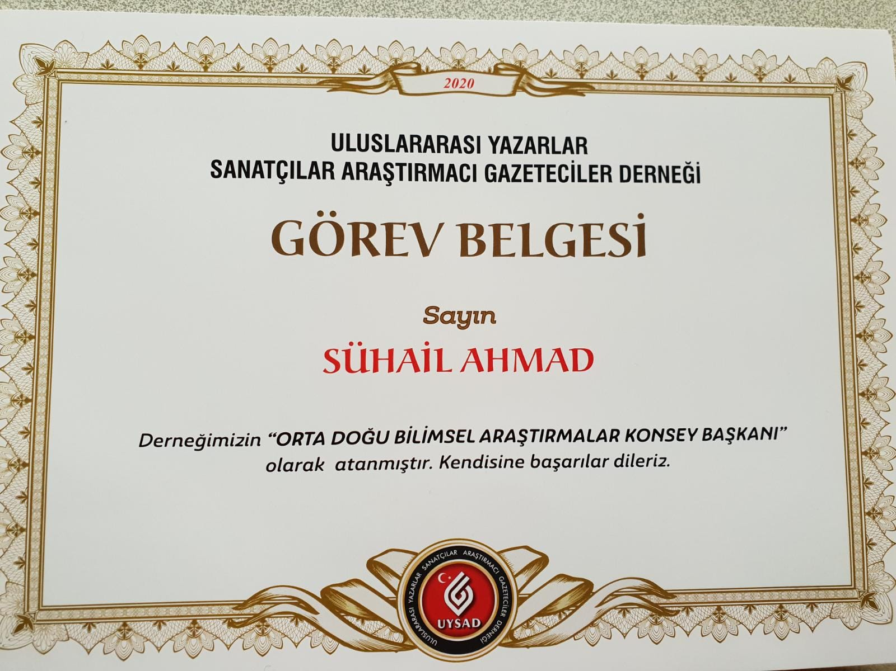

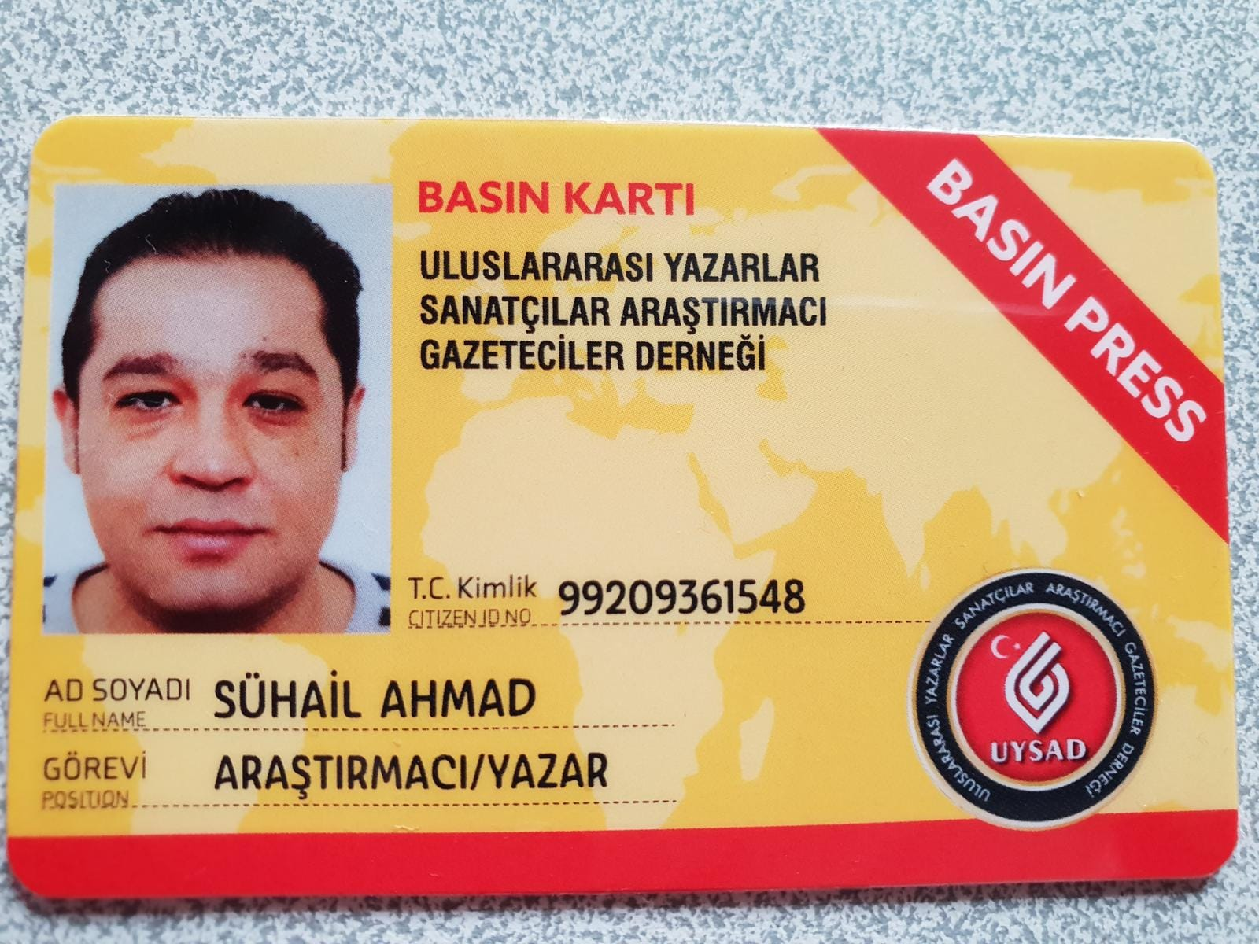

Digital skills - Self-assessment grid

Microsoft Office Programs (Word, Excel, PowerPoint, Outlook)

ADDITIONAL INFORMATION

Certifications GBV (TOT)

Certifications Psychological Firt Aid for Children Trainer Certifications Case Management officer with concern Certifications Introduction to Sexual exploitation and abuse
TOT psychological first aid trainer for teachers with ministry of education

