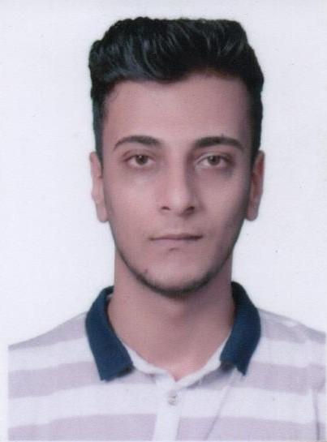 Omer Mohammed Ahmed Shaheen

Address: Al Naser Street

Mobile Number: 0592525604 E-mail Address: omar_shaheen2021@hotmail.com

EXECUTIVE SUMMARY

A professional psychologist seeking a senior position as a psychosocial counselor. An energetic team player, interested in challenge and development, I have good experience in psychosocial services. I have Strong writing and communication skills. Good in planning, organizing, implementing, monitoring and evaluating, experience in data management and reporting, delivery focus initiative, decision-maker and leader, highly motivated and used to work under pressure besides being flexible and adaptable to different environments.

WORK EXPERIENCE

psychiatric hospital 16/10/2022 till On top of my job psychologist
- Prepare monthly plans
- Conduct focus group for need assessment, monitoring and evaluation.
- Implement individual counseling sessions.
- Implement group counseling sessions.
- Carried out awareness sessions (Psychological support)

Japanese campaign to support the children of Palestine(CCP) 30/08/2021 till 1/10/2022 psychologist
- Prepare monthly plans
- Conduct focus group for need assessment, monitoring and evaluation.
- Implement individual counseling sessions.
- Implement group counseling sessions.
- Carried out awareness sessions (Psychological support)
- Conduct regular field visits for assessment, beneficiary identification, activity identification, implementation and monitoring.
Writing monthly reports

The National Society for Rehabilitation 30/08/2021 till 1/10/2022 psychologist
- Prepare monthly plans
- Conduct focus group for need assessment, monitoring and evaluation.
- Implement individual counseling sessions.
- Implement group counseling sessions.
- Carried out awareness sessions (Psychological support)
- Conduct regular field visits for assessment, beneficiary identification, activity identification, implementation and monitoring.
- Writing monthly reports

PALESTINIAN MEDICAL RELIEF SOCIETY 14/07/2021 till 13/08/2021 psychologist
- Prepare plans
- Implement individual counseling sessions.
- Implement group counselling sessions.
- Carried out awareness sessions (Psychological support)

AL-AMAL INSTITUTE FOR ORPHANS 07/06/2021 till 19/08/2021 psychologist
- Prepare monthly plans
- Conduct focus group for need assessment, monitoring and evaluation.
- Implement individual counseling sessions.
- Implement group counselling sessions.
- Carried out awareness sessions (Psychological support)
- Conduct regular field visits for assessment, beneficiary identification,activity identification, implementation and monitoring.
- Writing monthly reports

psychiatric hospital 19/5/2018 till 10/4/2020 psychologist
- Prepare monthly plans
- Conduct focus group for need assessment, monitoring and evaluation.
- Implement individual counseling sessions.
- Implement group counselling sessions.
- Carried out awareness sessions (Psychological support)

psychiatric hospital 13/1/2018 till 15/5/2018 psychologist
- Prepare monthly plans
- Conduct focus group for need assessment, monitoring and evaluation.
- Implement individual counseling sessions.
- Implement group counselling sessions.
- Carried out awareness sessions (Psychological support)

Green Plains Assembly 1/09/2015 till 30/08/2017 Facilitator
- Implement activating games for children.
- Implementation of life skills sessions for children.
- Re-arrange for regular meeting.
- Write reports
Wafi youth team 12/9/2016 till 10/3/2017 Facilitator
- Participate in preparing the plan of the initiatives.
- Participate in regular meeting with the team.
- Participate in campaigns.
- Write report.
- Attend with life skills training.
Youth team 19/2/2016 till 1/7/2017 Facilitator
- Participate in preparing the plan of the initiatives.
- Implement initiatives and documenting it.
- Sharing in supplying materials of the initiatives.
- Attend with life skills training

Youth councils 1/3/2018 till 18/7/2018 Facilitator
- Participate in preparing the plan of the initiatives.
- Participate in regular meeting with the team.
- Participate in the association activities.

Tamer Association for community education 1/5/2018 till 1/12/2018 Facilitator
- Participate with reading campaign.
- Prepare the plan of the initiative.
- Participate in implementing the intuitive.
- Carries out focus group with children for need assessment.
- Implement activities with the children.
- Attend with life skills training.

Summer Camp/ Association Soufaraa Saada 20/6/2018 till 25/7/2018 Facilitator

- Implement activating games for children.
- Implementation of life skills sessions for children.
- Re-arrange for regular meeting.
- Monitor and supervisor of the children.

 |  | EDUCATION
 | Islamic University of Gaza, Gaza, Palestine |  |  | Sep. 2015– Jan. 2019
 | BSc- Psychological counseling  Islamic University of Gaza, Gaza, Palestine  Master of Community Mental Health |  |  | GPA: Very Good  2020-2022  GPA:Very Good

SKILLS AND ACHIEVEMENT

- Trainings:
Oct. 2015 Phycological support training,
Nov. 2015 Communication skills.
Nov. 2017 Physiological first aid training
Jun. 2018 First Aid training
Mar. 2018 Youth Leaders.
Jan . 2021 psychological exams course
Aug . 2023 Self Care TOT

  - IT Skills: Microsoft Office Word, Excel, PowerPoint, Outlook, CRM interfaces, Internet surfers.

  - Languages: English good, Arabic (Mother Tongue)

  - Various management, business and skills courses

REFERENCES

  - Eng. Fatma. Anwer Alkhladi Project coordinator – TAMER Society
Mobile: 0597800476
Email: eng.fatma.alkhaldi@gmail.com

  - MR. Husam Al Sheikh Yousef Project coordinator – The National Society for Rehabilitation
Mobile: 0599331887
Email:

