Emad Said Kamel 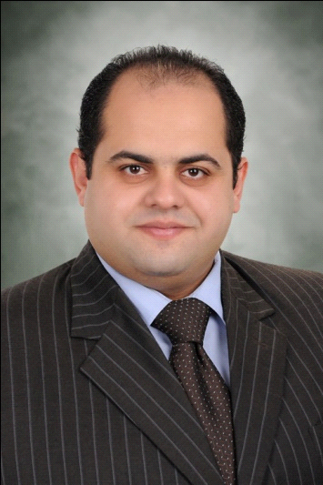
Personal Information
▪ Nationality: Egyptian
▪ Date of birth: 2 July 1980
▪ Marital status: Married
  ▪ Military service: Exempted
▪ Phone Mobile: 01223716938
▪Email : emadsaid2003@gmail.com
Education
B.A. law from Alexandria university 2007
Diploma in TOT from Cairo University 2015
Diploma in HR from Cairo University 2014
Diploma guidance prisoners from the Institute of Education and Welfare Cairo2012
BA from the College Seminary in Alexandria2009
Languages English
Computer Skills ICDL A+
^{Work experience}
- team manager at Delta Life Insurance 2015- NOW
- lawyer St. Mark's Hospital & Managing Director 2011-2014
- Sales man in personal loans department Barclays
^{From1-8-2009 To1-9-2011}
- Assistant Director of the Department of Electronics Carrefour hypermarket
^{From1-12-2007 To15-7-2009}
- Marketing representative in Elico for life insurance
^{Co. For 3 month}
- Marketing representative in Arkadia tourism
- ^{e company (timeshare}

