Oday Alawi Jasim  (B.D.S., MSc in Veterinary Anatomy)  Email : odayalawi82@yahoo.com  Mob : 00964- 7712100390  Tikrit university-College of Veterinary Medicine  http://tu.edu.iq/colleges/veterinary-medicine | 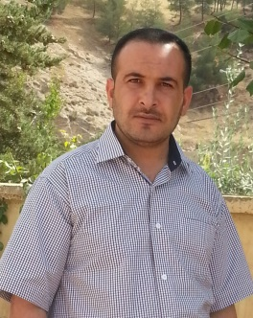

RESEARCH INTERESTS
I am interested in a wide range of research areas in the field of veterinary medicine, including stem cells, and cellular changes and anatomical differences between animals and their relationship to the vital functions of the body. My main research interests are linked to the strength and hardness of the animal with many cellular and anatomical changes .

ACADEMIC QUALIFICATION
- MSc Degree
2011 MSc in (Veterinary Anatomy) (2 years)
University College of Veterinary Medicine of
Baghdad
Teaching Language English
General specialty Veterinary Medicine
- Bachelor (B.D.S) Degree
2001 - 2006 Bachelor in Veterinary Medicine (5 years)
University College of Veterinary Medicine of
Baghdad
Teaching Language English
General specialty Veterinary Medicine

LANGUAGES KNOWN AND COMPUTER SKILL
Arabic and English.

PRESENT OCCUPATION

- Working with COLLEGE OF VETERINARY MEDICINE, UNIVERSITY OF TIKRIT from 22nd Sept. . 2006 till now.

Designation: Assistant lecturer in Veterinary Anatomy

PRESENT STATUS

- Assistant lecturer in the Veterinary Medicine , University of Tikrit, department of Anatomy .

TEACHING

- Undergraduate: Veterinary Anatomy, Histology and Embryology .

ADMINISTRATIVE ROLES

- Decision Branch

PERSONAL DETAILS

Date of Birth 24th Aug. 1982
Gender Male
Nationality Iraqi
Marital Status Married
Kids (1 Boy, - 1 girl,)
Passport no: A1675884
______________________________

