CURRICULUM VITAE

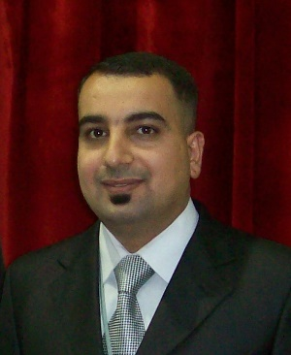
PERSONAL INFORMATION
Surname, Name: Mohammed Al-Falahi
Date and Place of Birth: 25 Jan 1983 Baghdad
Marital Status: Married
Phone: +964 7730201066
Email: mohmunim83@gmail.com

EDUCATION
Degree | Institution | Year of Graduation
M.Sc. | Çankaya Univ, Information Technology | 2017
B.Sc. | Baghdad College for Economic Sciences Univ, Computer Science | 2004
High School | Al-Qudus High School | 2000

WORK EXPERIENCE
Year | Place | Enrollment
2010- Present | Ministry of higher education in Iraq / AL Iraqi University | Teaching assistant
2008-2010 | Equaproject Company | IT & Administration
2004- 2008 | Technical Rescuers Company | IT & Administration

CERTIFICATE
- Optimization Clustering Routing Techniques in Wireless Networks / IEEE.
- Classification of Multi Heart Diseases with Android based Monitoring System / University of Technology
- Classification of scientific laboratories / Iraqi University.
- Education and learning administration by google classroom / Iraqi University.
- Preparation of the academic advisor / Iraqi University.
- The role of information technology in developing the accounting job / Iraqi University.
- How to write a CV in a professional way / Iraqi University.
- A training course in the excel program / Iraqi University.
- Teaching methods / Iraqi University.
- Integrity Arabic language / Iraqi University.
- Research experiences of scholarship outside Iraq / Iraqi University.
- MS project program / Baghdad University.
- Primavera program / Baghdad University

FOREIN LANGUAGES
Advanced English, Beginner Turkish

HOBBIES
Travel, Books, Swimming, Fitness

