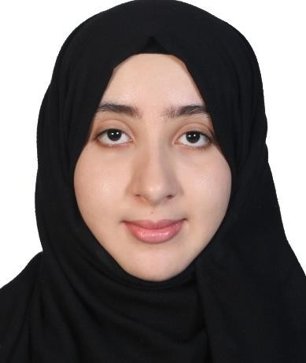

PERSONAL PARTICULARS

Name | : | Wafa Abdulahmed . M Shtawi
Date of Birth | : | 25/09/1997
Nationality  Passport No | :  : | Libyan  PG3YHKLY
Contact Details | : | +60183274006
Email ID | : | wafaaga797@gmail.com
EDUCATION HISTORY

Year | School / College Attended | Achievement
2016/2017 -  2020 | University Putra Malaysia “Biomedical Science” | Final year , last semester Current CGPA :3.471  Final semester GPA : 3.925
2015 | Libyan School in Kuala Lumpur (Malaysia | High School Diploma (CGPA : 3.7)

PROFESSIONAL MEMBERSHIP

Year | Body
2019-  Present | Assafa Academy

LANGUAGE PROFICIENCY & OTHER SKILLS

 | Language/Skills | Rating
Spoken | English and Arabic | Excellent
Written | English and Arabic | Excellent
Computer Knowledge | MS Office (PowerPoint, MSWord) | Excellent
Technical Skills | - Handling, feeding, and breeding of mices, dissection of mice, rats  - Preparing ies containing animal tissue sections by processing, cutting, and staining.  - Handling Cell culture (Suspension & adherent Cells)  - Flow cytometer | Good  Good Excellent

EMPLOYMENT HISTORY

Year | Employer | Position Held
2016-2019 | Taj alwaqar Academy | Teacher
Feb 2019- present | Assafa Academy | Teacher

ACHIEVEMENTS

Improvements / Projects | Institution
Year: 2018  Regeneration and Characterization of Umbilical cord Human Mesenchymal Stem Cells  & Preparing Histological Slides Researcher  Year: October 2019 – September 2020  ASSESSMENT OF THE COMBINED CYTOTOXIC EFFECT OF ETHANOLIC EXTRACT OF MORINGA OLEIFERA AND HUMAN MESENCHYMAL STEM CELLS ON LEUKAEMIC CELL LINES  Researcher  - In charge of the research as Final Year student. | University Putra Malaysia  University Putra Malaysia
Award Received

Name of awards | year
Conferred Bachelor Dean’s List “Faculty of Medicine and Health Science; University Putra Malaysia. | 2020
Certificate of participation in volunteerism program at Pusat Jagaan  -Al -Fikrahfikarh and hundreds of field offices. | 2016
Awarded a certificate for the highest score in mathematics Subject (Libyan School in Kula Lumpur Malaysia) | 2015
Awarded a certificate for the highest score in Physics Subject and Best student during High School (Libyan School in Kula Lumpur Malaysia) | 2015
Awarded a certificate of the best student in Libyan school | 2014
Soft Skills Trainings Attended

Trainings | Year
Improvement of teaching strategies in teaching | present
Academic Writing Course | 2015
Teaching with Love | 2016 - present
Conducting Valid Research | 2019 - 2020
Managing the Research Journey | 2018- 2020

Workshop , Seminars and Conferences

Conference/ Seminar | Venue | Year
Real time PCR | University Putra Malaysia | 2020
Cellular cross talk in cancer | University Putra Malaysia | 2019
Multiplex PCR | University Putra Malaysia | 2018
Elsevier publishing workshop: Writing a  great paper and getting it published in a research Journal | University Putra Malaysia | 2018

EXTRACURRICULAR ACTIVITIES

Voluntary work for University Putra Malaysia QS Survey for university ranking.
Voluntary work in elderly care home ( Kajang, Malaysia )
PERSONAL STRENGTH

I have a positive attitude, self-efficacy, and ability to make things go right regardless of circumstances to meet my research objectives. I am both people-oriented and results-oriented. My past track record as trainee research and my recent exposure as researcher in the University are evident that I am good in each undertaking which reflecting my performance skills. I do possess the ultimate passion for striving for excellence in quality, productivity, delivery and integrity to drive results for any institution through people and make a difference. I am proud to declare that I am a fast-learner and without fail seek for challenging roles which I consider as opportunities to excel.

ACADEMIC REFEREES
- Associate Professor Dr Rajesh Ramasamy : Professor, Pathology department, faculty of medicine and health science, University Putra Malaysia, Selangor, Malaysia.

Email: rajesh@upm.edu.my

Phone: +603-9769 2377

- Associate Professor Dr Norshariza Nordin Biomedical Science Department, Faculty of Medicine and Health Science, University Putra Malaysia, Selangor, Malaysia.

Email: shariza@upm.edu.my

Phone: +603 8947 2650

- Dr. Fezah Othman: Biomedical Science Department, Faculty of Medicine and Health Science, University Putra Malaysia, Selangor, Malaysia.

Email: fezah@upm.edu.my

Phone: +603 8947 2333

