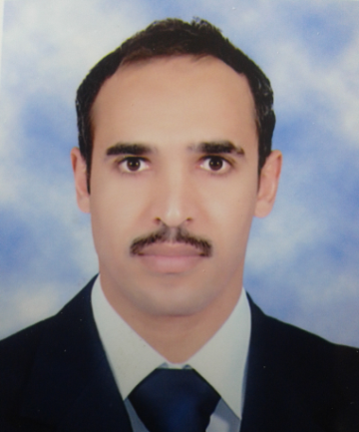
Rabeea Dahy
CV

PERSONAL DETAILS:
Date of Birth: December 9, 1986
Citizenship: Egyptian
Gender: Male
Work Address: Chemistry Department, Faculty of Science, Al-Azhar
University, Assiut, Egypt
Telephone: 002 01112151185
E-mail: rabia.chem@yahoo.com, Rabeea.D.Abdel-Rahim@Azhar.edu.eg

EDUCATIONAL QUALIFICATIONS:
September 2016: Master of physical chemistry
Chemistry Department, Faculty of Science, Al-Azhar University, Assiut, EGYPT

January 2014: Registered for Master of Chemical Science
Entitled: "Determination of some pharmaceuticals compounds using
nanotechnology developed voltammetric techniques and spectrophotometric
methods"
Chemistry Department, Faculty of Science, Al-Azhar University, Assiut, EGYPT

May 2013: Pre Master in Chemistry, Inorganic Chemistry
Chemistry Department, Faculty of Science, Al-Azhar University, Cairo, EGYPT
Chemistry 501( Advanced Analytical Chemistry)
Chemistry 502(Chemical application of group theory, Coordination chemistry and
determination of stability constants, and Advanced organometallic chemistry)
Chemistry 503 (Organic synthesis, Heterocyclic chemistry, and Reaction mechanism)
Chemistry 504 (Advanced chemical kinetics, Thermodynamic of solutions (Macromolecules),
and Heterogeneous catalysis)
Chemistry 505 (Applied Physical Chemistry, Advanced)
Chemistry 506 (A special course in Physical Chemistry)

May 2009: B.Sc. in Special Chemistry (Excellent With Honor Degree)
Chemistry Department, Faculty of Science, Al-Azhar University, Assiut, EGYPT

INSTRUMENTAL WORKING AND OPERATION:
• Perkin Elmer Pecss program (treatment the experimental results of Visible spectra)

PROGRAMMING SKILLS:
• Desktop Publishing (Office, Excel and PowerPoint)
University/Institution  (Employer) | From | To | Job  Title/Rank  (Position) | Inclusive duties  (teaching,  research) | Type of Job  (full time,  part time)
Al-Azhar Univ., Faculty of  Science | 2016 | Now | Assistant  Lecturer | Teaching, research | Full time
Al-Azhar Univ., Faculty of  Science | 2013 | 2017 | Demonstrator | Teaching, research | Full time
Ceramica Cleopatra Group | 2010 | 2013 | Chemist | Laboratory measurements and quality | Full time
EMPLOYMENT HISTORY:-

COURSES TAUGHT AT Al-AZHAR UNIVERSITY (Undergraduate)
Experimental Physical Chemistry (kinetics chemistry, and instrumental analysis)
Experimental Analytical Chemistry (qualitative and quantitative analysis)
Experimental Organic Chemistry (qualitative analysis and organic Synthesis)

MASTER THESIS ABSTRACT:
The work mainly attempts to purification of phosphoric acid solution from Fe(III) pollutant. Our concern is based on preparation of a new adsorbent based on polyvinyl alcohol and zirconium oxide composite and its phosphorylation to become cross-linked phosphorylated PVA-ZrO₂ composite and this composite was characterized using FT-TR spectra, XRD and SEM. and we focus in experimental application of the obtained adsorbent for adsorption of Fe(III) ions from different phosphoric acid percentage solutions.
RESEARCH INTERESTS:
• sorbents (Preparation, Characterization and Application).
• physical and Analytical chemistry.
• Spectrophotometric analysis (Quantitative Analysis).

REFEREES AND SUPERVISORS:
Prof. Dr. Mahmoud Mohamed Kamel
Professor of physical Chemistry - Faculty of Science, Al-Azhar University (Assiut branch(
Telephone: 00201113033830, 00966537106764
E-mail: Mmk.electro@yahoo.com

Prof. Dr. Mahmoud Ahmed Taher
Professor of physical Chemistry - Faculty of Science, Al-Azhar University (Assiut branch(
Telephone: 00201224816666
E-mail: mahmoudtaher@yahoo.com

Dr. Mohamed Hassan Ahmed
Lecturer of physical Chemistry- Faculty of Science, Al-Azhar University (Assiut branch)
Telephone: 00201152445569
E-mail: mohm7762@yahoo.com

