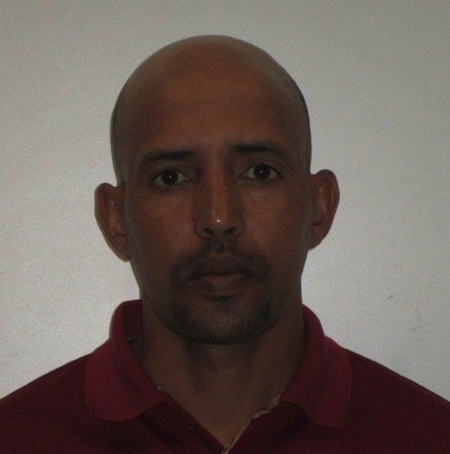

Sayid Ahmed

Personal Information

Surname : Cherif Mohamed Ahmed
First Name : Sayid
Nationality : Mauritanian
Place of birth : Nema (Arafat)
Date of Birth : 31 December 1979

Physical Address : 57 Barkston Drive
Blarigowrie Randburg
Johannesburg 2194 RSA
Home Number : +27 11 888 7587
Cellular Number : +27 61 542 6443
E-mail : shingitee17@gmail.com
Skype Name : live:binahmad222_1
LinkedIn Page : https://www.linkedin.com/in/sayid-ahmed-4022708a
Face book Page : https://www.facebook.com/shingitee17

Health : Excellent.

Languages : Official Arabic and dialect of 16
Arab countries
(Algeria, Bahrain, Egypt, Iraq, Jordan, Kuwait, Libya, Mauritania, Qatar, Saudi Arabia, Sudan, Syria, Tunisia, United Arab Emirates, Western Sahara and Yemen).
Level of the language: Native

Other languages : 1 - Hausa (West African language)
(Benin, Ghana, Niger, Nigeria &Togo)
Level of the language: Average

2 - English
Level of the language: Average

EDUCATIONAL QUALIFICATIONS

Name of School: E & M of Imam Nafeeá Al.Layette
(Memorizing of holy Quran in Medina Saudi Arabia)
Year Completed: 1995 - 1996

Name of School: Ouhod Secondary School
In Medina Saudi Arabia
Year Completed: 1998 - 1999

College : Business Training limited
(Manchester UK)
Course : National Diploma in Business English (Correspondence)
Year : 2001 – 2002

University : University of Nairobi (Kenya)
Course : Bachelor of Arts in Islamic Studies
Year : 2004 – 2005

College : Wits Language School ( JHN RSA)
Course : General English (6 months)
Year : December 2011- May 2012

College : Dawratt Aljuhani Islamic Centre
Courses : Islamic Sciences and Arabic Linguistics (Correspondence) Cairo Egypt
Period : From 01/01/2016 to 17/12/2018
Reference : Sheikh Khalid Aljuhani
Contact : +201 90 243 7964

Academy : Benaa Islam Academy (Online academy)
Courses : National Diploma in Islamic Studies
Period : From 2016/2017 to 2019/2020
The Percentage: 93%
Reference : ttps://benaa.islamacademy.net/student/
index.php

Academy : ZAD Academy (Online academy)
Courses : National Diploma in Islamic Studies
Period : From 2016/2017 to 2019/2020
The Percentage: 94.31%
Reference : https://graduation1.zad
academy.com/course/index.php?categoryid=2
file:///C:/Users/WAHEGURU/Downloads/Certificate_of_Completion.pdf
file:///C:/Users/WAHEGURU/Downloads/grade_report.pdf

Academy : Rwaq Academy (Correspondence)
Reference : Sami bin Omar Al.Hessain
Contact : https://t.co/Yp3slak77A
Reference : Fouad Alfarhan
Contact : https://t.co/Yp3slak77A

Riyadh Saudi Arabia

Course 1 : The Biography of the Prophet
Period : From 16/01/2018 to 13/04/2018
The Percentage: 100%

Course 2 : Educational Session Certificate for Arabic teachers 1
Period : From 20/01/2018 to 20/04/2018
The Percentage: 69%

Course 3 : HTML5 CSS3 Java Script Programs
Period : From 18/03/2018 to 15/07/2018
The Percentage: 90%

Course 4 : Writing Media Reports
Period : From 20/03/2018 to 25//04/2018
The Percentage: 94%

Course 5 : The Biography of the Prophet in
Medina
Period : From 24/03/2018 to 28/08/2018
The Percentage: 98%

Course 6 : The Eloquence of the Educational
Discourse in the Qur'an and Hadith
Period : From 20/04/2018 to 01/07/2018
The Percentage: 100%
Course 7 : Jurisprudence of Fasting and its etiquette
Period : From 25/04/2018 to15/06/2018
The Percentage: 89%
Course 8 : How do I get a score of 7 in the IELTS test?
Period : From 29/04/2018 to 31/07/2018
The Percentage : 93%
Course 9 : Informatics Crime - Level 2
Period : From 10/05/2018 to 10/10/2018
The percentage: 90%

Course 10 : Ihyaa (Reviving) in the new dress
(Section I: Educational) Curriculum
Aqidi (Nodal).
Period : From 23/08/2018 to 18/11/2018
The Percentage : 100%
Course 11 : Trends in linguistic correction (Arabic)
Period : From 31/08/2018 to 18/12/2018
The Percentage : 100%
Course 12 : Educational Session Certificate for
Arabic teachers 2
Period : From 01/11/2018 to 30/01/2019
The Percentage: 85%
Course 13 : Ihyaa (Reviving) in his new dress (Section II:
Jurisprudence of worship and its purposes
And literature
Period : From 01/12/2018 to 02/02/2019
The Percentage: 100%
Course 14 : English vocabulary
Period : From 02/10/2018 to 03/03/2019
The Percentage: 100%
Course 15 : Righteous Caliphs 1
Period : From 06/10/2018 to 28/02/2019
The Percentage: 100%
Course 16 : Ihya Educational and Secular Section III
Period : From 28/01/2019 to 21/03/2019
The Percentage: 92%
Course 17 : English Academic writing skills
Period : From 14/02/2019 to 21/03/2019
The Percentage: 100%

Course 18 : Comprehensive definition of TOEFL test
and preparation method
Period : From 15/02/2019 to 30/03/2019
The Percentage: 87%

Course 19 : Developing the skills of graduates of Islamic
studies, and ways to improve income - the
second level
Period : From 27/01/2019 to 07/04/2019
The Percentage: 90%

Course 20 : Methods of teaching Arabic language skills
to non - native speakers
Period : From 25/02/2019 to 25/04/2019
The Percentage: 85%

Course 21 : Righteous Caliphs 2
Period : From 26/01/2019 to 14/06/2019
The Percentage: 100%

EMPLOYMENT HISTORY

Name of Company: Al.Qabas House for certified translation in Madina Saudi Arabia
Position held : Translator and Interpreter
Duration : 2005- 2007
Reference : Mr. Ameen Al.Shingitee
Contact : +966 50 532 4113

The association : Darul Arqam Islamic Centre
Lenasia South /JHB South Africa
Position Held : Islamic Studies & Arabic Teacher
Duration : 2008-2012
Reference : Sheikh Mohamed Ataya
Contact : +27 82 751 1685

Name of Company: Abu Bakar Communications CC
Mayfair/JHB South Africa
Position held : Supervisor
Duration : 2013 – 2018
Reference : Mr. Maina Garba
Contact : +27 76 324 1364

Currently : Representative of Bin Hashan for
Recruiters SRL (Saudi Arabia)
In South Africa
Reference : Mr. Abdalla Bin Hashan
Contact : +966 53 397 8456

