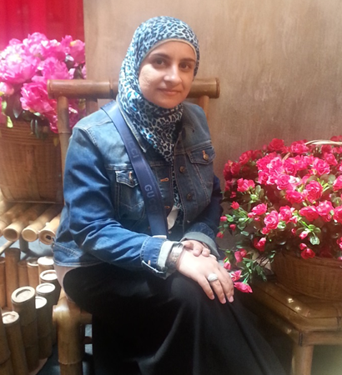
Dr. Khansa Mohammed younis
Department of Biology/Microbiology
Faculty of Science
University of Mosul
Iraq

BIOGRAPHY:
Dr. Khansa Mohammed, is a lecturer of Microbiology / Biotechnology at Biology department of Mosul University/ Iraq. The motivation for her work is the fact that her parents allowing her to realize her potential and teaching her that her job in life was to learn, to be happy, and to know and understand herself. She holds the PhD of Anti-biofilm and Quorum sensing inhibition from University Kebangssan Malaysia (UKM) / Malaysia, her Master degree of Biochemistry as well as a Bachelor of Science degree in food poisoning from Mosul university/Iraq.
She has over fifteen years’ experience of microbiological research and lectureship. This includes experience of water microbiology, bacterial pathology, molecular biology, microbial physiology and biochemistry. In addition to participating in national and international conferences and seminars. She served on several committees relating to Microbial Biotechnology applications. She has also delivered papers to several national and international journals.
CONTACT INFORMATION:
Email: khansaa_altaee@yahoo.com
Phone number: 0182489067.
RESEARCH INTEREST:
Microbiology, Biofilm, Biocontrol, Molecular biology, Antibacterial and Biochemistry

