CV

Zid Chaher
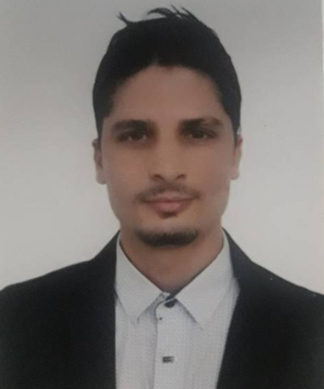
Personal Information

Gender : Male
Marital Status : Single
Residence : Kuala Lumpur, Malaysia.
Language known : Arabic, English and French.
Email :

chaher_hse01@hotmail.fr /zchaherz@gmail.com

Education / Qualifications:

- Please email me

Skills:

- Please email me

Work Experience:

- Please email me

Research Activities:

- Please email me

- Please email me

Language:

- Please email me

MISCELLANEOUS:

- Please email me

