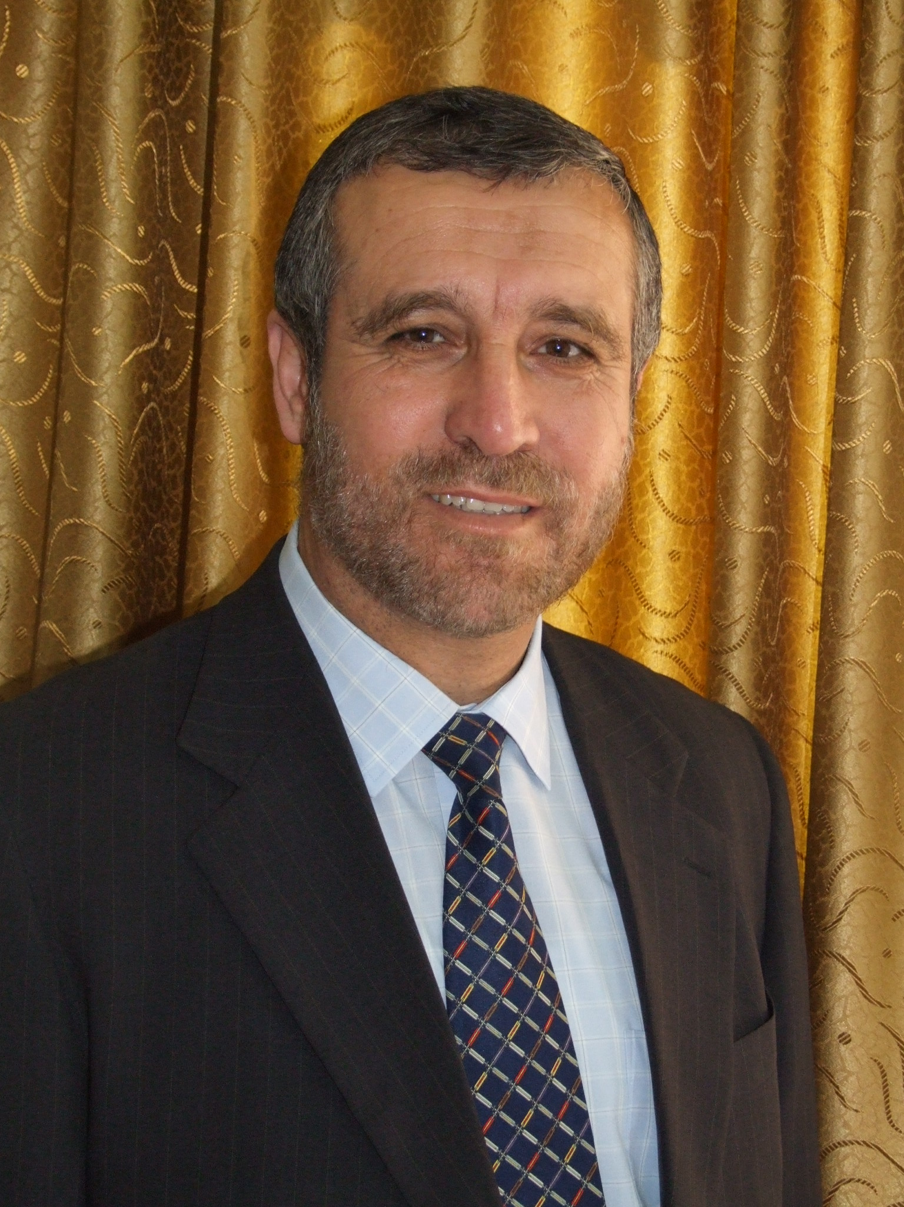

Curriculum Viate

Dr. Issam Buhaisi
Prof. of Accounting and Financial management
Financial and Managerial Trainer and Consultant

January . 2020

NAME | Issam Mohammed Buhaisi
Home Address | Dier El Balah , Gaza Strip – Palestine  Tel: 08- 2534236
Contact Information | Mobile: 0592610232 - 0599781217  E-mail: is2210@hotmail.com
Place and Date of Birth | Dier El Balah ,Gaza Strip, Palestine. 22nd of October 1963
Marital Status | Married + 4
Main  Qualifications | Academic  - PH.D in Accounting and Financial Management, University of Valladolid, Spain, May, 2004.  - Master in Accounting and Financial Management, University of Salamanca, Spain, Sept, 2000  - Bachelor in Accounting, Islamic university of Gaza, July 1987.  Professional  - Training Course in SAP; ERP, organized by SAP Corporation, Beirut Lebanon, June, 2013  - Training of Trainers Course in International Human Law, organized by International Committee of Red Cross – Geneva ( ICRC), Gaza, February 2010  - Training of Trainers Course in Business Simulation organized by University of Maryland – USA. Jun 2006  - Arab Certified Public Accountant (ACPA) – since February 2006  - - Certificate of Professional Accountant from of the British Royal Society of Arts, R.S.A. (UK),December,1992.  - Training of Trainers Course in Finance and Management, organized by German GTZ, Cairo, April, 1998.
Other Qualifications  (post graduate courses)  Other Qualifications  (post graduate courses) | - Using Computer programs in accounting, organized by Palestinian Accountants and Auditors association PAAA, Gaza,1991.  - Developing the small business in the Arab World, organized by DRC, Amman, Jordan, 1994.  - Developing the small business, organized by UNRWA, Gaza, 1997.  - Managing the small business, organized by UNRWA, Gaza, 1997.  - Methods of Mathematics investigation, University of Salamanca, Spain 1999.  - International Accounting Standards, organized by USAID, Gaza, 2000.  - Using Excel program in the financial analysis, DBRS, Gaza, 2000.  - Advances Financial Management, organized by General Foundation – University of Salamanca, Spain 2001.  - Strategic Marketing, organized by General Foundation - University of Salamanca, Spain 2001.  - Using SPSS program in financial and managerial analysis, University of Salamanca, 2002.  - ERP SPA training course, University of Sant Joseph, Beirut, Lebanon, 2013
Academic Experience  Academic Experience | Actually:  - Full Professor of accounting at the Accounting Department, Faculty of Finance and Business Administration– University of Palestine {since October 2015}. (Teaching language is English)  - Head of Accounting Department, Faculty of Finance and Business Administration– University of Palestine { since September 2015}  - Vice President of Scientific Research Council, University of Palestine, since march, 2017.  - - Member of the Examinations Committee of the Palestinian Certified Accountants Council since Oct. 2008.  - Director of Planning Committee – University of Palestine, since September 2015  - Member or Erasmus Committee – University of Palestine, since September 2015  Before  - Associate Professor of accounting at Accounting Department, Faculty of Finance and Business Administration– University of Palestine { { February 2014- October 2015}.  - Associate professor of accounting at Accounting Department, Faculty of Commerce – Islamic university of Gaza (IUG).}.(Teaching language is English) - 2009 November2009 - 2014 January2014)  - Assistant professor of accounting at Accounting Department, Faculty of Commerce – Islamic university of Gaza (IUG).}.(Teaching language is English) May2004 -2009 November2009.  , Lecturer of accounting at at Accounting Department. Faculty of Commerce – Islamic University of Gaza (IUG.) - 1987—2004  - Member of the steering committee of the accountants enhancement training program shared by the Islamic university of Gaza, University of Maryland and the Education For Employment foundation (Mini MBA). Jan 2005 – Dec. 2006  - - Member of the education quality committee - Faculty of Business - Islamic - university of Gaza (IUG), Jun. 2007- January 2014.  - 2005 -2006 Coordinator of the accountants enhancement training program shared by the Islamic university of Gaza, University of Maryland and the Education For Employment foundation (Mini MBA).  - 2014-2017 Director of 10 Master Thesis at the joint program between University of Palestine and North Virginia University. And Examiner of another 15 Master Thesis in the same program.  - 2005 -2014 Advisor (director )of 62 Master Thesis, faculty of Business – Islamic University of Gaza, Palestine
Academic Experience  As a Thesis director and Examiner | - Examiner of three Master Thesis, Al-Azhar University, Gaza, Palestine  - 2005 -2014 Advisor (director ) of 62 Master Thesis, faculty of Business – Islamic University of Gaza, Palestine  - 2005 -2014 Examiner of 74 Master Thesis, Islamic University of Gaza, Palestine  - 2013 Director of 2 Master Thesis, Faculty of Public Health, University of Jerusalem, Palestine  - 2012 Advisor of Master Thesis, academy of Policy and Management, Palestine
Administrative Experience | - Head of Accounting Department, Faculty of Finance and Business Administration– University of Palestine { since September 2015}  - Head of Accounting Department Faculty of Commerce – Islamic University of Gaza (IUG). { August 2012- January 2014}  - Head of External Relations and International Cooperation Committee – Faculty of Business - Islamic university of Gaza (IUG), Jan. 2008 – July 2012.  - June 2004 – June 2006 Director of Business Research Unit Faculty of Commerce – Islamic university of Gaza (IUG).  - Director of Planning Committee – University of Palestine, since September 2015
Editorial Board Membership | - Editorial Member of The Journal of Accounting and Finance – USA, since October 2012  - Editorial Member of Universal Journal of Accounting and Finance –USA, since October 2014  - Editorial Member of The Islamic University Journal of Economics and Business Administration may 2010 – January 2014  - Editorial Member of Journal of Business Management and Economic Development – England, since May, 2010  - Editorial Member of International Journal of Business and Economics Research, USA, since January 2011  - Editorial Member of the journal Advances in management -India during 2010  - Editorial Member of The Islamic University Journal – Human Studies Series. – Palestine, Sept. 2004 – Sept.2006  - Editorial Member of University of Palestine journal, since may 2015
Teaching and investigation Interests | - Financial Accounting  - Financial Management in Private Sector  - Financial Management in Government Sector  - Financial Management in NGO's  - Managerial Accounting  - Cost Accounting  - Financial Analysis  - Budgeting and financial planning  - Strategic Management
Training Experience  Training Experience | 1993 – Present More than 10500 TRAINING HOURS of managerial and financial training with different international and local organizations and training centers in Gaza Strip, such as:  SMET( UNRWA) ,TAMI, PALCON, Woman Affair’s Center, IUG (Continues Education Center), MAAN, NFID, DBRS, Save Children - Sweden, Save Children – UK, Care, Impact, USAL, Pioneers, INFRA, Kanaan, PINGO, EFFECT, SASTIC, Red Cross, CRA, and Shams Al Horiah.  The training was concentrated at the following fields:  - Financial Management for private sector  - Financial Management for NGOs  - Financial Management for small and micro business  - Financial Accounting for small and micro business  - Feasibility studies conduct  - Budgeting and financial planning for Business  - Budgeting and financial planning for NGOs  - Managerial Accounting  - Financial analysis  - Cost accounting  - Proposal writing  - Preparing Business Plan  - Management Skills  - Small business - starting, management and development  - Business evaluation and problems diagnostic.
Professional Experience  As Financial Consultant and Financial System Developer  Professional Experience  As Financial Consultant and Financial System Developer | - 1990 - Present a financial consultant for several local companies and NGO.s.  - 2001- Present As a consultant, sharing the formulation process of many national economic and financial plans for the Palestinian National Authority prepared by different ministries of PNA.  - 2001- Present As a consultant, sharing the process of evaluating and developing the financial system of 75 Palestinian NGOs.  - 2001- Present As a consultant, sharing the process of evaluating and developing the financial system of 23 private companies in Gaza Strip and west bank.  - Conducting 168 feasibility studies for investment projects.  - Preparing 39 project plans for different local organizations.  - Sharing the process of preparing the financial budget of several companies and NGOs in Gaza Strip since 1990.
Professional Memberships | -1987 – Present a member of the Palestinian Accountants and Auditors Association in Gaza Strip (P.AAA).  -2004 – Present a member of the Arab Certified Public Accountants Association (ASCA)  - 2010 – Present Member of European Economic Chamber of Commerce
Publications  Publications  (Continue)  Publications (continue)  Publications (continue)  Publications (continue) | Research & Articles published at Refereed Journals and Conferences  - Buhaisi, Issam (2019)" Analysis de la empresa palestina" Diarios Economicos, Universidad de Salamanca, Vol. 1, No. 4, PP.57-69.  Buhaisi, Issam (2016). "Implementation of IFRS in Palestine, possibilities, advantages and challenges from the point view of Palestinian accountants". Presented at XI International scientific conference, «Accounting, Analysis and Audit: History, Present and Prospects» hold in the Business and Finance Faculty, Saint Petersburg State University of Economics. Russia Federation 19th October 2016.  - Buhaisi, Issam (2016) "Role of accounting information in the development of Small and medium business in Gaza Strip". Presented to the scientific congruence for Social Responsibility and Development – Al Azhar University. 5-6 Nov.  - Buhaisi, Issam (2014)." The impact of published accounting information on the Market Share Price: Case study of the listed Palestinian corporations" University of Palestine Journal, No. 7, pp. 269-285.  - Buhaisi, Issam (2014)." Effectiveness of internal control in computerized accounting information systems: case study of the banks in Gaza Strip" University of Palestine Journal, No. 6, pp. 78-95.  - Buhaisi, Issam (2013). "IFRS and small firms in developing countries". Cuadernos Economicos, Universidad de Salamanca. España. Vol. 2, No.1, pp. 22-31.  - Buhaisi, Issam (2013) " Evaluating the accounting information system in Small and medium business in Palestine" Islamic University Journal for Economics and Business. Vol.2 No. 1 pp.243-256.  - Buhaisi, Issam (2012) "Evaluating the accounting information system in Palestinian NGO's " Islamic University Journal for Economics and Business. Vol. 20, No. 2, pp. 361-380.  - Buhaisi, Issam " Contabilidad in Beit el Mal (Casa de Hacienda)" presented to VIII Encuentro de trabajo sobre historia de la contabilidad Organizado por El Departamento de Economía Financiera y Contabilidad de la Universidad de Valladolid. Soria 14 - 16 noviembre 2012  - Buhaisi, Issam (2011) "The application of IFRS en Palestine firms advantages and obstacles". Presented to el Segundo Congreso Iberoamericano de Investigación contable, Reflexiones y Perspectivitas. Universidad ICESI, Cali. Colombia 1-2 de Marzo.  - Buhaisi. Issam (2011) " The role of accounting information in the decision making process in developing countries: The case of Palestinian managers". Advances in Management, Vol. 4, No. 1, pp. 58-68.  - Buhaisi. Issam (2011) "Role of accounting information in credit decision making in Palestinian banks". Islamic University Journal. Vol. 19, No. 2, pp. 1137-1177.  - Buhaisi, Issam (2011) "Threats of that affect computerizes accounting information systems". Islamic University Journal. Vol. 19, No. 1, pp. 1349-1357.  - Buhaisi, Issam (2010) " Toward to the development of accounting in Palestine: Evaluating the current situation". Islamic University Journal.vol.18, No. 2, pp. 1249-1276.  - Buhaisi, Issam and Anwar Nejem (2009) "The awareness of the investors at the Palestinian Securities Exchange to the importance of accounting information to their investment decision". Islamic University Journal, vol. 17, No. 2. pp 713-740.  - Buhaisi Issam (2009) " Financial System en Palestinian NGOs" Presented to the Conference titled "Reality of Palestinian NGOs: Prospects and challenges" organized by Relief and Development Association, Gaza, July 5.  - Buhaisi Issam (2009) " Financial management for NGOs between local and international standards" presented to the conference titled " Financial Management in Palestinian NGOs" organized by Palestinian NGOS Network, Gaza, Dec. 11.  - Buhaisi, Issam and Horiah Al Shareef (2008). "Threats of that affect computerize accounting information systems: Case study the banks of Gaza Strip, Palestine". Islamic University Journal, vol. 16, No. 2, pp.895-924.  - Buhaisi Issam and Khaled el Kahlout (2007) "Using financial analysis in credit decision making at the banks that are working in Palestine"". Islamic University Journal, vol. 15, No. 2, pp.581-606.  - Buhaisi, Issam and Yousef Jarboua (2007) "Application of international auditing standards in Palestine". Journal of Commerce Research and studies, Vol. 25 , No.1, pp705-775. – Banha University – Egypt.  - Buhaisi Issam. (2007) "Toward a best regulation of accounting and auditing profession in Palestine: An analysis of the low number 9/2004. Presented at the accountant Day conference, held at the Faculty of Business, Islamic University 20 of March, 2007.  - Buhaisi, Issam. (2006) Measuring diversification in international accounting systems- Literature review. Islamic University Journal, Vol. 14, No. 1, pp.179-212.  - Buhaisi, Issam. (2006) " Modern information technology and its influence on managerial decision making in business organizations: case study of Palestinian firms" Islamic University Journal, Vol. 14, No. 1, pp. 155-178.  - Buhaisi, Issam. (2006) "Toward New financing methods for small business at Gaza Strip from the point view of business owners". Presented to Congress titled " Developing the Gaza Strip after the Israeli withdraw" held at the Faculty of Business, Islamic University 13-15 February, 2006.  - Buhaisi, Issam. (2005) "Palestinian Stock Exchange and it is ability to attract local and foreign investments". Presented to The First Congress of Finance and Investment in Palestine held at the Faculty of Business, Islamic University 8-9 May, 2005.  - Buhaisi Issam and Mercedes Fajardo Ortiz. (2005) "The role of accounting information at the business decision in developing countries: the case of Palestinian managers" presented at the IX Simposio Internacional de Contaduría y Finanzas. 26, 27 y 28 de Octubre de 2005. Ciudad Obregón, Sonora, México.  Research & Articles at Specialist Journals (without Referees)  - - Issam Buhaisi, (1991) "Taxation in the Gaza strip", Research for the UNRWA Field Office –Gaza, (English) with others.  - - Issam Buhaisi, (1992) "Evaluation of Investment Projects in the Islamic Thought". (1992), Palestinian Accountants journal, Gaza, No.3, March, pp. 20-23.  - - Issam Buhaisi. (1992) "Rules for Cost accounting". Palestinian Accountants journal, Gaza, No. 4, August, P. 28-31.  - Issam Buhaisi(1993) "Accounting Principles and Standards a cording to the Islamic Thought". Palestinian Accountant Journal, Gaza, No. 5, March, pp.19-25.  - Issam Buhaisi, (1994). "Corporate Companies Accounting. Palestinian Accountant Journal, Gaza, No. 6, March, pp. 46-48.  - - Issam Buhaisi, (1994). "Unemployment in the Gaza Strip". Palestinian Accountant Journal, No. 7, August, pp. 25-27.  - - Issam Buhaisi, (1995). "Contracts Accounting". Palestinian Accounting Journal, No. 8, pp. 62-65.  - Issam Buhaisi, (2005), "Role of Accounting information system in decision making". ASCA Journal, Vol. 25 May – Jun, pp.16 -32.  - Issam Buhaisi (2005) "Balanced Scorecard as new evaluation instrument for business firms" Palestinian Accountant Journal, No. 25. p. 24-33.
Conferences, and workshops  Congress, conferences, and workshops  (Continue) | Coordinating  - Member of the Coordination Committee of the conference titled " Scientific Research of Palestine- Toward a map of scientific research, held at the Islamic university , March 2013.  - Head of Coordination Committee of the conference titled "Graduates from accounting departments at Palestinian universities and their ability to integrate the labor market" held at the Islamic university of Gaza. March, 27. 2010.  - Head of Coordination Committee of the Congress titled "The development of management performance in the Palestinian public sector l" Organized by the Palestinian Personnel General Office. Held at Gaza City, 30 of April, 2009.  Coordinator of the at the first Palestinian accounting forum, held at the Faculty of Business, Islamic University March,20, 2007.  Head of Coordination Committee of the Congress titled "The development of Gaza Strip after the Israeli withdrawal" held at the Faculty of Business, Islamic University 13-15 Februarys, 2006.  Head of Coordination Committee of the First Congress of Finance and Investment in Palestine held at the Faculty of Business, Islamic University 8-9 May, 2005.  - Coordinator of several workshops, study days and scientific meetings during the last 10 years at the Islamic university of Gaza.  Participating  Participating XI International scientific conference, «Accounting, Analysis and Audit: History, Present and Prospects» hold in the Business and Finance Faculty, Saint Petersburg State University of Economics. Russia Federation 19th October 2016.  Participating The scientific congruence for Social Responsibility and Development – Al Azhar University. 5-6 Nov.  - Participating "VIII Encuentro de trabajo sobre historia de la contabilidad Organizado por El Departamento de Economía Financiera y Contabilidad de la Universidad de Valladolid. Soria 14 - 16 noviembre 2012  Participating the conference titled "Financial Management in Palestinian NGOs" organized by Palestinian NGOS Network, Gaza, Dec. 11. 2011.  - Pariticipating "El Segundo Congreso Iberoamericano de Investigación Contable, Reflexiones y Perspectivitas. Universidad ICESI, Cali. Colombia 1-2 de Marzo. 2010  - Participating the conference titled "Reality of Palestinian NGOs: Prospects and challenges" organized by Relief and Development Association, Gaza, July 5. 2010  - Participating the First Congress of Finance and Investment in Palestine held at the Faculty of Business, Islamic University 8-9 May, 2005.  - Participación the IX Simposio Internacional de Contaduría y Finanzas. 26, 27 y 28 de Octubre de 2005. Ciudad Obregón, Sonora, México.  - Participating the 25 annual conference of European Accounting Conference Copenhagen 21-23 of April 2003.  - - Participating Several workshops concerned with Economic, financial and development issues, organized buy the PNA ministries and local and international organizations as a consultant.  -
Computer Skills | A user level of the following programs (under Windows):  WinWord  Excel  - SPSS  - Power Point
Other Activities | - Attending many Local and International seminars, conferences and workshops dealing with accounting, finance, management and development in Gaza Strip.
Languages | - Arabic (Mother Language)  -Spanish (Speaking, Reading and Writing)  - English((Speaking, Reading and Writing)  - Hebrew (Speaking, Reading and Writing)
Reference | Up on request

