**CURRICULUM VITAE**

Name: Kareem Kadhim Hammadi 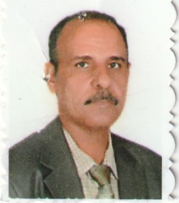

D.O.B:1-7-1960

Sex: male

Marital Status: Married

Citizenship:Iraqi

Address: Akrameen,Hilla,Babel

Mobile:07723008766

E-Mail:karam.7788@gmail.com

Educational History :

1-Mustansiriya University, Faculty of Administration and Economics B.sc in Statistics, 1983

2-University of Baghdad, Center of Urban and Regional Planning Msc in Urban Planning for post graduate studies (Environment),2010

**Researchers:**

1- Determine the dimensions of the problem of sanitation in the city of Hilla, Babil University Journal,2012.

2**-** Schematic Analysis of the Green Areas in Al-Hillah City, Civil and Environmental Research, Vol.3, No.12, 2013 .

3- The importance of environmental awareness in achieving sustainable development (in hilla city),2017.

4- Environmental education and its impact on the protection of the environment from pollution, the World Conference on Environment and Environmental Research Center University of Babylon,2013.

Employment History :

1-1992-2010 presidency of Babylon univ ,Employer.

2- 2010-2013 Qassim qreen university/ College of Agriculture,Assistant lecturer

3- 2013 - Qassim qreen university/ College of Environmental sciences**,** Lecturer.