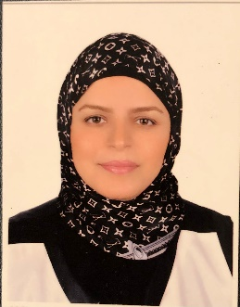
Noha Ahmed Mahmoud El Defrawy
Tel : (202)22751364
Mobile : (20)1005211264

Address : Madinaty -Cairo- Egypt

Email : beautty_noonaa@yahoo.com

Personal Data:
Date of Birth : 09.08.1980
Nationality : Egyptian
Religion : Muslim
Marital Status : Married

Education:
Faculty  University  Department | : Faculty of Languages and translation  : October 6 University  : English Language

Languages Skills:
Arabic :Mother Tongue
English :Fluent

Computer Skills (High level of Computer literacy):

Apple - Mac / Excellent Knowledge Windows Office,
(Word/ Power Point/ Excel/ and Internet)

EMPLOYMENT HISTORY:

  - English teacher at AlManara languages schools from 2001 till 2008
  - Translator At Aywa international CO. from 2009 till 2012
  - Senior Translator At Aywa international CO. from 2012 till 2020
  - Freelance English teacher from 2020 till now.
  - Instructor at The University Of The People from 2022 till now.

Skills:
- Hard Working, self-motivated solution oriented, energetic, reliable and active.
- Good communication & Leadership skill.
- Teaching & training skills.
- Ability to learn new tasks quickly.
- Ability to take decision.
- Ability to work individually and as an effective team member.

Objective:
To develop a challenging position in a professional environment in
Which working conditions depend on mutual respect.

Hobbies:

Drawing / Writing / Reading / Traveling.

