Personal Data:
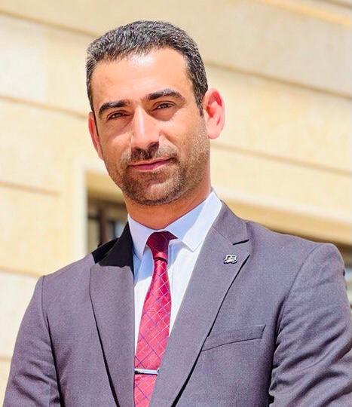
Name as in Passport | Abdullah Ali Jabber
Date of Birth | the 20th of June,1992
Place of Birth | Babylon
Province | Babylon
Country | Iraq
Nationality | Iraqi
Religion | Muslim
Male Gender | Male
Marital Status | Married
Health Condition | Excellent and Non-smoker
Mobile No. | +9647725998747
Email | aalhusseini742@gmail.com  abdullah.ali@atu.edu.iq

Scientific Qualifications & Employment:
Major Field of Study | Year | Country | University | Education Background
Electrical  Engineering | 2012-2013 | Iraq | Babylon University | Bachelor of Science (BS)
Electrical Engineering | 2015-2016 | Iraq | Babylon University | Master of Science (MSc)
Electrical Engineering | 2018-2021 | Iraq | Mustansiryah  University | Philosophy of Doctorate (PhD)
Employment Status |  |  |  | Employed
Al Furat Al Awsat Technical University / Najaf College of Technology /  Department of Techniques of Avionics Engineering Department |  |  |  | Place of Employment
Training & Work Experiences:
Training/Experiences | Date | Location
Training Course of Safety (HSE) at Engineers Union-Babylon | 2020 | Engineers Union-Babylon
Electrical Engineering projects (Supervisor and implementer) | 2016-2023 | Zaid bin Ali Shrine (Engineering Division)
Lecturer | 20216-2017 | Al-Mustaqbal University and Al-Qassim Green University
Lecturer | 2021-2022 | Imam Al-Khadim College for Islamic Sciences
Lecturer | 2021-2023 | Hilla University College
Instructor at the Digital Signal Processing and Control Systems Laboratories for the 3rd and 4th stages BSc. | 2021-2023 | Hilla University College

Other Certification:
1 | Telkomnika Journal certification of publishing a paper in Scopus
2 | Indonesian Journal certification of publishing a paper in Scopus
3 | IEEE Conference certificate for participation and publishing a paper in (IEC2020)
4 | IOP conference Certificate for participation and publishing paper in (3rd International Conference on Sustainable Engineering Techniques (ICSET 2020))
5 | AIP Conference certificate for participation and publishing a paper in (COEC8 - 2021 8th Engineering and 2nd International Conference for College of Engineering - University of Baghdad)
6 | IEEE Conference certificate for participation and publishing a paper in (AEST2022)

Language Skills:
Arabic | Native Language
English | Other (s)

Standardized Test Scores:
Location | Score | Date | Score

Special Skills:
- University Teaching (given courses; Electromagnetics, Communication Skills, Digital Signal Processing, Control Systems).
- Academic Researcher
- Electrical Engineering and Biomedical Engineering Projects.
- Matlab, Auto CAD, C++, Arduino C, and LabView.
- Lecturing.
- Teamwork.
- Microsoft Office (Word, PowerPoint, Excel, etc.).

Hobbies:
Collect more information about computers and programs, reading books, traveling, playing football, planting, and fishing.

List of Publications (Journals and Conferences):
- Abdullah A. Jabber, Ali Khalid Jassim, Raad H. Taher, Compact reconfigurable PIFA antenna for wireless applications‏,‏ TELKOMNIKA (Telecommunication Computing Electronics and Control) 18 (2), 595-602.
- Abdullah A. Jabber, Raad H. Taher compact tri-band T-shaped frequency reconfigurable antenna for cognitive radio applications‏, Bulletin of Electrical Engineering and Informatics 9 (1), 212-220‏.
- Abdullah A. Jabber, Ali Khalid Jassim, Raad H. Taher “Compact 3x1 Elements Reconfigurable MIMO Antenna for Cognitive Radio Applications”, IOP Conference Series: Materials Science and Engineering 881 (1), 012148.
- Abdullah A. Jabber, Raad H. Taher “New compact multiband inverted-L frequency reconfigurable antenna for cognitive radio applications”, Indonesian Journal of Electrical Engineering and Computer Science 19, 267-275.
- Abdullah A. Jabber, Raad H. Taher “Design, and Optimization of Compact Multiband Reconfigurable MIMO Antenna for Cognitive Radio Applications”, Technology Reports of Kansai University TRKU 62 (3), 767-776.
- Abdullah A. Jabber, Raad H. Taher “Multiband Reconfigurable MIMO Antenna for Wireless Applications”, 2020 6th International Engineering Conference “Sustainable Technology and Development IEC 2020.
- Abdullah A. Jabber, Ghada Ali Shadeed, " DUAL-BAND RECONFIGURABLE MIMO ANTENNA FOR WIRELESS APPLICATIONS", Journal of Engineering and Sustainable Development JEASD, Vol. 25, No. 03, May 2021.
- Abdullah A. Jabber, Ghada Ali Shadeed, Nahid H. Alawsh “I. Covid-19 Detection using Deep Learning Models”, 2021 1st Babylon International Conference on Information Technology and Science BICITS 2021.
- Abdullah A. Jabber, Ghada Ali Shadeed, Design and analysis of two elements reconfigurable ultra-wideband multi-input multi-output (UWB-MIMO) antenna for wireless applications‏

Lecturer Dr. Abdullah Ali Jabber Al-Husseini
aalhusseini742@gmail.com
abdullah.ali@atu.edu.iq

Google Scholar ID:
https://scholar.google.com/citations?hl=ar&user=6DaYo2YAAAAJ&view_op=list_works&gmla=AP6z3ObWzLxPn0FvsoeN8qXOUPVFsj4Cn_MbgFYCakJX60cgrrIKpiD8UNIOJH51xnjN2w334VhqxpkPdJdQ-c1XW3gjspDAh5c4vni0iRJtvJSujkU5OmzV

Research Gate ID: https://www.researchgate.net/profile/Abdullah-Jabber

Publons ID: https://www.webofscience.com/wos/author/search

ORCID ID: https://orcid.org/my-orcid?orcid=0000-0002-1313-3748

