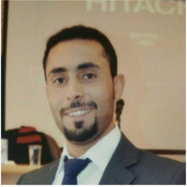
Name | Abdallah Mohammad Alshanty
Nationality | Jordanian
Languages | Arabic, English
E-mail | Alshanti0@gmail.com
My resume in summary

Over 4 years' experience in enterprise resource planning system and administer for commercial web site , worked as consultant in non-profit organization, and implemented government projects in Jordan in health care field, currently , I am PhD business management student in Girne American university(GAU), I hope produce many to center for management research through coordinating events and other aspect like academic research and i have professional skills in graphic design such as designing logos, publications, web sites and presentations, also i interested in programming websites. In addition i participated in many volunteer activities in royal society scientific and Jordan volunteer's community.

