Curriculum Vitae
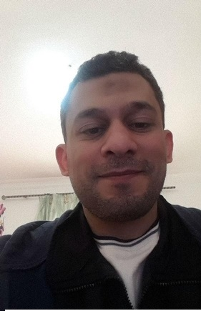

PERSONAL INFORMATION : Maged ghonim
ADRESS: Jalan 3A/155, Bukit OUG, 58200 Kuala Lumpur, Wilayah Persekutuan Kuala Lumpur
CELL PHONE: +601115590985
EMAIL: majed.ghonim@taleem-edu.com
Sex male | Date of birth 15 December 1975
JOB APPLIED FOR : physical education teacher - manger – headmaster
WORK EXPERIENCE :
August 1997 –August 2003
physical education teacher in Egypt Teaching physical education curriculum for grades kindergarten and primary ,Participation in correcting the mistakes of the movement to kindergarten and to help kinetic discipline
August 2003- August 2007
headmaster of secondary school in Egypt
August 2007– July 2010
, headmaster of schools in Saudi Arabia

August 2010-july 2014,
Head of the Department of Physical Education and General Supervisor of physical education teachers in the Rabdi group schools in Saudi Arabia
August 2014-Decmber 2015,
Head of planning for the curriculum of physical education department at Rabdi GROUP SCHOOLS in Saudi Arabia and after that Academic supervisor at the Department of Physical Education

EDUCATION AND TRAINING :
1993- 1997 Bachelor of PHSICAL EDUCATION Tanta University, EGYPT
Training : ABC movement
Scout
Physical Education curriculum planning for preschool
Handbook referee
How do you plan to study Physical Education

PERSONAL SKILLS
Mother tongue(s) Arabic
Other language(s) English
The ability to use the computer at the educational applications

Communication skills
team work: I have worked in various types of teams from research teams to . For 2 years I coached my schools football team and handball team
The leadership of academic accreditation for schools team
mediating skills:
I work on the borders between young students, youth students ,
- intercultural skills:
I am experienced at working in schools with students and how to planning for physical education
Computer skills :
competent with most Microsoft Office programmers - experience with HTML Other skills Creating pieces of Art and visiting Modern Art galleries. Enjoy all sports particularly, football and running. Love to travel and experience different cultures

