Curriculum Vitae
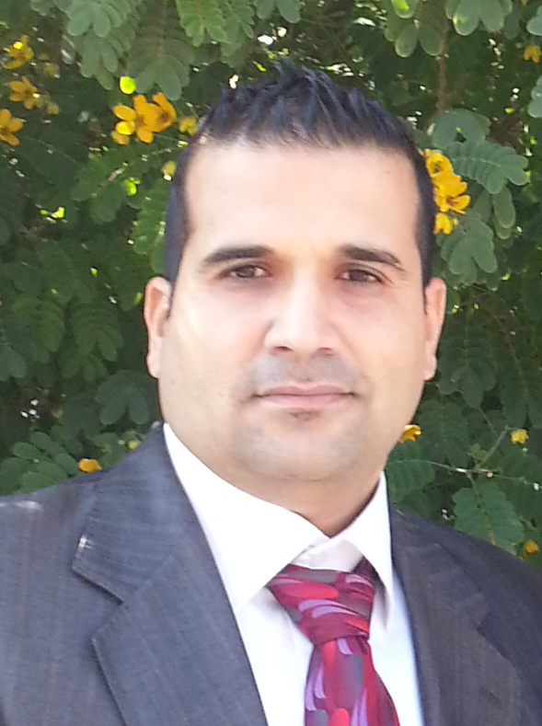

Personal information
Name: Mohammed Fadhel Abo-Kosour.
Address: Al-Mohandesin Haye, Baghdad, Iraq.
Mobile : 00964-7718051974
Email : iraqimoon1@Yahoo.com
Nationality: Iraqi
Date of Birth : 3/9/1980.
Place of Birth: Baghdad, Iraq.
Marital state : Married.

Education Level
Mailing address : Collage of Sciences / Baghdad
Knowledge of languages: Arabic, English (Excellent reading &writing)
Date of starting in MHESR: 27/12/2005.
Academic Background:
- M.B.Ch. Microbiology, College of Sciences in Al-Mustansiryia University (1997/2002)
- MSc. Laser Technique in Microbiology, Laser & Plasma Institute for Higher Equation in Baghdad University (2002-2005)
- PhD. Genetic Microbiology, College of Sciences in Baghdad University (2005-2010)
MSc. Thesis title:
Study The Effect of (632.8 nm) Helium-Neon on Some Virulence Factors of Staphylococcus aureus and Escherichia coli
PhD. Thesis title:
Occurrence of some heavy metals in inhabitants and water of Iraqi marshes and their relations with bacterial DNA
Technical skills
Work experience:
Lecturer of Molecular biology in Collage of Sciences in Al-Mustansiryia University.
Lecturer of Antibiotics in Collage of Sciences in Al-Mustansiryia University.
Responsibility:
- Head of Commission to purchase laboratory equipment and medical supplies in collage of science (2012).
- Head of Commission to buy and choose the curriculum and methodology books in collage of science (2013).
- Head of Commission laboratory devices evaluated in the University of Al-Mustansiryia University (2013).
- Head of Sterilization unit in Collage of Sciences in Al-Mustansiryia University (2014-2020).
- Member of some thesis examiner of M.S.C. in many colleges.
- Member in Quality Assurance Committee of college of science in Al-Mustansiryia University (2018-2020).
- Head of Occupational Safety Committee in the life sciences department laboratories in Al-Mustansiryia University (2018-2020).
- Member in Sports Activities Committee in Collage of Sciences in Al-Mustansiryia University (2017-2020).

Area of interest:
- Molecular Biology
- Antibiotics & Antibacterial
- Microbial degradation
- Bacterial Biotechnology
- Medical & Applied Microbiology
- Environmental Pollutions
Patenting:
- Planted of using a new media to both bacteria and some fungal isolates from The Iraqi Standardization and Quality Control Authority (ISQCA) (2020).

Technical (Practical) skills:
- Microbiology Techniques
- Medical Bacterial Isolation
- ELISA
- Electrophoresis
- PCR
- Centrifugation Techniques (Differential)
- Atomic Absorption
- DNA Sequences
Personal Skills:
- Ability to deal with people diplomatically.
- Willingness to learn.
- Confidence.
Additional Skills:
- Desktop Management Skills
- Typewriting in English & Arabic
Conferences & Meetings:
Many scientific conferences and meetings of Iraqi Higher Education Ministry, Iraqi Health Ministry, (through Medical & Science Colleges) during 9 years of working in lecturing of students , searching and advisory which about more than 9 conferences and meetings.
Published Papers:
- Comparative study between liquid state fermentation and solid state fermentation for production of endo – 1, 4- beta – xylanase by Bacillus licheniformis.
- Isolation and culture of Acinetobacter baumannii.
- Purification of Endo-1,4 – beta-xylanase from Trichoderma reesei and Functional Characterization of the Produced Enzyme
- Response of Resident Bacteria of a Crude Oil-Polluted soil to crude Oil
- Isolation of crude oil degrading bacteria from soil contaminated with crude oil.
- Presence of Extended-Spectrum β-Lactamases Genes in E. coli Isolated from Farm Workers in the South of London.
- An evaluation of water pollution in the southern Iraqi marshes by using bacterial indicators and other related parameters.
- Influence of Helium-Neon laser on some virulence factors of Staphylococcus aureus and Escherichia coli
- Vieulence genes detection in Brusella in isolated from animal farms in west of Iraq.

