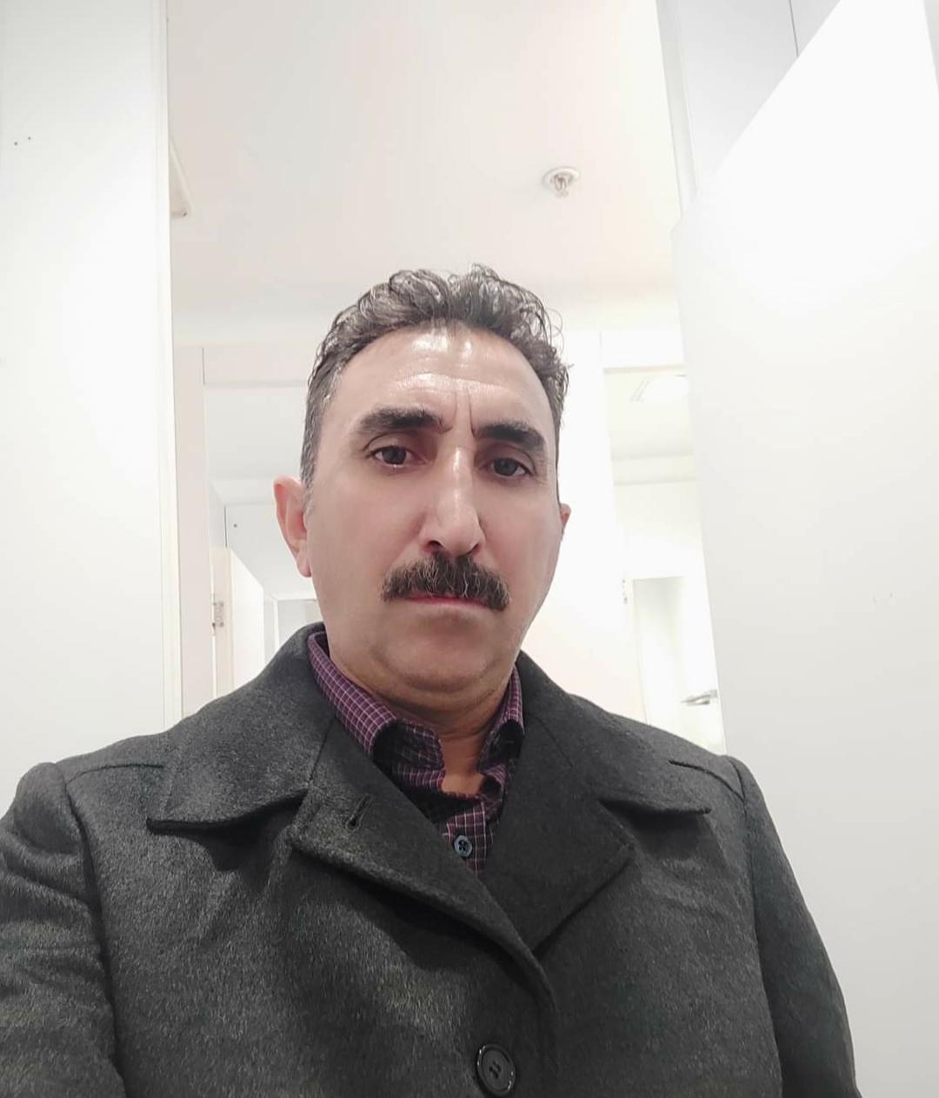
MUAYAD IBRAHIM HAMMOOD
E-mail :
moaid.ibrahim@yahoo.com
Website: MOAYADIBRAHIM@Linked in.com
Iraq residing in Turkey : +905318625429 wup
Iraq / Age and date of birth / 1972 /49 Age
I am free to work and all my work and my work is limited to the Internet

Work experience

I am currently working in the field of marketing for companies online, I have good experience in the use of computers and experience in Word, Excel, PowerPoint, and I have good communication skill in the use of e-mail and communicate with clients and I can deal effectively with the requirements of modern work and master the art of dealing with others and now I work online with several Companies and at the bottom of a Brazilian company, you can pick up a phone and call a company and ask about me with open arms and ask them what you want and how to manage the art of international marketing for them

UNIBELEZA INDUSTAIA E COMERCIO
2019 — 2022
DE COSMETICOS LTDA
News partner
Position: Marketing and promotion specialist for companies, more than one year of experience in the field of e-marketing, as well as marketing or promotion directly on the ground.
High ability to plan marketing offers, high ability to identify market data and awareness in the e-commerce market, experience in using various computer tools.
The ability to use Google and its usefulness in commercial marketing, analysis, data, and market risks and fluctuations.
High skill in communicating with people and companies.
CPC use
Cost Per Clik
SMS

Qualifications

Through my mastery of several languages, it helped me a lot in dealing with clients with accuracy and intelligence in general. I am advanced in writing and communicating with others in the English language as well as conversation. I can manage matters clients and enjoy intelligence and acumen as I am quick to learn and important. I am free to workBachelor degree graduate
He mastered four languages
Language English
Turkish language: the mother tongue
Kurdish language: Good
The Arabic language: the specialty language

Interests

Marketing and e-commerce
I now work for a company Commission meeting
Mr. Paulo Batista Commercial Director Unibeleza Group in Brazil.
Whatsapp +5531 99654 0642

References

References
MUAYAD IBRAHIM HAMMOOD 1
I always try to learn everything and have comprehensive information and ways to deal with itI participated in several online courses from the University Alison.com in Ireland Such as :
Course in English
A course in customer service
Course in pharmacy
Course in AIDS
MUAYAD IBRAHIM HAMMOOD 2

