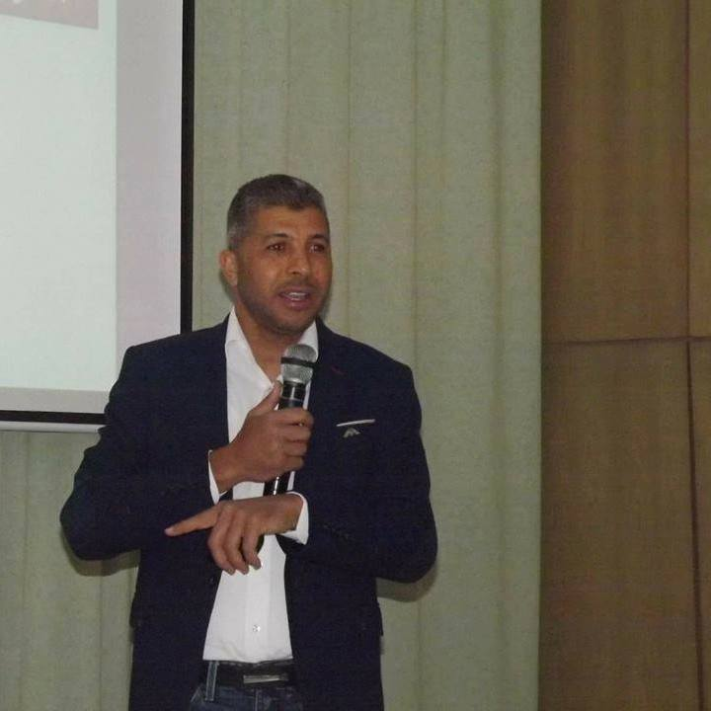

* Primary school teacher
* Experience +23 years
* Obtained the National Teacher Education Certificate in 1998
* National certificate for Education Sciences2020
* Mastar Research in Education Sciences
* MIE master trainer 2021-2022/2022-2023
* MIE expert microsoft 2021-2022/2022/2023
* Certified skills trainer from the Canadian Center and the Egyptian Creative Center
* American Board NLP Certificate
* Certificate in NLP from the Canadian Center
* Field and remote coach

**Sousse /Tunisie**

Tél.  **+21629830203**

Email [**ziraoui2017@gmail.com**](mailto:ziraoui2017@gmail.com)

Né le **06/04/1975**

Marié -3 Enfants

Permis : oui

Passport : oui

**National and international certificates**



**Cv ziraoui mohamed**

* 2016-2020- National Certificate for Education Sciences 2020
* 9/102020 – 3/1/2021 • Mie trainer • Center for teachers

Training

**Training in life skills and technological and pedagogical**

**employment for all learners**

**Compétences**



**Formation**

