Safad Mudhafar Mohammed (CV)

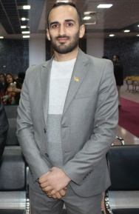
Personal Information:

Marital Status | Gender |  | Nationality | Date of Birth | Surname | Name
 | Female | Male
Married |  | × | Iraq | 1987 | Mohammed | Safad

Email | Address | Telephone
 |  | Mobile
safad.mohammed@uoz.edu.krd | Department of Physical Education, Faculty of Education University of Zakho , Zakho , Duhok, Iraq | 009647503103453

Professional Positions:
Name of Institution | Date |  | Place | Employment History Title
 | To | From
University of Zakho , Zakho , Duhok, Iraq | Continue | 2014 | Department of Physical Education | Assistant Lecturer
University of Zakho , Zakho , Duhok, Iraq | Continue | 2018 | Faculty of Education | Head of Physical Education Department

Educational:
Date | Country | City | Name of Institution | Field of Specialization | Degree
2006-2010 | Iraq | Mosul | University of Mosul | Physical Education and Sport Sciences | B.A
2011-2013 | Iraq | Mosul | University of Mosul | Physical Education and Sport Sciences | M.A

Master Thesis: Centralization and decentralization in decision-making at the Central Basketball and its relationship to Job Satisfaction from the perspective of the employees in the branch of sport federation

Professional Societies:
Date | Country | Name of Institution/ Association
2015- continue | Iraq | Olympic Committe  Repersentative of Duhok Governorate
2019 - continue | Kurdistan Region - Iraq | Kurdistan Teachers Union

