Curriculum Vitae
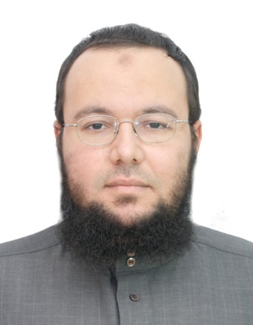
contact  information | Mobil: 00601139074872  00213541525670  Email: khelifati.hamza@live.iium.edu.my  hkhelifati88@gmail.com  address in Malaysia: mahallah Zubair PG 2.18 iium Malaysia  address in algeria : District 8 May 1945 ,BP 444 Sorical Bab ezzouar Algiers, Algeria

personal information | - Date of birth: 28/08/1988 in blida (Algeria)  - Nationality: Algerian  - social situation: Unmarried

Education | - BA in Islamic Studies (2009/2013) from Faculty of Islamic Sciences University of Algeria 1  - M.A in Islamic studies (2015/2017) Faculty of Islamic Sciences University of ammar thledji laghouat algeria
Prepared Diploma | - PH.D in international islamic university malaysia
Field | Islamique science & fiqh and Usul al-Fiqh

Other certificates | - Certificate of composition from the manuscript section of the Algerian National Library

Training | - Teacher of the Holy Quran in mosque Ali bin Abi Talib algeria  - Member of the Committee for the preparation of courses at Ali bin Abi Talib School for Quran memorization  - manuscript indexer at the Algerian National Library  - indexed the manuscripts with Al-Furqan Islamic Heritage Foundation

language | - Arabic: Excellent  - English: Beginner  - French: intermediate

