Curriculum Vitae

PERSONAL INFORMATION | Aymen Hasan Rahsid AlAwadi
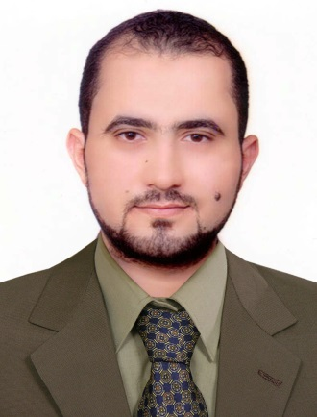
 | Iraq - Najaf
 | +9647801196814
 | aymen@uokufa.edu.iq
 | uokufa.edu.iq/faculty/staff_sites/en/index.php?aymen
 | Sex Male | Date of birth 19/04/1985 | Nationality Iraqi
ACADEMIC LIFA:
I am a computer engineer; I got my B. Sc. in Computer and Control Systems from University of Technology (Iraq - Baghdad) in 2006-2007. Later, I got my M.Sc. degree in Computer Science (Distributed Computing and Networks) from USM (Universiti Sains Malaysia). In academic career, I was a lab instructor in the Assembly programming laboratory at Islamic University College (Iraq – Najaf) in the department of Computer Technical engineering (2008-2009). Also, I was a Lab instructor in the Operating System laboratory at the University of Kufa in the faculty of Education for girls – Department of Computer Education (2009). As for carrier experience and training, I got number of certificates and training regarding networking and security aspects from Cisco like CCNA exploration and SNAF (Cisco ASA), in addition to a certificate in personal strategy planning. Currently I am the manager of the Programming Department of the Information Technology Research and Development Center.

RESEARCH INTERESTS:
1. Computer and network security.
2. Intrusion detection system.
3. Malware.
4. Web system engineering.
5. SDN and Openfolw.
6. Digital Forensics.

TEACHING INTERESTS:
1. Computer Networks and Data communications.
2. Operating Systems.
3. Network Security.
4. Parallel and Distributed Computing
PUBLISHING:
1. Aymen H. Awadi, (2012). Multi-phase IRC Botnet and Botnet Behavior Detection Model, Master thesis, Computer Sciences, USM, Penang, Malaysia.
2. Aymen Hasan Rashid Al Awadi and Bahari Belaton. Article: Multi-phase IRC Botnet and Botnet Behavior Detection Model.International Journal of Computer Applications 66(15):41-51, March 2013. Published by Foundation of Computer Science, New York, USA.
3. Aymen H. Awadi , K Hakim, Ismail A Survey: MOBILE IPV4/IPV6 Fundamentals, Advantages and Disadvantages. International Journal of Advanced Research in Computer Science and Software Engineering 4(4) 2014.
4. Hakim Adil Kadhim, Aymen Hasan AlAwadi, and Mohammad Ali Sarvghadi. "Experimental Study of Parallelizing Breadth First Search (BFS) Algorithm." Research Journal of Applied Sciences, Engineering and Technology 12.4 (2016): 465-472.
BOOKS:
1. Mandriva Linux 2008 Administration, User guide published online by Kutub 2008.

