Mohamed Issam Hazem Elshahidi

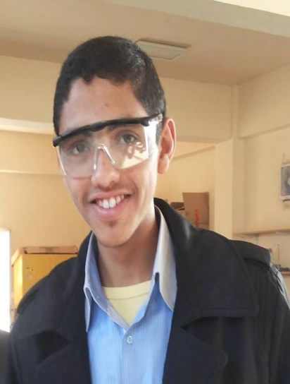
Personal contacts:
Address: 19th Horiya st, Mit El-Amel Village, Aga, Dakahliya, Egypt.
Postal code: 35764
Telephone: (+2)0506328005
Mobile: (+2)01226553382
E-mail: mohamed.elshahidi@gmail.com mohamedelshihidi@students.mans.edu.eg

- Education:
2012-2015 | STEM Egypt High School for Brilliant students, 6th of October. GPA: 4. Percent grade: 95.31%. Certificate: https://goo.gl/3sjXL3
December, 2014 | ACT Exam: grade24/36
2015- till now | Student at Mansoura Faculty of Medicine.
- Research Experience: Honors & Awards:
2012 | Honor of the Best Poster and Capstone Presentation. STEM Egypt High School, Ministry of Education.
2015 | Certificate of the Best Graduation Capstone project and best Poster presentation. STEM Egypt High School, Ministry of Education.
2015 | Appeared in the national newspaper “Al-Ahram”.  Link: http://goo.gl/bN2bPq

- Seminars & Presentations:
2015 | “Designing Wearable Artificial Kidney” Mohamed Hazem et al; Arab Ministries of Education Conference in Sharm El-Shaikh, Department of Research, STEM Egypt School, Egypt. Link: https://goo.gl/mi78mk
- Courses and continuing medical education (CME) credit hours:
September 17, 2015 | Protecting Human Research Participants from the National Institute of Health, Office of Extramural Research. Certificate: https://goo.gl/7Ui1yP
February 9-11th, 2016 | Systematic review and meta-analysis: a workshop.

- Conferences:
September, 2015 | 1St Annual National Conference for Experimental Research,
- Language Skills:
- Arabic; mother tongue.
- nglish. TOEFL (February 20th, 2016) : 87
- German; beginner. A1: Punketen 49/60
- Technical skills:
- Microsoft office (Powerpoint, Excel, Word)
- Cochrane Revman 5
- Meta-analyst
- Professional Membership:
- American Physiological Association (APS)-undergraduate membership.
- Digital IDs:
- ARID: 0001-5156

