Zaid Alnuaimi Resume

NAME : Zaid Ali Khamees Alnuaimi
DATE OF BIRTH : 07/ Jul/ 1988
NATIONALITY : Iraqi
Contact : +9647805113002
E-mail : zaidalneame88@gmail.com
RESIDENCE : Babylon/ Iraq
MARITAL STATUS : Single
Education

- Name of University: Babylon University college of veterinary medicine

Degree: Bachelor Veterinary Medicine and Surgery (B.Sc.B.V.M&S)
- Name of University: Babylon University College of medicine.

Specialization: Master Medical Physiology (Msc)

WORK EXPERIENCE/EMPLOYMENT HISTORY

- Name of Company : Winzor pharmaceutical Company
Location : Babylon
Date, from till : 1/2/2011 – 31/1/2014
Job title : Medical Representative

- Name of Company : Stragen company
Location : Babylon
Date, from till : 1/2/2014 – 30/12/2014
Job title : Medical Representative
- Name of Company : Stragen company
Location : Middle Euphrates and Southern Iraq
Date, from till : 1/1/2015 – until now
Job title : Supervisor
- Name of University : University of Babylon Collage of Pharmacy
Location : Hilla
Date, from till : 1/10/2017 – 30/62018
Job title : Lecturer (Medical Physiology)

Courses and Training

- He has experience in the field of pharmaceutical media, worked in more than one company and started more than one position in the work period, taking more than one course in the medical Representative and sales skills.
- Holds a certificate from Mustansiriya University in teaching methods.
- TOT certificate.
- Certificate from the Federation of Arab Training Centers.
- Certificate from American university of science state of Oregon.
- Certificate from the Arab Parliament for training experts.
- Certified by the World Council of Institutional Development.
- Certified by the Arab Academy for Training and Solutions consulting practical.
- Certified by international innovation power.
- I worked as a lecturer at the Faculty of Pharmacy, University of Babylon.
- Participated in the first Iraqi - Germany conference of medical sciences at university of Babylon collage of medicine in cooperation with saint George hospital, university of Leipzig for the period 4-5 march 2018.
- Coaching Certificate from UDI Company During May 2018
- Selling skills certificate from UDI Company During April 2018

Published Research

- A COMPARISON STUDY OF SYNTHETIC CORTICOSTEROID AND NATURAL PLANT LICORICE CRUD EXTRACT IN REGARD TO PROVOKE ALLERGIC ASTHMA IN RABBITS.
(International Journal of Pharmacy and Technology)
- A Study Effects of Licorice plant and Prednisolone on some Physiological and Immunological Parameters in Experimental Model.
(Journal of Babylon Medical No. 1/2017)

Skills, Qualifications and Language

Skills:-
- Excellent Skills in Microsoft office 2003, 2007. 2010, 2013, 2016
- Internet
- Win 10 , Win 8.1, Win 7, Win XP
- Network
- Software and hardware maintenance for the PC and laptop
- Vehicle driving and Driving Certificate (own a car).

Qualification:-
- Team work
- Leadership
- Hard work
- Communication
- Work under Pressure
- Motivated
- Fast to Learn and improve
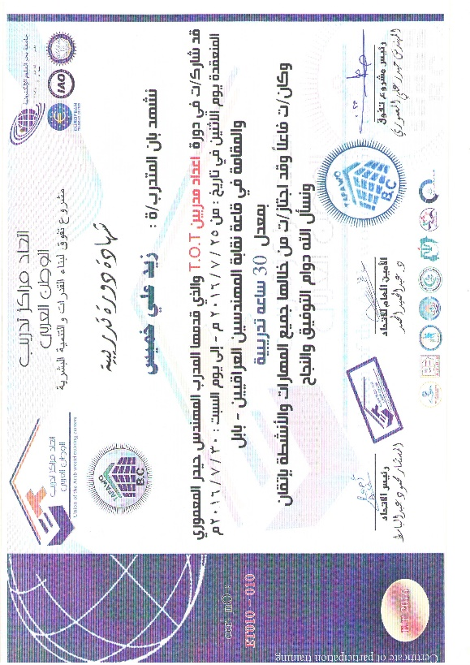
Language:-
- English (Good)
- Arabic (native)
