Curriculum Vitae
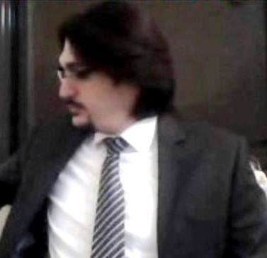
Oubaida harba
ENG St >>SYRIA
Idleb , Syria
Istanbul -zukak yaşellbınar>>TÜRYA

Tel Sy: +963 951991808
Tel TURKIA : +905350120019

E-mail:oubaida-86@hotmail.com

Personal
Information
      - Date of Birth :Julay,15, 1986
      - Place of Birth : Syria - Idled
      - Nationality : Syrian
      - Marital Status : Single
      - Religion : Muslim
Education:
- University OF DAMASCUS, Faculty of LOW DAMASCUS, Syria 2012-2013
Certificate in low, Grade Very Good, Ranked 12 of 460 students.
Work Experience:
- Working in Syria Group Co. – legal relations department for three years.
- Working in Albnaa magazine for engineering in marketing department.
- Working in AL – Byan office for nine years.
- Working in bids with AL – Byan office for engineering

Experiments
Certificates of organization Geneva for the Humanities and the upgrading of the approved communities from the European University in Switzerland in Geneva, also approved by the United Nations as an international relations consultant and a consulate in the International Commercial Arbitration of the Arab Republic of Egypt number and code recorder they have supported the Arab League and the supporting entity on its territory State Turkish and Turkish-Arab Chamber, all certification are credible of any embassy in the world, depending on the code number on the Organization and the United Nations and a permanent membership, and successful pass program for preparation consultants in consulate and diplomatic relationship & politically relationship in Geneva Institute.

Skills:
Language: | - Arabic Native tongue.  - English Very Good in reading, writing and listening  - Turkish well .

Computer knowledge: Windows, Ms Office , AutoCAD 2d&3D, photoshop, Internet , Software.

Personal Specification:
* Excellent Organizational ,human-relations, technical and problem-solving abilities.
*Autonomous, independent work style that supports & contributes to team-based goals.
* Willing to quickly learn and adapt to new technologies.
* Outstanding Communication skills and attitude.
* Ability to manage and work under pressure.
* Ready to relocate.

