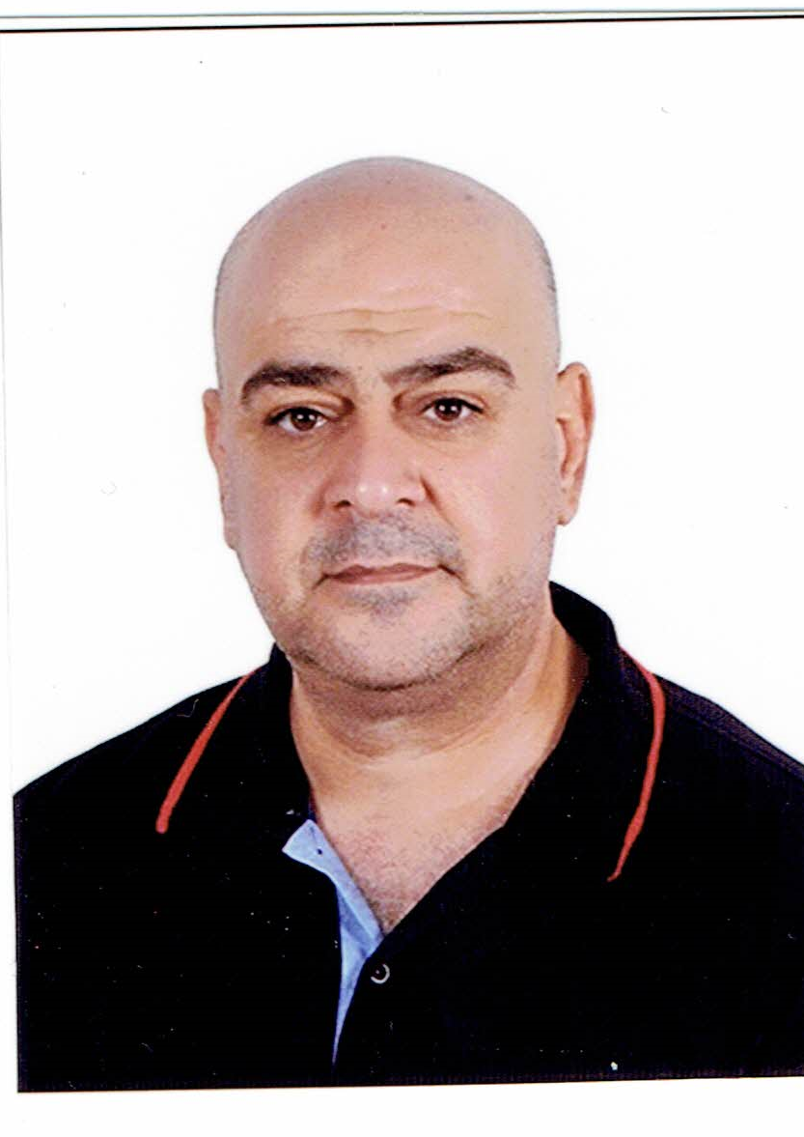
Curriculum vitae
Personal Information
Surname : Al-Safi
First Name : Mohammed Ghazi Sabri
Date and Place of Birth: Iraq-Baghdad-1968.
Address : Baghdad-Resapha Q.-Q633-S25-H51/1.
Mobile : 009647702815992, 009647813703860
Email : mohammedsabri68@yahoo.com , mohammedsabri68@gmail.com
Marital Status : Married / Children: 4.
Gender : Male.
Education
- B.Sc. in Mathematics (1990).
- Project titled “Numerical solution of Differential Equation”.
- Project Advisor : Prof. Dr. Abd Aullah Al-Safadi.
- Department of mathematics / College of Science / AL- Mustansiriyah University.
- M.Sc. in Mathematics (2001).
- Thesis titled “Solution of Inverse Problems for Integral Equations with Application to Radiative Heat Transfer”.
- Thesis Advisor : Asst. Prof Dr. Fadel Subhi.
- Department of mathematics / College of Science / AL- Mustansiriyah University.
- PhD. in Mathematics (2015).
- Thesis titled “Solving Fractional Order Partial Differential Equations by Using Sinc-Shifted Polynomials Methods”.
Thesis Advisor :
Asst. Prof. Dr.Osama H. Mohammed Asst. Prof Dr. Fadel Subhi.
- Department of mathematics / College of Science / AL- Mustansiriyah University.
Membership
- Iraqi Association of Physics and Mathematics.
- Iraqi Association of Information Technology.
Computer Skills:
- Programming languages: Pascal, Delphi, Matlab.
- Software packages: Microsoft Office (Word, Excel, Power point).
Work Experience
- 2001-current: Lecturer at the different departments in Dept. of mathematics / College of Science / AL- Mustansiriyah University, Al-Rafidan, Engineering Technical College.
Naw - Lecturer in Department of Accounting Al-Esra'a University college, Baghdad-Iraq and Department of Medical instrumentation Engineering.
Research Interests
- Mathematics
- Numerical Analysis.
- Numerical Modeling.
- Iterative Methods.
- Applied and Computation Mathematics.
- Differential Equations.
- Integral Equations.
- Fractional Calculus.
- Computer Security
- Data Security (Cryptography and Cryptanalysis).
- Steganography and Steganalysis.
- Statistical Randomness Test.
Teaching Experience
- Computer Security.
- Operation Research.
- Structure Programming.
- Systems Analysis.
- Discrete Mathematics.
- Numerical Analysis.
- Advanced Mathematics.
Languages
English and Arabic (reading and writing).

Published Papers
- "Solution of Inverse Problems for Integro Differential Equations”, The 1st National Conference in Mathematical Sciences, Baghdad-Iraq, Sep. 2001.
- “Cryptanalysis of the Stream Cipher Systems Using the Genetic Algorithm”, Information Technology & National Security Conference, Al-Riyadh-KSA, 1-4/Dec./2007.
- ”Design of new Steganography Mechanism for Images based on LSB Technique”, Jornal of Baghdad college of Economic Sciences University, volume 41, 2014.
- ” Dynamic Stream Ciphering Algorithm”, IOSR Journal of Computer Engineering, Volume 16, Issue 2, Ver. VIII (Mar-Apr. 2014), PP 72-78.
- “Shifted Jacobi tau method for solving the space fractional diffusion equations”, IOSR Journal of Mathematics (IOSR-JM) e-ISSN: 2278-3008, p-ISSN: 2319-7676. Volume 10, Issue 3 Ver.IV (May-Jun. 2014), PP 34-44 www.iosrjournals.org.
- “Numerical solution for the time-Fractional Diffusion-wave Equations by using Sinc-Legendre Collocation Method”, Mathematical Theory and Modeling, ISSN 2224-5804 (Paper) ISSN 2225-0522 (Online), Vol.5, No.1, PP 49-57, 2015. www.iiste.org.
- “SINC-JACOBI COLLOCATION ALGORITHM FOR SOLVING THE TIME-FRACTIONAL DIFFUSION-WAVE EQUATIONS”, International Journal of Mathematics and Statistics Studies Print ISSN:2053-2229-Online ISSN: ISSN 2053-2210 Published by European Centre for Research Training and Development UK, Vol 3, No.(1), PP 28-37, (2015), (www.eajournals.org)
- “Numerical Solution for Telegraph Equation of Space Fractional Order by using Legendre Wavelets Spectral tau Algorithm”, Australian Journal of Basic and Applied Sciences, 10(12) July 2016, Pages: 383-391.
- "Approximate Solution for advection dispersion equation of time Fractionalorder by using the Chebyshev wavelets-Galerkin Method", Iraqi Journal of Science, 2017, Vol. 58, No.3B, pp: 1493-1502, DOI: 10.24996/ ijs.2017.58.3B.14.
- "Numerical solution for fractional order space-time Burger's equation using Legendre wavelet-Chebyshev wavelet spectral collocation method",Journal of Al-Nahrain university, 2018 .
- "Approximate Solution for Two dimensional Volterra-integro differential equation of fractional order by using generalized deferential transform method",Muthana journal of pure scinces,2018.
- "A new approximate solution for the telegraph equation of space fractional order derivative by using Sumudo Method."Irai journal of scince", Iraqi Journal of Science, 2018, Vol. 59, No.4B.
- "An efficient numerical method for solving Volterra-Fredholm integro-differential equations of fractional order by using shifted Jacobi-spectral coolocation method", Baghdad scince journal, 2018, DOI: http://dx.doi.org/10.21123/bsj.2018.15.3.0344.
Scientific Conferences
- Data and Computer Security and Protection Workshop, Baghdad-Iraq, 2001.
- The 1st National Conference in Mathematical Sciences, Baghdad-Iraq, Sep. 2001.
- Information Technology & National Security Conference, Al-Riyadh-KSA,1-4 Dec. 2007.
- The 2nd National Conference in Mathematical Sciences, Bassra-Iraq, Oct. 2013.
- 1st Scientific International Conference, College of Science, Al-Nahrain University, 21-22/11/2017.
- The 2nd National Conference in Mathematical Sciences, Baghdad-Iraq, College of Science, Baghdad University, 27-28-Feb. 2019.
WAMS-CIMPA

- West Asia Mathematical Schools WAMS-CIMPA entitled :Analytic Number Theory, Primitive roots and Elliptic Curves, arbil 01/12/2014-08/12/14.
- West Asia Mathematical Schools WAMS-CIMPA entitled :“Boundary Value Problems and Approximations” , arbil 20/12/2015-27/12/2015.
- West Asia Mathematical School WAMS-CIMPA-Izmir-Turkey 2018, entitled: "Inverse Problems: direct methods and optimization", Izmir-Turkey, 28/10/2018-4/11/2018.

Google scholar: https://scholar.google.com/citations?hl=ar&user=cbkaSLwAAAAJ

Researchgate:https://www.researchgate.net/profile/Mohammed_Al-Safi?ev=hdr_xprf&_sg=e1t1ySCY5CwkrMVvQpK9bE5KmghNka-vZnLLducnSY_4eoRqk1tz00UTh6DrKZ5WWfRw25J8knE0YXAyB1l6i2nC
ORCID https://orcid.org/0000-0002-8887-7194

Publons https://publons.com/researcher/1712320/mohammed-gs-al-safi/

