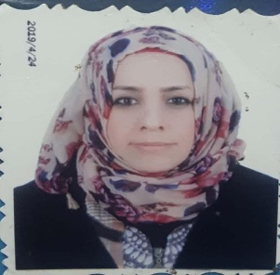
شعار الكلية
شعار الجامعة
الصورة الشخصية

القب العلمي والاسم الثلاثي :ا.م.د زهره عدنان داخل الشمري
Name :Zahrah Adnan Diackal Al-Shammerri
Phone number :07711165148
ألاختصاص: احياء مجهريه – جزيئي بكتريا طبيه
مكان العمل : جامعه ميسان- كليه العلوم
E-mail:russia-201369@yahoo.com
بكالوريوس احياء مجهرية الجامعة المستنصرية
ماجستير احساء مجهرية طبيه كليه الطب جامعه بغداد
دكتوراه كليه الطب جامعه النهرين
البحوث المنشوره
1-Antibacterial effect of watery plants extract and antibiotics sensitivity
2-Bacterial isolates associated with urinary tract infections in children
3-Inhibition bacterial adhesion for E.coli by ciprofloxacin from patients suffering gingivitis
4-Bacterial isolate associated with urinary tract infections in children
5-Antibacterial effect of watery plants extract and antibiotics sensitivity
6-spectrum of bacterial of acute and chronic osteomyelitis.
7-prevalance of aerobic bacterial vaginosis and Trichomonas vaginalis associated with socioeconomic factor among women in Misan Governorate .
8-Genotyping of lactobacillus spp in a group of Iraqi women with aerobic bacterial vaginosis and Trichomonas vaginalis
9-Study of some virulence factors and inhibitory effect of saliva on identified gram positive and gram negative bacteria isolated from soil.

