Ehsan Al Said ALY

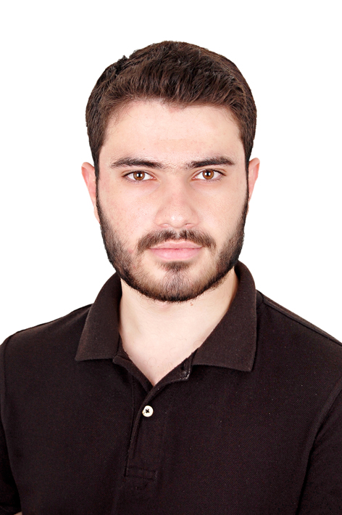

Cairo

O1121287275
ehsanhasan66@yahoo.com
PERSONAL INFORMATION:
Date of Birth: 14/1/1995
Gender: Male
Marital Status: Single
Nationality: Syrian
EDUCATION:
High School Syrian certificate  Start study in Faculty of pharmacy Helwan University  Concentration: Clinical Pharmacy  CME Online: Challenging Cases in Toxicology  from The Harvard medical school (Boston, Massachusetts, USA) | 2012  2013 even now  2016
EXPERIENCE:
Attended ABC (ACHIVE BRIGHT CAREER) at AUC
OTC (Over The counter Drugs)
Patient counselling 2015
Communication Skills
Worked at Atta health care center in Hatay-Turkey 2015
SKILLS:
Language | -Fluent in Arabic and English
Computer knowledge | Windows, MS Office, ICDL
OTHER INFORMATION:
Activist in The Syrian Network For Human Rights
Volunteer at Syria Al Gad Reliefe Foundation

