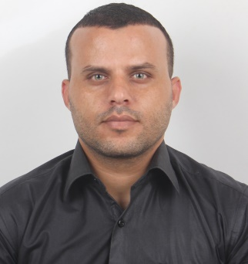
C. V

PERSONAL INFORMATION

Full name: YOUSEF AHMED YASEEN ALMADHOUN
Nationality: PALSTINE
Sex: Male
Marital Status: Married
Contact address: Universiti Sultan Zainal Abidin - Kampus Gong Badak
21300 Kuala Terengganu

Mob. palstine : 00970599859747
Mob malasia : 00601133501006
Email address: yosefmadhoun@gmail.com

Academic Qualifications:*

Date | Award | Field of Study | Degree Awarding Institution | Country
2016-2017 | Master student | MASTER OF SCIENCE IN MANAGEMENT | Universiti Sultan Zainal Abidin (UNISZA ) | Malaysia
2004-2008 | Bachelor | Bachelor of Media (Public relations( | AL-aqsa Universiti | Palestine
2000-2001 | Certificates | secondary school | Abu Obeida Bin Jarrah School | Palestine
2-26 April 2017 | Certificates | Certificate of English language | Universiti Sultan Zainal Abidin | Malaysia
1-30 August 2016 | Certificates | Certificate of English language | Universiti Sultan Zainal Abidin | Malaysia

Other ACADEMIC QUALIFICATIONS /EDUCATION BACKGROUND

Qualification | Name of University/ place | Date
Certificate of Principles Scientific Research | Edraak - online course | 8 th May 2017
Certificate of Participation In International conferene student soft skils (ICOSSS ) 2017 | Universiti Sultan Zainal Abidin | 2 th April 2017
Certificate of Participation And Presented one Paper In International seminar on Islamic jurisprudence in contemporary society 2017 | Universiti Sultan Zainal Abidin | 4-5 March 2017
Certificate of Participation and Volunteer In “ Kenyir Bied & Nature Quest 2017 “ | Visit Beautiful Terengganu | 4-5 March 2017
Certificate of Project management | Edraak - online course | 14 th December 2016
Certificate of Participation and Volunteer In “ we are Brother Camp “ | Universiti Sultan Zainal Abidin | 2-7 December 2016
Certificate of Participation In International postgraduate research conference (IPRC ) 2016 | Universiti Sultan Zainal Abidin | 8-10 October 2016
Certificate of Reseaech Methodology course | Universiti Sultan Zainal Abidin | 25-29 September 2016
Certificate of Planning personal finances | Edraak - online course | 17 th Augst 2016
Certificate of Computer Driving License )ICDL ) | Jerusalem Human Development Company | 16/2 - 9/3/2010
Certificate of international law and media | The Independent Commission for Human Rights (ICHR) | 13-16 April 2003

WORK EXPERIENCE/SKILL

Period From to Period To DURATION | Company / Institution /PLACE | Position Function /DUTIES
2010-2015 | North Printing Company | Manager of public relations
2009-2008 | Al Nahda Association for Development and Development | Manager of public relations
2008-2006 | Palestinian Society for Relief and Development | Manager of public relations
2004 | Ministry of media | Coordinator of the press and media course

Main Supervisor : Dr. Mohd Shukri Bin Jusoh
Email address : mshukrijusoh@unisza.edu.my
Tel : 09-6688256
Mob : 0139328721
Mob : 0139488721

