Northern Technical University
Technical Engineering College of Kirkuk

Personal information
Full name | Huda Jamal Jumaah | 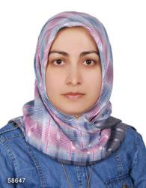
Scientific title | Lecturer
Employment position | Lecturer
Department | Environment and Pollution Engineering
E-mail | Huda80@ntu.edu.iq  Huda.rs2018@gmail.com

Academic Degrees
Northern Technical University | Bachelors 2003 | Surveying Engineering/ Iraq
University Putra Malaysia UPM | Masters 2018 | Remote Sensing/ Malaysia
University of Tabriz | Ph.D. Student 2024 | Remote Sensing and GIS/ Iran

Scientific and research interests:
Remote sensing, GIS, AI GIS, Sensors, Environmental Applications, Statistical analysis, Modelling, Surveying, Air Quality, and Water Quality.

Profiles
https://scholar.google.com/citations?user=08pAwP8AAAAJ&hl=en
https://www.researchgate.net/profile/Huda-Jumaah
https://www.webofscience.com/wos/author/record/ABQ-6946-2022
https://orcid.org/0000-0002-3438-3033
https://www.scopus.com/authid/detail.uri?authorId=57208735005

‏

