**جمهورية العراق**

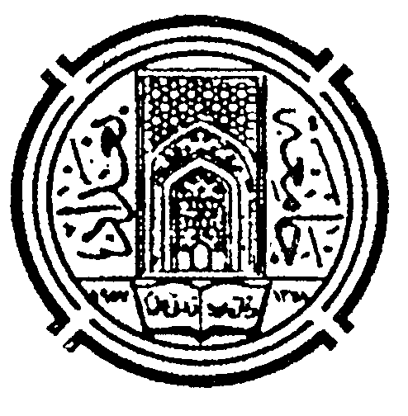

**MINISTRY OF HIGHER EDUCATION & SCIENTIFIC RESEARCH**

**BAGHDAD UNIVERSITY**

**COLLEGE OF EDUCATION FOR WOMEN**

# وزارة التعليم العالي والبحث العلمي

جامعة بغداد

كلية التربية للبنات

العدد:

التاريخ:-

**Curriculum Vitae**

**Nawal Fadhil Abbas**

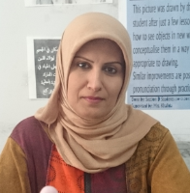

* **Full Name**: Nawal Fadhil Abbas.
* **Country**: Iraq.
* **Place of Birth:** Baghdad –Iraq.
* **Sex:** Female.
* **Scientific title:** Professor
* **Cell Phone:** +9647702517018
* **E-mail Address: [nawal.fadhil@coeduw.uobaghdad.edu.iq/](mailto:nawal.fadhil@coeduw.uobaghdad.edu.iq/)** [nawal_fa71@yahoo.com](mailto:nawal_fa71@yahoo.com)
* **Scopus account: <https://www.scopus.com/authid/detail.uri?authorId=56950190400>**
* **Web of Science account: <https://www.webofscience.com/wos/author/record/W-5264-2019?state=%7B%7D>**
* **Google scholar account: <https://scholar.google.com/citations?hl=en&user=CN9ZoW0AAAAJ&view_op=list_works&authuser=1>**
* **Research gate account: <https://www.researchgate.net/profile/Nawal_Abbas>**
* **ORCID account: <https://orcid.org/my-orcid>**
* **Eotvos Lorand account: <https://doktori.hu/index.php?menuid=192&lang=HU&sz_ID=28549>**
* **AWEJ account: <https://awej.org/e>**
* **ASELS account: <http://asels.org/executive-board/>**
* **SageOpen account: <https://mc.manuscriptcentral.com/sageopen>**
* **Education:**
  + Ph.D. in English Language and Linguistics/Semantics and Pragmatics/University Sains Malaysia 2014.

Title: **Using (Im)Politeness Strategies to Achieve Social (Dis)Harmony: A Pragmatic Analysis of L. M. Montgomery’s Anne of Green Gables**

* + M.A. in Language and Linguistics /Baghdad University/College of Education for Women /Department of English 2002.

Title: **A Pragmatic Analysis of Selected Modern Short Stories**

* + B.A in English Language/Baghdad University/College of Education for Women/ Department of English 1998.
* **Field of specification**: English Language and Linguistics /Pragmatics & Semantics
* **Letters of Thanks**: 100+
* **Experience:**
  + Teaching assistant between 1998-2002.
  + Teaching in the department of English/College of Education for Women/ University of Baghdad/ Iraq from 2002-up to now.
  + Rapporteur of the higher studies in department of English/College of Education for Women/ University of Baghdad from 2002-2006.
  + Rapporteur of the department of English/College of Education for Women/ University of Baghdad from 2006-2009.
  + Member of the Examining Committee, 2002-2009.
  + Head of the Examining Committee in the Department of English, 2015-2018.
  + Member of the Higher Studies Committee, 2015-2018.
  + Member of the Scientific Committee.
  + Member of the Proficiency Test Committee.
  + Lecturer in many language courses in different ministries and institutions.
  + Lecturer of English for the postgraduate studies in other departments /College of Education for Women/ University of Baghdad.
  + Head of the department of English/ College of Education for Women 2015-2018
  + Head of the scientific committee in the department of English 2015-2018.
  + Dean of the College of Education for Women 2018-19.
  + Executive board member in the Arab Society of English Language Studies (ASELS), USA.
  + Editorial board member in the Journal of the College of Education for women, UOB, Iraq.
  + Editorial board member in the Arab World English Journal (AWEJ)/ USA.
  + Editorial board member in ATRAS Journal/ Saida University/ Algeria.
  + Editorial board member in the College of Education Journal, University of Wasit, Iraq.
  + Reviewer and editor for Sage Open, UK.
  + Linguistic assessor in Awtad Journal for Human Sciences, Iraq
  + Linguistic assessor in the Iraqi Journal of Market Research and Consumer Protection, University of Baghdad, Baghdad, Iraq.
* **Research Papers and Books published: 75 plus**
* **Courses Attended: 13**
* **Workshops Attended: 50 plus**
* **Conferences and Symposiums Attended: 45 plus**
* **Thesis & Dissertation examinations: 50**
* **Students Supervised:26 (4 International PhD candidates).**
* **Scientific and linguistic evaluation of dissertations, theses and research papers: 400 plus**