Yassin S. ALKUBASIE

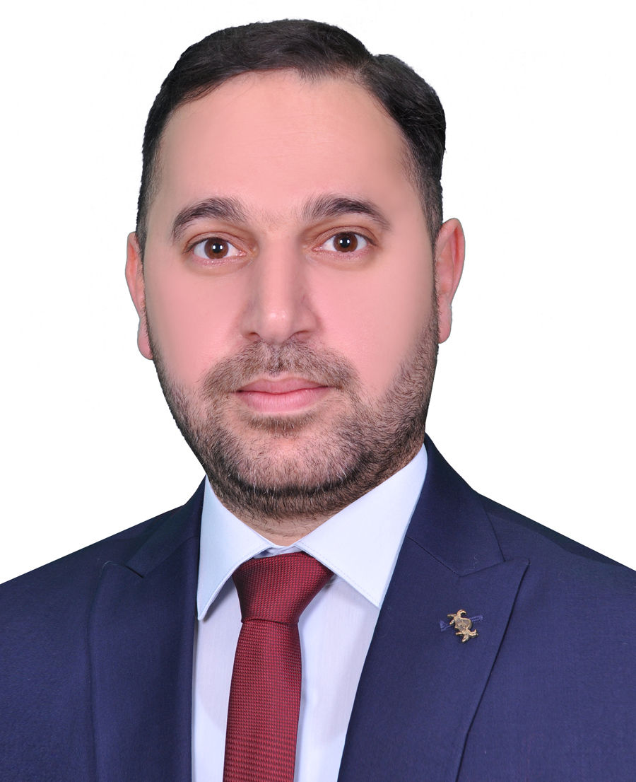

**Topics I have taught**

* Assembly language Lab at University Al-Marrif 2011.
* Matlab program Lab at University Al-Marrif 2011.
* Cisco Packet Tracer Lab at Al-Marrif University College 2016.
* Quartus program Lab at Al-Marrif University College 2018.



**EDUCATION**

**BSc**. Engineering college / Electrical and Electronic Department / Branch Electronic and communication / Al- Mosul University

Starting a job at Al-Maarif University college/computer Engineering Techniques as Assistant Reader

2008

2011

ABOUT ME

Name 🡒 Yassin Salih Fayaid

Surname 🡒 Al-kubasie

Birthday 🡒4/9/1986

Religion 🡒 Muslim

Status 🡒 Married

CONTACT



Iraq-Anbar-Fallujah

07901214833-07711988001

Yassinsalih86@uoa.edu.iq

LANGUAGES

**SOFTWARE**

Arabic

English

Microsoft office

Photoshop

Internet app.

C++

C#

Matlab