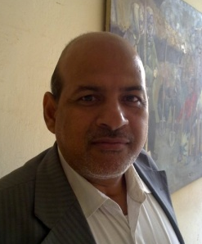
CV

- Born in Baghdad in 1966.
2) completed elementary school, middle and high school in Baghdad.
3) was accepted in the Faculty of Fine Arts, where he got his bachelor's degree in fine arts (drawing), in 1991.
4) got his first appoint him in the Research Center and the Museum of Natural History of Iraq / Baghdad University in the 9-5 - 1996.
5) obtained a Certificate of Proficiency in English language testing center in the College of Education / University of Baghdad, in 1998.
6) received a master's degree in the philosophy of fine arts (drawing), in 2003.
7) studied at the Faculty of Education / University of Iraq.
8) currently serves as Chairman of the Division of Technical Research Center and the Museum of Natural History.
9) He has written articles in conferences, seminars and workshops inside and outside Iraq. Then he has several research in the field of competence the most published in journals and solid, including technical, historical and literary.
10) received a master's success in the English language test "TOEFL", the first 410 second 363 on the year 2010.
11) received the degree of success in the "IC3", in 2010.
12) received a thank you from several Iraqi, Arab and foreign universities.
13) He earned a degree in Museum Management from George Washington University.
14) He contributed to the establishment of the "Animal House" project in 2015.
15) He got promoted to a teacher's title of Fine Arts (Painting) on 1 September 2013.
16) He became the head of the technical unit in the center according to administrative order 269 on 26 March 2017.

