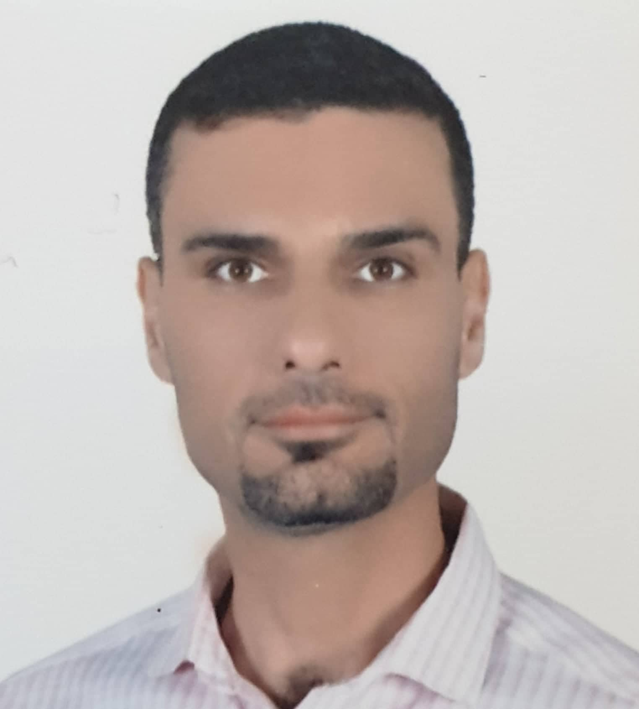

picture

Full Name: Wisam Hussein Selman
College: College of Veterinary medicine
Date of Birth:08/30/1978
Marital Status: Married
Specialization: Pharmacology and Toxicology/Pharmaceutical Sciences
Academic rank: Assistant professor
Work address: College of veterinary medicine/ /University of Al-Qadisiyah
E-mail: wisam.salman@qu.edu.iq
Occupation
note | Date obtaining Job | Occupation | NO.
 | 29/12/2005 | Faculty Member | 1

Academic Qualifications (Cetificates)

Date obtained | University | College | Academic qualification
9/7/2002 | University of Al-Qadisiyah | College of Veterinary medicine | Bachelor’s degree
10/11/2005 | University of Baghdad | College of Veterinary medicine | Master’s degree
7/9/2018 | Oregon state University | College of Pharmacy | Doctorate

Academic rank:

Date obtained | Academic rank | NO.
5/2/2006 | Assistant lecturer | 1
4/6/2009 | Lecturer | 2
4/6/2012 | Assistant professor | 3

Scientific researches
Date published | Research Title | NO.
2019 | A de novo substitution in BCL11B leads to loss of interaction with transcriptional complexes and craniosynostosis. Hum Mol Genet. Volume 28, Issue 15, 1 August 2019, Pages 2501–2513. | 1
2019 | Alteration of Bcl11b upon stimulation of both MAP Kinase- and Gsk3-dependent signaling pathways in double negative thymocytes. Biochem Cell Biol. 2019 Apr;97(2):201-213. | 2
2009 | A comparative study between using of fentanyl-ketamine and xylazine-ketamine combinations as anesthetic regimen in rabbits. Al-Qadisiya J. Vet. Sci. 2009. 8(2):26-33. supplement of 3rd conference. (pp:26-33). ISSN:1818-5764. | 3
2009 | Antinociceptive effect of watery suspension of Nigella Sativa Linn. seeds in mice. Iraqi J. Vet. Sci., Vol.23, supplement II, 2009. (pp:245-248). ISSN:1607-3894. | 4
2009 | Evaluation of anaesthetic activity of fentanyl, xylazine and ketamine in domesticated pigeons. Bas. J. Vet. Res.Vol.8, No.1, 2009. (pp:157-165). ISSN:1813-8497. | 5
2011 | The sedative effect of intranasal administration of some sedative agents in budgerigar (Melopsittacus undulatus). Al-Anbar J. Vet. Sci., Vol.: 4 No. (2), 2011. ISSN:1999-652. | 6
2011 | Study of the anti-leukotrienic effect of watery suspension of Nigella Sativa Linn.seeds in mice. Al-Qadisiya J. Vet. Sci. Vol.10, No.1, 2011. ISSN:1818-5746. | 7
2011 | Comparsion the analgesic activity of watery suspension of Nigella Sativa Linn.seeds with naproxen in mice. Al-Qadisiya J. Vet. Sci. Vol.10, No.1, 2011. ISSN:1818-5746 | 8
2010 | Study of the antinociceptive effect of Zingiber Officinale ethanolic extract and vitamin C in rats. Iraqi J. Vet. Sci., Vol.34, No.1,2010 (pp:171-176). ISSN:1609-5693. | 9
2009 | Assessment of the antidiarrhoeal activity of Ceratonia Siliqua fruit in rodents. Al-Anbar J. Vet. Sci. Vol.2. No.1, 2009 (pp:1-8). ISSN:1999-652. | 10
2010 | Study of the sedative activity of watery suspension of Nigella Sativa Linn. seeds in mice. Iraqi J. Vet. Med., proceeding of 10th veterinary scientific research conference. (pp:596-601). ISSN:1609-5693 | 11
2011 | An evaluation of neurotoxic effect of metronidazole in rabbits. Al- Kufa J. Vet. Med. Sci. 2011. Vol 2, No 2 (2011). ISSN: 2077-9798. | 12

Number of Theses
Number | Supervision | NO.
 | Higher diploma
 | Masters
 | Ph.D

Academic Conference, seminars and workshops attended
Date | place | Kind of participation | Title | NO.
2009 | College of Veterinary medicine/University of Al-Qadisiyah | Speaker | 3rd conference of veterinary sciences
2009 | College of VeterinaryMedicine, University of Mosul | Speaker | the 5th Scientific Conference
2010 | College of Veterinary Medicine, University of Baghdad | Speaker | the 10th Scientific Conference
2014 | College of Pharmacy, Oregon State university | Speaker | Pharmacy retreat conference
2014 | College of Pharmacy, Oregon State university | Speaker | Pharmacy retreat conference
2014 | College of Pharmacy, Oregon State university | Speaker | Pharmacy retreat conference
2014 | College of Pharmacy, Oregon State university | Speaker | Pharmacy retreat conference
2014 | College of Pharmacy, Oregon State university | Speaker | Pharmacy retreat conference

Permanent and temporary committees
Date | Permanent or temporary | Committee | NO.
2012 | Permanent | Examination Committee me | 1
2019 | Permanent | Acquisition of accreditation for the laboratories in college of Veterinary Medicine | 2

Other Scientific activities
Kind of activity | NO.
Evaluating Scientific Research ( 21) | 21
Scientific Initiatives
Evaluate Theses
Patent
Contracting with State Institutions

Course Taught
( Master,PhD)postgraduate | Undergraduate | NO.
Pharmacology/theory | Pharmacology/theory | 1
Pharmacology/practical | Pharmacology/practical | 2
Clinic | Toxicology | 3

Voluntary initiatives and actions
Date | Voluntary initiatives and actions | NO.
2019 | Voluntary initiative with post-graduate students | 1

Awards, Certificates and Letters of appreciation
Date obtained | Institution Awarded | Awards, Certificates and Letters of appreciation | NO.
2016 | Rho Chi society/USA | Member of the Beta chapter of the Rho Chi
2017 | Oregon State University | Sponenburgh Award for the best podium presentation overa
2017 | Oregon State University | Holt Graduate Fellowship
2018 | Oregon State University | Phi Kappa Phi member for academic excellence

Languages skills
Level ( Beginner,Inermediate,Advance ) | Language | NO.
advance | Arabic
advance | English

