c.v
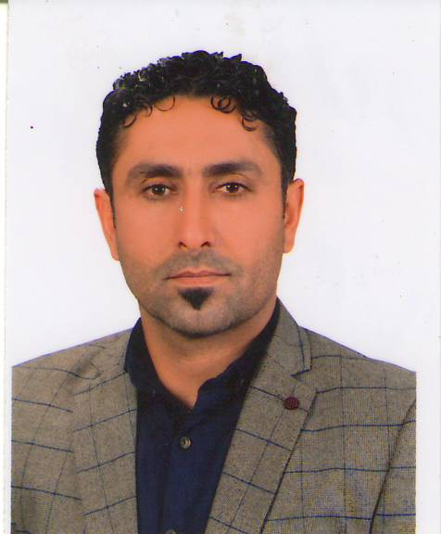
- Name: Hikmat Adil Aziz Al-Lami.
- Lecturer at the Dept. of Medical physiology College of Medicine, University of Al-Qadisiyah , and a lecturer in (College of Physical Education and Sports Science - College of Education for Girls).
Breeding: Iraq. Al-Qadisiyah Governorate. 8/23/1977.
Graduated from the College of Physical Education and Sports Science - University of Qadisiyah for the year (2001-2002), sequence 11.
- Appointment at the University of Qadisiyah / Directorate of Physical Education 1/10/2003.
- I was admitted to the Master's degree October 30, 2005, University of Qadisiyah / College of Physical Education and Sports Science.
- She obtained a master’s degree, 22/1/2008, University of Qadisiyah / College of Physical Education and Sports Science.
- Obtaining a scientific title (assistant teacher) 12/2/2008.
- My acceptance to PhD 10/27/2009, University of Qadisiyah / College of Physical Education and Sports Science.
- She obtained a Ph.D. 8/8/2012 University of Qadisiyah / College of Physical Education and Sports Science.
- Obtaining a scientific title (Teacher Doctor) 26/8/2012 Specialization in Physiology of Training, Athlete / Handball.
- I got a scientific title (Assistant Professor Doctor) 8/8/2015 (Physiology of Athletic Training / Handball).
The first distinguished student at the university as an official in the Physical Education Unit in 2011.
- Rapporteur of Medical physiology College of Medicine. Officer of the Division of Student Activities in the Faculties of (Administration and Economy - Education for Girls - Medicine) at Al-Qadisiyah University.
I have 7 papers published in scientific journals.
I have a book published (Handball between Dietary Supplement and Athletic Training).
- I participated in more than 18 international and foreign conferences as a researcher, participant and member.
- He holds an English language proficiency certificate from Al-Mustansiriya University, Al-Qadisiyah University and the British Cambridge Institute.
- She represented the Qadisiyah Governorate Education Team for handball as a player for the years (1993 - 1994 - 1995 - 1996 - 1997) and got advanced positions.
I got first place in the Iraq Handball Cubs Championship in (1992) as a player.
- I won first place in the Iraq handball championship for the first class for Al-Najma Club for the year (2005-2006) as a player.
- I represented many clubs with handball, including (Salah Al-Din - Najaf - Kufa - Al-Diwaniyah - Al-Daghara - Al-Ahly - Al-Shamiya - Al-Sunni) as a player.
She represented the Qadisiyah University handball team for several years.
- The clubs that supervised its training (Al-Diwaniya, Al-Ahly, Al-Shamiya, and Al-Sunni).
Currently a coach at the Daghara Club and the Handball Association, Diwaniya branch, for different age groups.
- Coach of Al-Qadisiyah University team, by hand, currently won first place in (2010) and second place in (2012).
- training courses :
1- A training course from the International Handball Federation, rating [D].
2- A training course from the European Handball Federation.
3- A training course from the Asian Handball Federation.
4- A training course from the Arab Handball Federation.
5- A training course from the Slovenian Handball Federation (2).
6- A training course from the Iraqi Handball Federation.
7- AFC Training Course [C].
- A second-degree handball arbitration certificate.
- Field visits to trainers in Al-Diwaniyah governorate for the categories (youth, juniors, youth).
- Training advice for trainers in Al-Diwaniyah governorate for the categories (Cubs - Juniors - Youth).
The subjects I studied are (handball - physiology - athletic training - school health - physical education).
- Lecturer in many courses in the specialty (sports training planning - fitness - sports medicine - physiology of sports training).
Assist. Prof. Dr. Hikmat Adil Aziz Al-Lami
Dept. of Medical physiology College of Medicine, University of Al-Qadisiyah, Iraq

