CURRICULUM VITAE

Boudjelal Maroua 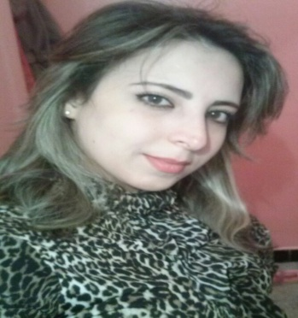

65; street president wilson ,Souk ahras; Algeria.

Mobile: [+213 5.55.42.01.67] E-mail: [miamibich90.mb@gmail.com]

Personal Profile

DATE OF BIRTH: 25/ 11/ 1990
Sex : female
PLACE OF BIRTH : Souk Ahras ; Algeria
LANGUAGES : Arabic , Frensh , English
MARITAL STATUS : Unmarried

Education

Grade achieved: [Grade] [ Specialization and the institution]

[2007-2008] [Bachelor] [literature and philosophy; High school of Rabahi Nouar ;Souk Ahras,Algeria]

[2008 – 2011] [Bachelor ] [Political Science and International Relations , University of Badji Mokhtar, Annaba, Algeria ]

[ 2011 – 2014] [Master] [mediterranean studies ; University of Badji Mokhtar, Annaba, Algeria ]

[ 2015 – 2014]: [doctorat] [regionalism studies , Political Sciences High School, Algiers, Algeria]
.

Work Experience

[2013– 2015] [French language instructor ] [Professional training center, dream school ]

[ 2013 –2014] [Trained in human development ] [Professional training center, dream school]

Skills

Technical: Computer literate: Windows applications.( word , excel, powerpoint;web....)

Interpersonal : good communication skills gained through my experience as trained in human development
 

Hobbies and Interests

[Travelling, international affairs, history, meeting friends...... ]

Referees

Referee : Salah Ziani
[Distinguished University Professor, / Political Sciences High School, Algiers, Algeria]
Tel: [ +213 6 62 00 78 33]

Email: [salah.ziani.dz@gmail.com]

