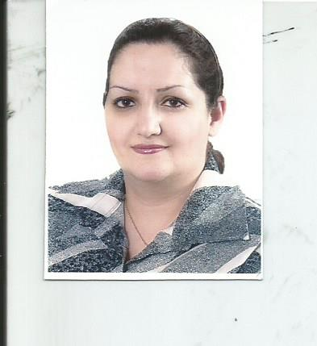

* Dalia Azhar Ahmed
* Assistant lecturer at College of Sciences – University of Baghdad
* Master degree in microbiology (molecular microbiology) 2015
* Participated in training courses in molecular techniques
* Participated in training courses in biosafety and biosecurity programs
* Published 7 scientific researches in several local and international periodicals