Aseel Basim Al-Najjar  00964 7727356061  Iraq/ Baghdad/ Alsaydia  aseel.b.najjar@gmail.com  Fully dedicated, respect time, encourage team work, and fast learner. | 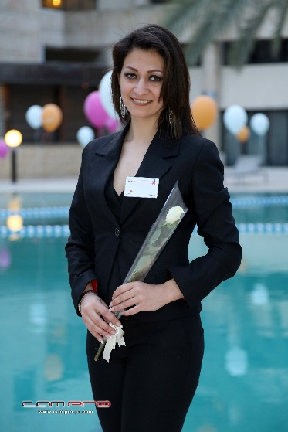

Education

November-2005 | Master degree in computer science. Degree Good.
Experience

February 2016 till now Administrative Assistant in PricewaterhouseCoopers/ Baghdad
Job Responsibilities:
Supporting Baghdad office with all administration tasks required. Such as organising meetings, arranging appointments, typing, booking transportation and accommodation, ordering stationery, dealing with correspondence, complaints and queries from clients, preparing letters, presentations and reports when needed.
Arrange visas and follow up.
Supervising and monitoring the work of secretarial, clerical and administrative staff.
Managing office petty cash.
Follow up on office and accommodation maintenance issues.
Support HR, IT and Finance teams in Amman.
Reference:
Rula Tahagloq: email: rula.tahagloq@jo.pwc.com | Mobile: +962 (79) 7743 438

October-2013-2016 lecturer assistant
Nahrain university/ College of Science/ Computer science department | Iraq/ Baghdad/ Al-jadriya
Job responsibilities:
- Responsible for managing and maintaining the LAN and the server computer of the college of science which connects 5 departments and 8 computer labs.
- Administrator of the electronic archive system that is used in the college to archive documents and connect the terminal archiving computers.
- Teaching computer science for under graduation stages students.
- Supervisor of two students working on a graduation-year research entitled "Electronic menu for restaurant on android"
Reference:
Dr. Haithem Al-Ani 00964 7901162871
Reasons for leaving the job:
- Enhance my abilities
- More room for growth
- Having bigger challenges
- Looking for a higher paying job

24-11-2005 | October-2013 manager assistant
Iraqi ministry of higher education/ scholarships directorate | Iraq/ Baghdad
Job responsibilities:
Select Iraqi candidates to join scholarships in other countries according to a specific criteria, review their documents, make sure they are eligible, make interviews with the candidates and facilitate the process of their joining the scholarships, finally, follow up and advise the students in the countries where they study.
Reference:
Miss Huda KadhimAlwan 00964 7903488670

November-2003 | 23-11-2005 graphic designer
Kululiraqnewspaper | Iraq/ Baghdad
Job responsibilities:
Design the newspaper pages using Adobe Photoshop and CorelDraw.

January-2003 | August-2001 office manager
Al-Kawakib Al-Tisaa trade company| Iraq/ Baghdad
Job responsibilities:
- Supporting the office with all administration tasks required. Such as organising meetings, arranging appointments, typing, booking transportation and accommodation, ordering stationery, dealing with correspondence, complaints and queries from clients, preparing letters, presentations and reports when needed.
- · Arrange visas and follow up.
- Supervising and monitoring the work of secretarial, clerical and administrative staff.
- Managing office petty cash.
- Follow up on office and accommodation maintenance issues.
- Support HR, IT and Finance skills.
- Windows Xp, 7, 8, 2012 server, Ubuntu
- MS office suite including Word, Excel, Access, PowerPoint, and Outlook
- Severalprogramming languages
- Knowledge of techniques for planning, installing, supervising, and maintaining networks
- Knowledge of using Cisco routers and switches

Languages
- Arabic (mother language)
- English (fluent)
- French (average)

