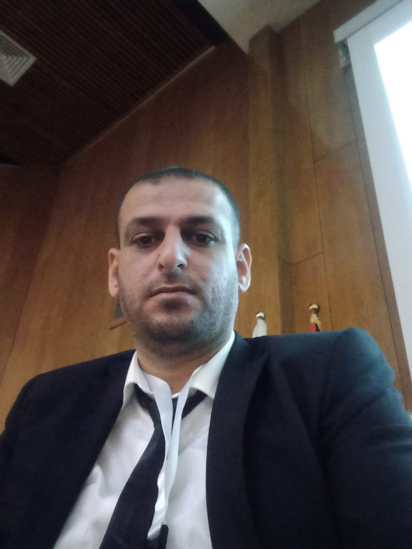

C.V
Personal Information:
Name: Mohammed Subhi Hamed Odeh
Date and Place of Birth: December 8, 1987, Nablus, Palestine.
Current Position: Part-time Professor at the Faculty of Sharia, An-Najah National University, Nablus, Palestine.
Contact Information:
Mobile: 598523494 (00972)
Email: m.odeh@najah.edu / m.s.odeh87@gmail.com
Education:
2006: General Secondary Education, Salem Deir Al-Hatab Secondary School – Nablus.
2010: Bachelor's Degree in Sharia, specializing in Jurisprudence and Legislation, An-Najah National University, Nablus.
2017: Master's Degree in Jurisprudence and Legislation, An-Najah National University, Nablus.
2019-2023: PhD student in the Jurisprudence and its Foundations program at An-Najah National University, Nablus, working on the doctoral dissertation.
Academic Experience:
2011-2013: Teaching in Islamic secondary schools in Nablus.
Since 2011: Imam and Khateeb at the Ministry of Awqaf and Religious Affairs - Palestine.
Since 2018: Lecturer at An-Najah National University, Nablus.
2018-2019: Teaching at the Academy of the Holy Quran for Quran memorization in Nablus.
Academic Contributions:
Published numerous scientific research papers, including:
1- The path of considering the innate nature and its impact on achieving the goal of respecting legislation.
2- The nullified interest and its contemporary applications.
3- Civil marriage in Jerusalem and Palestine 48.
4- The ruling on selling human blood as a donation and its consequences in Islamic jurisprudence.
5- Images of the transmission of the coronavirus and its ruling in Islamic law.
6- Preventive measures to limit the spread of the coronavirus.
7- Criminal responsibility arising from the transmission of the novel coronavirus in jurisprudence and law.
8- The concept of reciprocal compensation in the Hanafi school.
9- The ruling on participating in the democratic political system in light of the jurisprudence of budgets.
10- The reality of scientific research among students of higher Sharia studies and ways to promote it.
- Participation in various programs in cultural, religious, and social fields.
- Participation in numerous scientific, cultural, and social conferences, seminars, and workshops.
- Member of scientific and preparatory committees for conferences and the university, including:
1- Member of the preparatory committee for the Tenth International Scientific Conference of the Faculty of Sharia at An-Najah National University in Nablus, titled "Ethics of Medical Professions from an Islamic and Legal Perspective" in 2021.
2- Member of the scientific and preparatory committee for the international conference "Palestine in the Ottoman Era" at An-Najah National University in Nablus in 2022.
3- Member of the "Technical Support Committee for Faculties" representing the Faculty of Sharia at An-Najah National University for the academic years 2021-2022.
Skills:
1- Ability to teach academic programs related to the specialization.
2- Ability to work within purposeful scientific groups.
3- Ability for collective thinking and constructive dialogue.
Notable Individuals:
1- Dr. Jamal Zaid Al-Kilani – Dean of the Faculty of Sharia – An-Najah National University – Nablus – Palestine.
2- Dr. Abdullah Abu Wahdan – Faculty of Sharia – An-Najah National University – Nablus – Palestine.

