Evaluation of Historic Center Revitalization Project in Dair Ghasanh

Muayad Jumah Ismail Rimawi

INTRODUCTION

The old town is a civilization and cultural center that is important for people in various parts of the world , and represents the history and originality , old town areas suffer from several problems , and because of modernity of life and changing in human needs and requirements it had been abandoned ,and become dying town , for that reason many projects had taken a place for rehabilitation and revolution old towns in order to bring its live again , some of the project succeed and some fail , so there is a need to evaluate these projects in order to get results to support positive points and resolve negative one , so this paper will study and evaluate the revival process of the old town in Dair Ghasanh and find out the reasons for success or failure , reviewing a similar cases and literature review will be done , field visits , and questionnaire to direct the way of analysis .

LITERATURE REVIEW

Historic areas in the Palestinian areas suffer from several problems , the inability of the old towns to absorb developments , which led to the abandonment and increased the frequency and speed of devastation due to weather and environmental terms become healthy abomination and dens of crime in some places , resulted in the lack of services and poor infrastructure, particularly extensions (electricity, water and sewage) and narrow roads and alleys that have become commercial modern man needs and sometimes called underdeveloped areas , In the case of these services provide all or part of it does not take into account the ancient environment in the region and is working to distort and, in many cases, ignorance and lack of awareness of the importance of these areas to document and prove our existence and our right to our land in the demolition and removal of large parts of them for the benefit of the construction process or at the hands of the occupying forces to facilitate their movements and control over those areas contributed (Mufleh, Nahed 2009 Arabic) .

Another problems facing old towns is the progressive ageing and social exclusion of the residual population contributed to the decay of neighborhoods, Another common phenomenon in historical centers has been the inability to bring about a social unification of all the residents of the neighborhood , Furthermore, the arrival of newcomers implies a structural division within it into old and new residents , which increased the problem of identification which is necessary for solving problems , old centers become merely monumental areas with an exclusively museum-like character, which leads us to conclude that it is important to integrate historical centers in the daily life of cities as a whole (Fernández, Óscar 2007 ) .

The historic old town spatial structure like narrow streets , the absence of adequate parking , streets pattern and the traditional market in the historical area is one of the problems of leaving old towns (Dilmi, Djamel 2014 ) .
Another problem confront revitalization ,wealth and enterprise became stronger to the owners than notion of heritage and identity so investors increase of facilities and comfort or adapting properties to new functions without respect to their heritage values (Kulikauskas P. 2006) .

The modern problems of old towns arise in phenomenon's of , the high-rise buildings , which changed the scale of relationship of the old town and the surrounding landscape, and the loss of authentic fabric in building transformations for modern use
(Kulikauskas P. 2006) .

In order to protect historic buildings , work on the restoration of damaged buildings and rebuild what was destroyed so not to lost heritage and replace it by New buildings ( Abu Hija.2002 Arabic) .
Revitalization is the process by which bring life to the area to preserve the buildings and re-used again (Shakhshir,Suha,2010) .

A success revitalization project should contains those outputs , upgrading of essential infrastructure , improvement of the physical environment , rehabilitation of dilapidated housing , reuse of existing buildings , and construction of new commercial facilities and housing in a manner appropriate and in harmony with, the historic aspects (Steinberg F.2008) .
There are various methods to preserve heritage buildings ,Reconstruction , revitalization , Preservation Replication , Consolidation, Restoration, Deterioration Perversion (Maliki.2004 Arabic) .
So in order to preserve heritage buildings , it must go through a process which contains , Documentation ,Study and analysis ,Maintenance and repair ,Select the appropriate function of the traditional model ,The changes that will follow the new functionality (Maliki.2004) (Pickard.2006) .

STUDY SITE

Dair Ghasanh ( DG ) nominated as a case for this study , ( DG ) is a Palestinian village in the West Bank located 45 kilometers to the northwest of Jerusalem , The village reflects the historical period characteristic phenomenon of the history of Palestine called chairs villages which was formed during the seventeenth to nineteenth century , contains many religious shrines in addition to a set of desolate archaeological around the village in addition to the natural heritage of plant and springs , the old town contains many houses most of them abandoned and some of them used as residential buildings and shops (Maraqa .H , 2004) .

( DG ) contains one Mosque and two schools ,and a number of roman remnants, shrines ,and archaeological site called Khawas . (Bani Zeid Municipal Council, 2015)

According to (PCBS) in 2007 the total population of Bani Zeid including ( DG ) was about 5,184 and Dair Ghasanh about 2000 people .

METHODOLOGY

The evaluation process will considering the following aspects :

The quality of the space used in the living

housing is very important , so maintaining the existing houses and restoration in terms of materials used and the method of repair and providing the necessary services
of kitchens and bathrooms , With the possibility of building new homes fit with the traditional environment.

Urban spaces inside the town

Should not be meddling cars and for pedestrians only, in order to avoid the noise and pollution, with the possibility of use Small cars when needed , conservation the social structure of the houses that give a sense of security, while social control by the houses accumulated around the yard and give safety for children to play in it.

Cultural, health ,recreational and educational activities

Educational services available like schools , kindergartens and centers , health like clinics and hospitals and pharmacy , recreational like parks and playgrounds, cultural, such as cultural centers, theaters, and music centers .

Economic aspects

Economic activities which available like shops and services , enterprise . business and crafts that can revive the economy and the movement in the town .

social aspects

Visits and relations between neighbors , social behavior and events .

conserve the external shape of the town

the town horizon, the height of buildings and the materials used , the style of buildings and facades .

The methodology of this research divided into stages :
- Studying literature and cases for old towns problems .
Through studying literature we were able to find out the most important problems of the old town which led to the migration of the old towns, These findings formed the basic framework for evaluating the success of the revival operations .
- In order to evaluate the revival of the old town the study will examine of the stages and work that had been done by Riwaq , and to know if it achieved its objectives and goals .

- Field survey and data collection :
In this stage a data had been collected from Ministry of Local Government , Bani Zaid Municipality , Riwaq , and from field survey in order to update the old data .
- Studying the collected data and prepare maps for buildings physical classification , buildings usage and heights , those maps will indicate which services are available in this area and the condition of these buildings also views and horizon of old town with the map of buildings height .

- Do a questionnaire :
By taking a random sample of 10 families of the old town to see the extent of change that took place after the revival process and whether the revival led to solve the problems of the old town and the reasons that led to the abandonment of the old town .

- Studying of the results of the questionnaire within the created frame that Inspired by literature to Identify problems that have been resolved and the problems that still exist after the revival process in order to evaluate the revival project depending on its ability to solve the problem of migration from the old town .

RESULTS & ANALYSIS

The result will be evaluation of the project and identifying on the most important reasons that lead to succeed or failure of the project for revitalization old town of Dair Ghasanh .

case studies

Three case studies of revival of which have been two cases of local and other global address .

Revitalization and Development of AL-Habalah Quarter
“A Study in Urban Conservation and Revitalization of the Old Town of Nablus

Thesis was based mainly on descriptive analytical method, using a set Tools of scientific research, such as the questionnaire, field surveys and interviews with stakeholders from people and technicians in the municipality of Nablus.
The goals of the Revitalization were , to raise the residential environment, the level of process to attract people to live in (residential buildings and surrounding buildings) and improve and support the existing commercial activities , as well as tourism , and encourage the preservation of cultural heritage to encourage tourists to come to the old town , and the work of a general framework to attract tourists , and leave a spaces for parking to attract people to live in the old town.

The study dealt with the poor physical, social, economic, and practical solutions and realistic in order to promote Habla upgraded to suit the needs of the residents , as The study included the composition of the urban fabric of Habla, the study of architectural components and discover what the members of the urban and the characteristics of the process of revival and development and study of the situation social and economic of the people and the appropriateness of the current environment to their needs and how to reach solutions is working to develop an urban environment contribute to raising the social and economic level of the population and work on the development of regulatory frameworks and legislation for the process of preservation, rehabilitation and construction in Habla and work on linking the revival process and the development of Habla with urban sprawl outside the old town of Nablus.
The study concluded the need to improve the social and economic situation of the residents of the Old City in order to encourage them to stay in the country and stressed the importance of enhancing coordination and cooperation between the various authorities in the city of Nablus, as well as enhancing the participation of the population in the rehabilitation and development process.

The Commission experiment in revitalization the old city of Hebron

The preparation of draft studies and the development of buildings and functionally converted from housing to Extended families to apartments , offer privacy and services necessary, dwelling where nuclear families, embarked ,Committee in the implementation of a comprehensive scheme to preserve the old town and to clarify its relationship with the rest of the parts of the city, Prepared plans for the advancement of infrastructure, education, health, transportation and telecommunications services
tourism . exemption contractors working in the old town from the income tax to encourage them to work ,And continue to, support of the local population have contributed to the Reconstruction Committee in confronting the occupation authorities
And unfair decisions, volunteer work teams helped in maintaining the cleanliness of the old town .
the problems that have faced the revival process, the fragmentation of ownership, and the presence of some of the ( Waqf) Properties , the solution where to give the option for owners , to live in the building or leased for five years in return for a symbolic payment accord the right of the Commission to re-lease, is sufficiency in the completion of leases signed simple majority of owners on the contract.
The Commission has succeeded in part of the rehabilitation of buildings
In the old town and functionally adapted in line with the needs of the population, according to international standards in Preservation, restoration and cost less than building new housing units, and changed the social concept Prevailing among the citizens from the old town as an area full of social problems, not Safety or secured.

revitalization the Vilnius old town
Vilnius is the capital of Lithuania and symbol statehood it is important cause of the cultural heritage of its old town , methodology of the research based on discussions with the stakeholders, reviews the experience, extensive public consultations and opinion surveys were carried out, including issues such as visions of old town, living and working in the old town , problems of the service infrastructure, streets and squares, traffic and parking , parks and green spaces.

The vision of revitalization was based on supporting traditional fine crafts and fairs program , manifesting its involvement in local development organized many thematic meetings for the members of the Old Town community and published a number of publications as guidelines for conservation , investment, building components and the like .

Stages of restoration and revival of the old town by Riwaq

Riwaq is non- profit organisation established in 1991 ,Palestine , the main aim of Riwaq is, the documentation, rehabilitation and development of the architectural heritage of Palestine , It had many of restoration and revivals projects in Palestinian villages in historical areas, and ( DG ) was one of these villages .

Riwaq finish work on protection of the historic center at ( DG ) in 2005 the project started with restoration for a community building which became later, a center for Al- Kamandjati , the real work started in 2012 with the revival of the old town in cooperation with the Municipality of Bani Zeid and community, begin with restoration and rehabilitation of the main square in the old town , it was the first intervention in the public space in ( DG ) aimed to improve the overall appearance and provide space for community activities , this work allowed a deeper community interaction with the renovated spaces, the square location increase the people sense of ownership of the place because of it’s the gate to the clinic and kindergarten , floors and contemporary stone seats and the installation of a steel statue in the form of a tree in the middle of the square arena sent a new life to the old town .
In the same year Riwaq renovate the Palace of Saleh al-Barghouthi in order to protect from natural external factors , and also pave the southern entrance to the old town in order to create safe public spaces and attractive its residents and visitors.

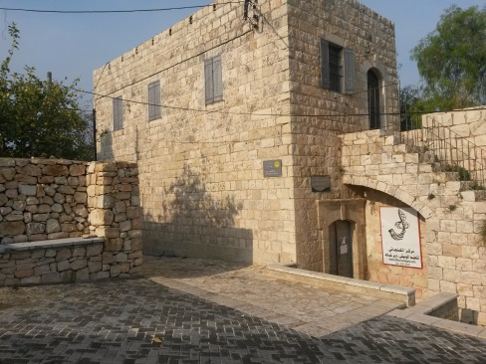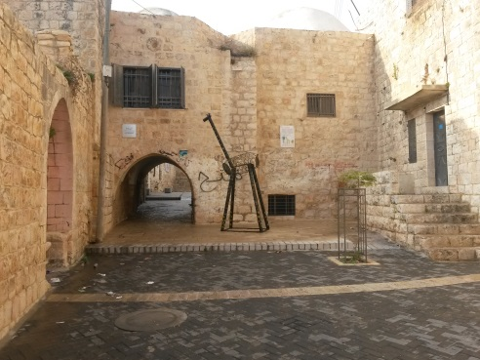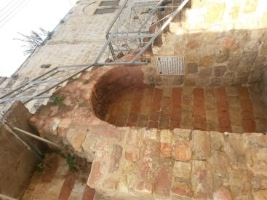

another building was renovated to be Bani Zeid Women Association center, providing jobs for many of the town's women, and provide income for many families.
In 2014 To overcome the division of the village into separate entities Riwaq start work on streets provide seats to sit and shading elements and creating green pockets in the corridors , in addition to strengthening the historical facades , Works that led to the creation of a physical and visual link to the main yard with a Shuaibi neighborhood , Some of the projects are beginning to emerge Such as the opening of a new hair salon at the entrance of the arena .

In the mid of 2014 The fourth stage of rehabilitation targeted Shuaibi neighborhood bega n, this phase is designed to highlight the historic architecture of the neighborhood and the provision of adequate infrastructure and community spaces to attract residents and visitors , Riwaq also encourage community participation in the process of restoration .

Riwaq revival - goals and objectives

Riwaq main goal is restore historic buildings abandoned life to make the old towns in Palestine live and attractive to residents and visitors and maintain the identity and cultural heritage .

Riwaq identified the goals and objectives of restoration and revival process in ( DG ) as follows:

- Create a visual and effective linkages between different neighborhoods .
- Provision of public spaces to attract people spend time in the old town and social interaction .
- Strengthening the structure and readiness of public spaces and clarity and accessibility .
- Provide a safe and attractive environment for local businesses and housing.

Maps and data analysis

In this stage the paper examine maps , pictures and data that had been collected in order to introduce the existing situation of ( DG ) .

Depending on Riwaq 1997 statistics , number of old buildings in the village about 268, including 259 building which is about 97% of the total number of buildings consisting of one floor, and 7 consists of two-story buildings which forms the proportion 3% , 196 building is in good condition , 38 in bad condition and 31 building in medium condition , and one building unusable, and about usage 135 building is used fully , 126 building is abandoned and 3 buildings used partially .

The survey in 2015 after the revival shows that the number of buildings in a bad condition decreased to 20 of building , and the building in used increased to 185 building .

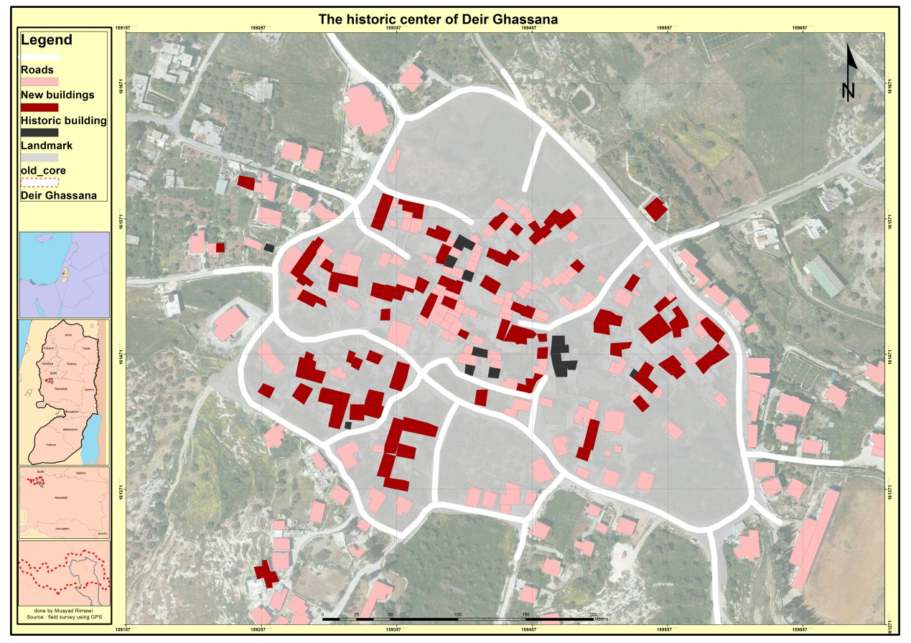
Map1 – the historic center of Deir Ghassana – GIS 2015

The map n1 shows that within the old core boundary there is 101 historic building 14 land mark 189 new buildings , which give indication that there is rise direction for construction in the old town , revival and emergence of business projects encouraging this trend .

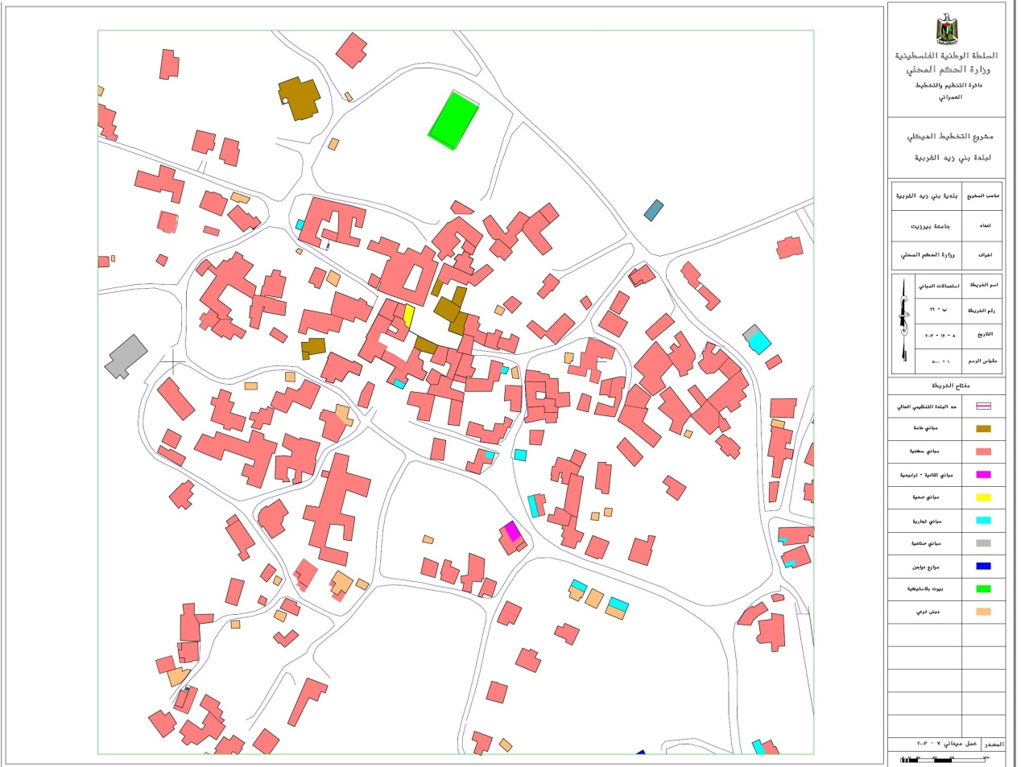
Map2 – the uses of buildings– Ministry of Local Government 2015

The map n2 shows that within the old core boundary there is 6 commercial buildings , 1 clinic , 7 public buildings , one greenhouse , 1 cultural building .

Questionnaire

The study take a sample of the old town residents represented by 20 families approximately 15% of the old town population , there were many questions some related to the family and the population , some related to the community needs ,and some related to the revival process and questions regarding the services and squares and social networking , which was aimed to know the family and housing in terms of the services and income level before and after the restoration and whether the latest spectrum change encourage them to stay in the old town , and to find out if the revival process which carried out by Riwaq was successful and whether it achieved its objectives .

The analysis of the questionnaire answers divided into items ,

The quality of the space used in the living

54% of the examined people confirmed that they had restoration of their homes and that 57% of them take the restoration process on his own account , and 43% of restoration process done by institutions , the restoration process included many of parts of the buildings 54.5% of restoration for walls and floors , 20% for ceiling and 20% for extensions and 10% for external , 75% of the construction materials used from the site itself, the research founded that buildings contain a sufficient amount of rooms as 72.7% as the buildings contain 4 bedrooms , 18.2% contain 3 rooms and 36.4% contain two rooms , 18.2% contain one-room , all buildings containing kitchens and bathrooms 81.8% of them are internal , 90.9% of the examined confirmed that the ventilation and lighting is good, 50% confirmed that the situation after the restoration is better while the other half confirmed it as acceptable.

As for the problems faced by some 54.5% of examined confirmed that there no problems in the buildings , but 54.5% of them confirmed the presence of cracks in buildings and 27.3% said they are suffering from water leakage in the winter period and water aggregation , while 27.3% of examined expressed his need for home addition , and that the basic problem of which 71.4% of examined suffer is water and power cuts, while the insects problem about 21.4% and 7.2% suffer from rodent problems.

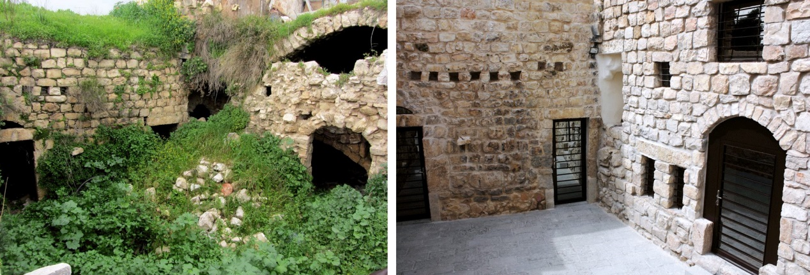Nada Shuaibi yard before and after the restoration - Riwaq -2013
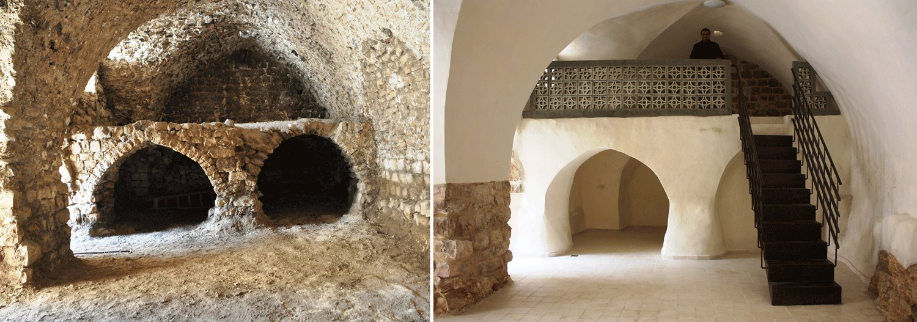Nada Shuaibi yard before and after the restoration - Riwaq -2013

Urban spaces inside the town
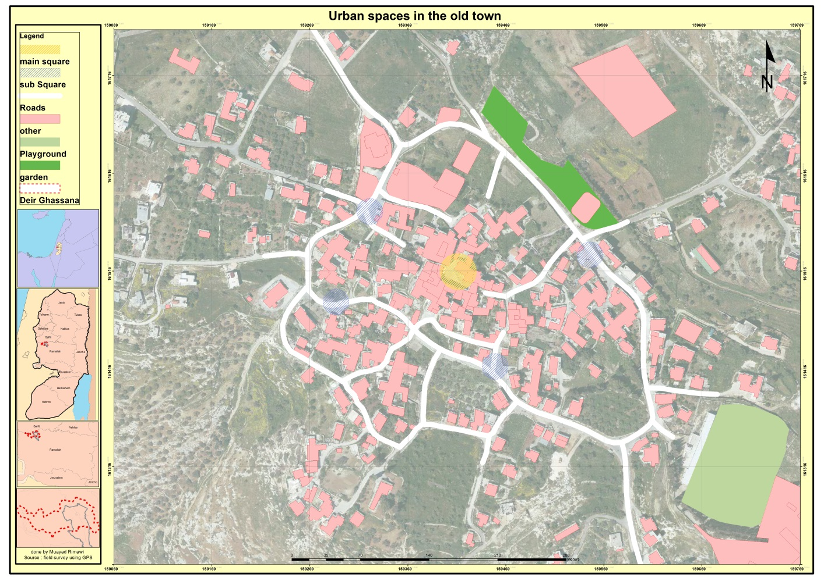Map1 – the historic center of Deir Ghassana – GIS 2015
There are many squares areas in the old town and the most important of are 5 yards , main square represented in orange and sub-squares represented in blue, mostly the yard surrounded by a group of buildings in so-called ( Hawsh), somet of these squares had been restored, including the main square, tiles and seats also been constructed in the site , and also outdoor lighting in 2012 by Riwaq .
The research found that there are places for waste collection, where 63.6% of the examined confirmed that it is accessible , squares become attractions for residents and encourage social interaction , some confirmed that 11% of their meeting with friends where in the squares , 63.6% confirmed that squares make a beautiful view for homes and 18.2% of them confirmed that they do not have views and 9.1% that their hand bad views, as 28.5% emphasized that they use the square for occasions and 7.5% were using the town center, while 72.7% of the examined confirmed that there problem in the lack of parking
.
Riwaq understand the importance of the square so it implements many elements that encourage the use of the square such as tiles , lighting and drainage , also green element such as trees and plants were used, pergolas also used for example as happened in Nada Shuaibi yard which restored by Riwaq in 2013.
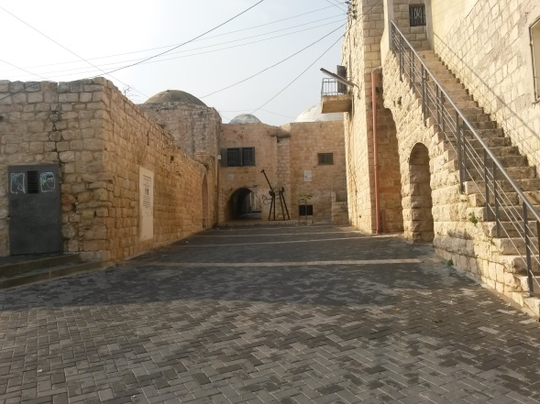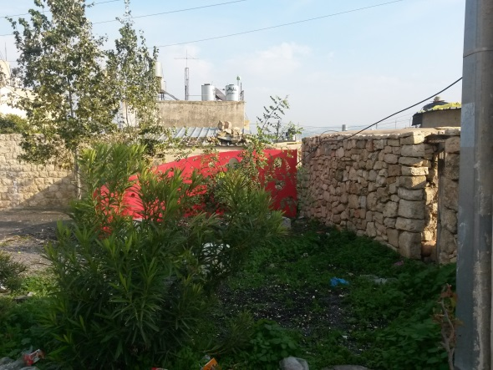
The main square - Deir Ghassana - Researcher 2015
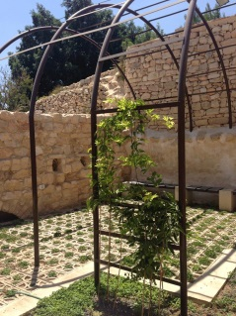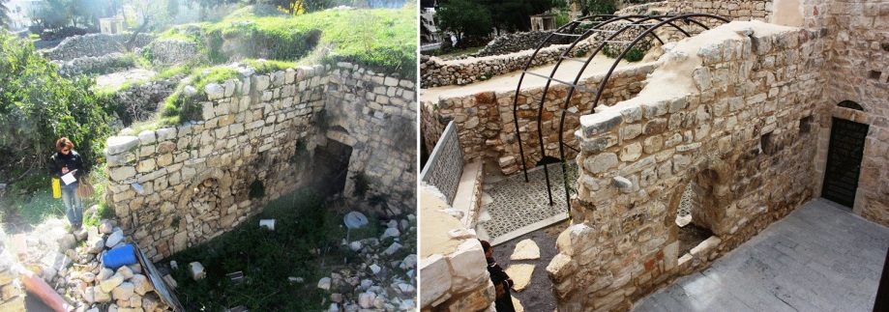
Nada Shuaibi yard- before and after the restoration and pergola - Riwaq 2013
The problems that have been observed in the squares are as follows:
Riwaq had neglected of the southern entrance to the old town ,it did not repaired or had interest in it, where olive residue piles accumulate on the parties, waste and mangled street, A visitor to the old town of this approach finds contradiction in its composition and in particular the existing square in middle of the road, which reflects another identity of the place.

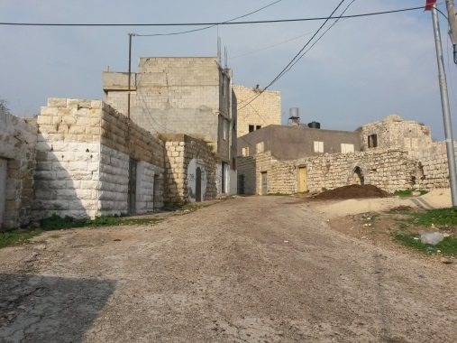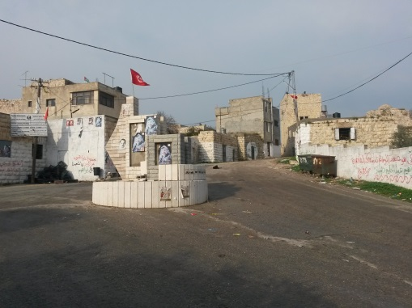
The southern entrance to the old town and the rotor - Researcher 2015
The second problem was the waste which is gathered in some areas that have been neglected and not covered by a private restoration to make up a scene and an abomination to bad health of the population and visitors.
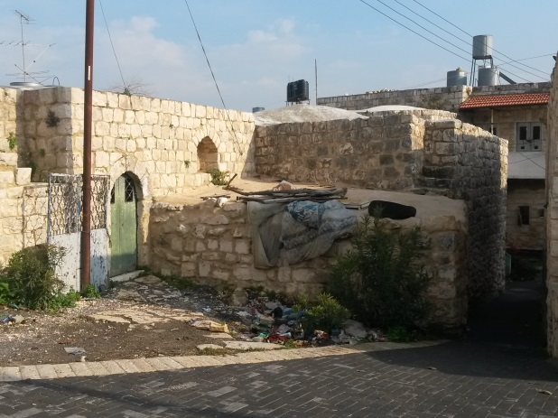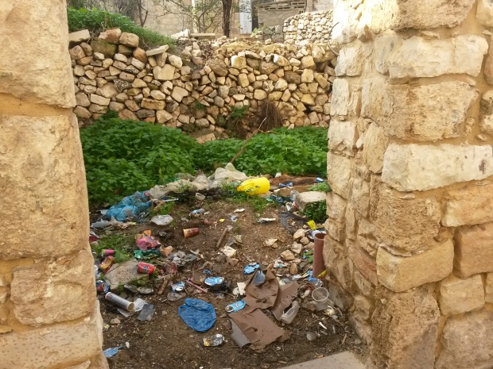
Waste gathered in some areas - researcher -2,015
The third problem was the lack of attention to sub-spaces As the picture shows the square in front of the mosque, north of the old town and that is not handled properly , all are covered by street which make it danger to children , there is no sidewalk and places for pedestrians with the knowledge although it vital area cause of it exists near the only mosque in the town.
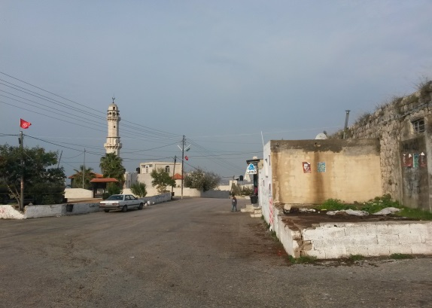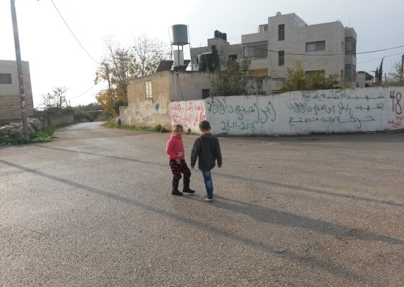
Northern town square - researcher -2015
The fourth problem was the lack of parking which is forced some parents to put their cars in far areas not intended for car , and walk a long distance to their homes .
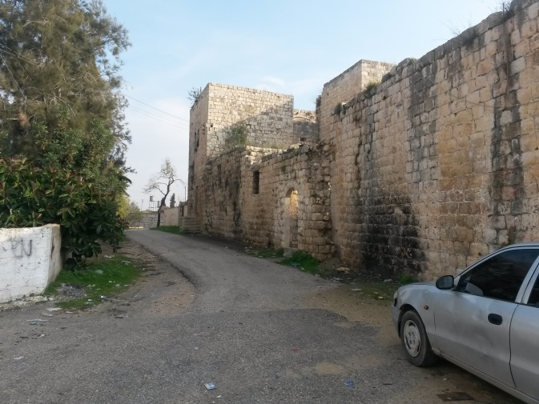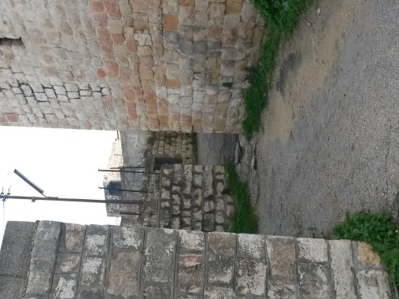
North of the old town - researcher -2,015
Cultural, health ,recreational and educational activities

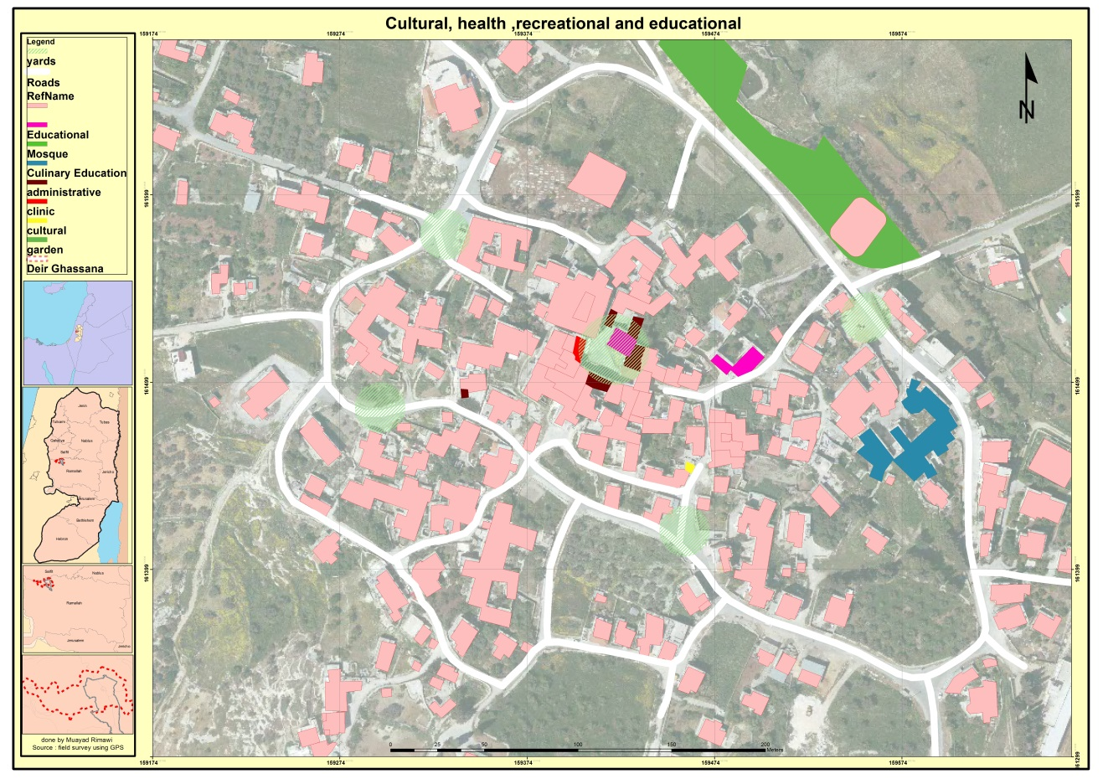 Map2 – the uses of buildings– Ministry of Local Government 2015
The map shows that the result of the collection data from the field and maps , that the town has many educational centers with different kinds represented in black color , where there a kindergarten in the center of town and educational centers, which also include Kamandjati Music Center, which is located east of the main square, and in the same direction with about 200 m the mushrooms house for teach cooking , and Bashir Barghouti secondary School south east of the town, and there is also a children's park on the outskirts of the old town represented in dark green color .
As for the health on the other hand , 63.6% of the examined has confirmed that they receive health care from the clinic and 27.3% from other centers , the clinic is located in front of the kindergarten in the main square, represented in red color , courtyards and squares represented in light-green can be used for recreation and movement , In addition to the park on the outskirts of town where 40% of the examined confirmed that they attend the park and 25% said they need a club, while 25% prefer the a coffee and 10% of them express their need for a youth center.

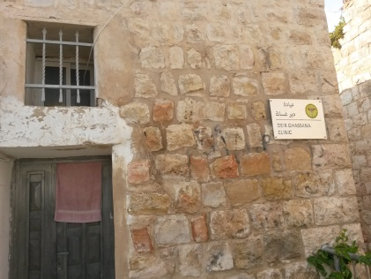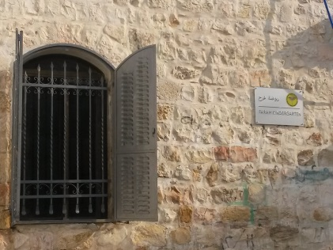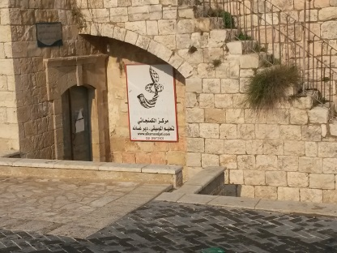Kindergarten , clinic, Kamandjati Center - Researcher 2015

Economic aspects

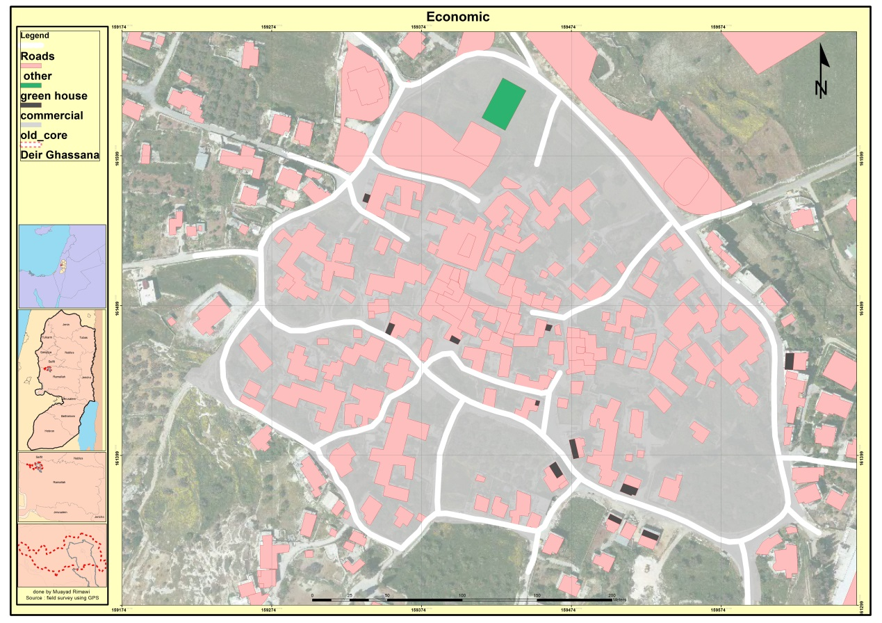Map2 – the uses of buildings– Ministry of Local Government 2015

The prevailing craft in the town were agriculture and animal husbandry, and yet 63.6% of the examined raise animals, but now 29.6% of the examined families are employee ,25.9% students and 18.5% Workers ,18.5% not working , 7.5% praivet work , 45.5% the examined work in Ramallah while 36.4% work in Dir gsanh , 90.9 of the population are owners of the houses and 9.1 are tenants , the monthly income of 45.5% of them from 2000-3000 NIS ,18.2% from 1000-2000 NIS as 63.6% of them with fixed income, the study also showed that parents work most notably 36.4 % employees and 18.2% workers , while the mothers about 81.8% are housewife and only 18.2% as employee , and 27.3% receiving help from organizations .
The study found that 71.4% of the examined buy from the town ,and 21.4% buy from the city of Ramallah and 4.2% from the old town .
As shown in the map within the boundaries of the old town contains eight shops, including 4 small shops 1 large grocers ,and sweets maker , building materials Store, and shop for chicken , and one greenhouse.

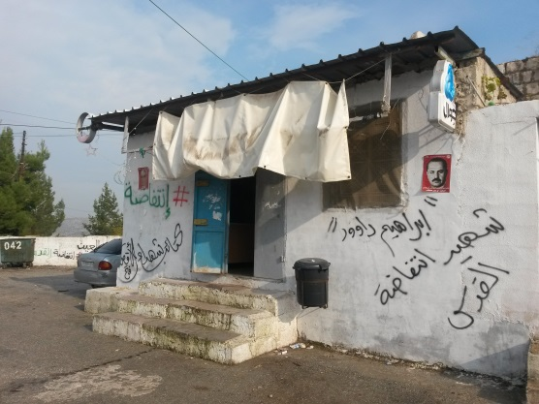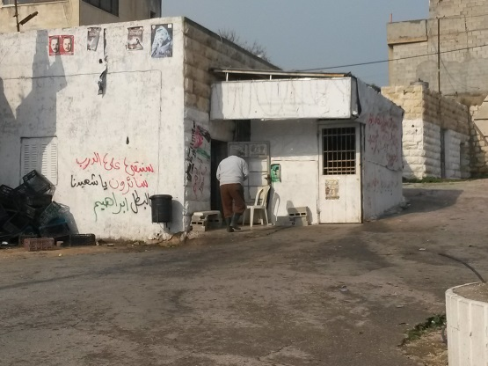
^{Small hops - Researcher 2015}
Study found that the problems of the economy in the old town are the small shops and a few exhibits that force people to buy from other places, they lack the shops clothing and footwear and household items, as lacking the handicraft business that has been neglected .

social aspects

Deir Ghassana coherence of the social relations among its residents, the study demonstrated that 90.9 of the examined had relationship with their neighbors and they all visits each other , cause they are neighbors more than 10 years ago, where 50% of the examined live in the Old City because of genetics and 41.6% cause thy love it and 8.4% due to a neighboring relatives, the study also showed that 35.3% of the age group that inhabit the town, most notably from 20-30 years , and 29.4% are above the 50 year , 54.5% of the examined confirmed that if they had a better chance they will leave , where there are 27.3% of the members of these families residing out of town and 27% outside of Palestine.
The study showed a decline in the role of square in social events where events and weddings had to be held , where this year decreased to 28.5% , while the halls occupied the largest proportion by 64% and 7.5% for town center .
conserve the external shape of the town

Deir Ghassana Characterized by the conjunction buildings , consistency and homogeneity where dating back to the chairs villages , and contain a large legacy of historic buildings as a Sheikh Saleh Barghouti palace , and Ottoman court and properties of a large number of buildings which form a beautiful horizon of the town.

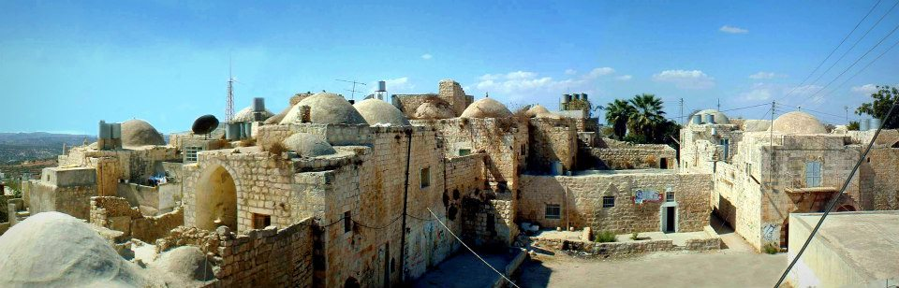 Interdependence and the horizon of the old town - Riwaq
Previous pictures showing the harmony and homogeneity of buildings in rural simulates nature and topography of the region to make up some of the spaces with each other and give some kind of privacy and protection for its residents and gather relatives in a one place acting as a playground and a place where children play without fear.
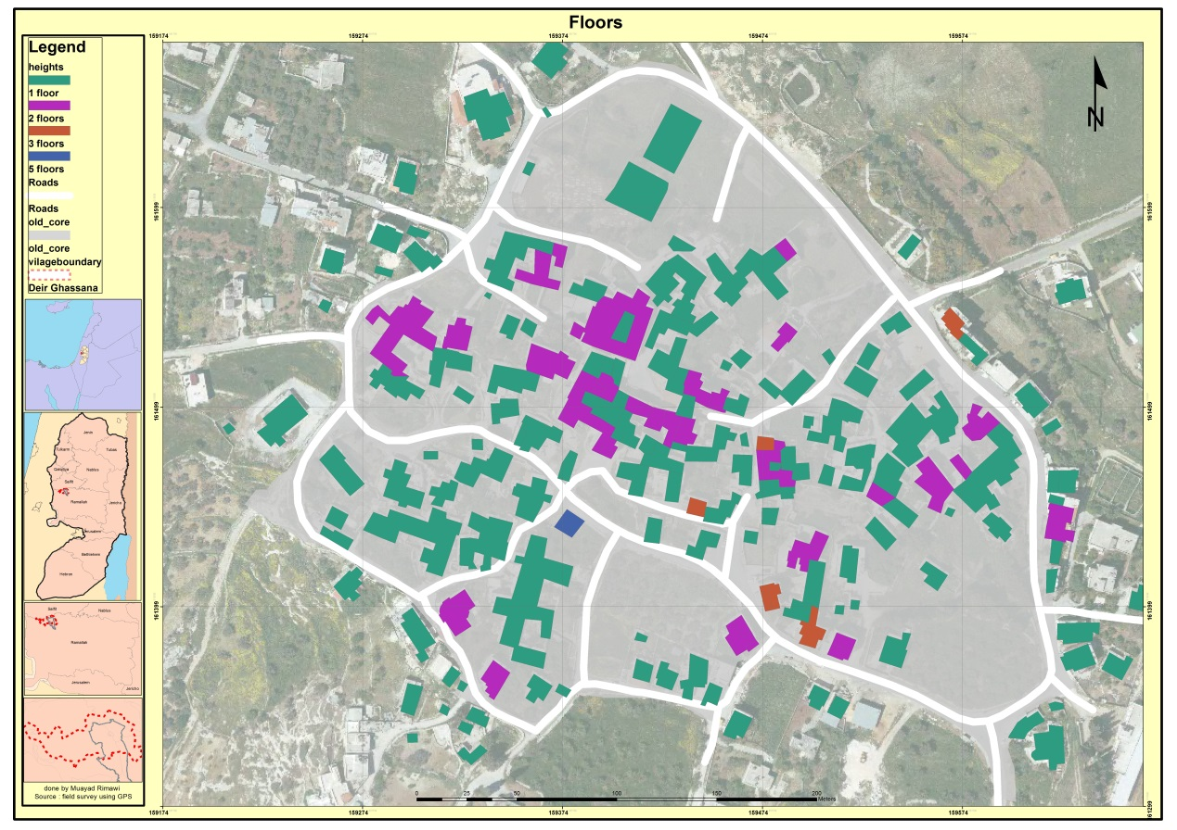Map2 – the uses of buildings– Ministry of Local Government 2015
The study shows that 80% of the buildings within the boundaries of the old town are single floor and 16.6% two floors , 2.4% three floors and 1% are 5 floors, as the study shows a number of emergence problems which became effective on the shape and the fabric of the old town, including the thoughtless additions shown by the pictures at the bottom in terms of form , materials and homogeneity .

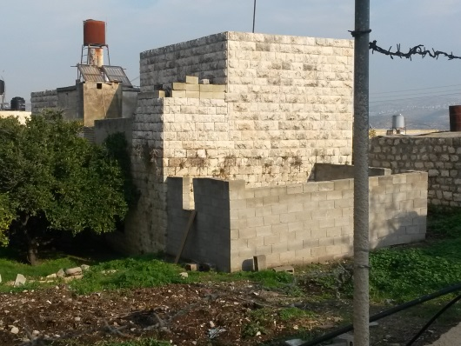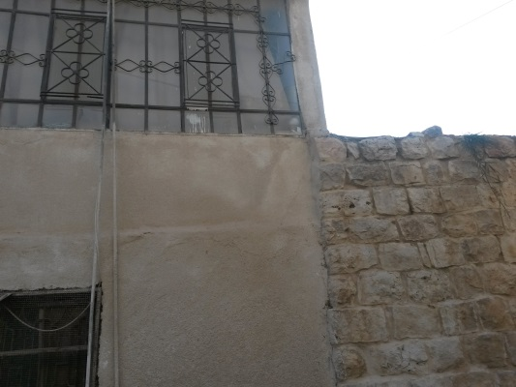
buildings additions - Researcher 2015
The second problem is in infringement of new buildings on the old buildings and cavern them , the emergence of high-rise buildings danger to the around , which may lead to blockage of the horizon and the closure of the beautiful debut , which influence negatively on the population.
.
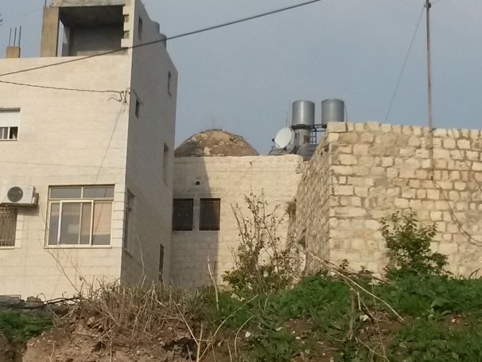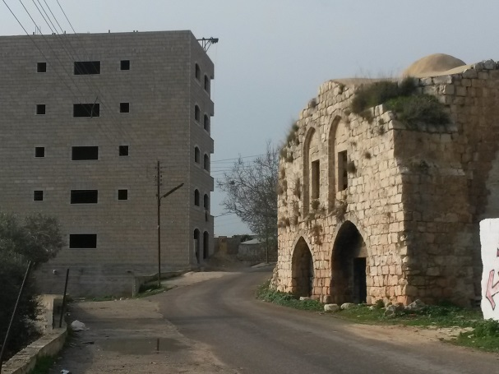
new buildings cover the old building - Researcher 2015
Discussion

The quality of the space used in the living

Buildings generally contain a sufficient number of rooms ,they also have a bathroom and a kitchen , as 90.9% of the examined confirmed that the lighting and ventilation are good , while half the examined confirmed that the situation after the restoration process is better than before and the other half said that the situation is acceptable , and this proves the success of the revitalization operation in this aspect, that it must take into account the existence of cracks in some buildings , power and water cut, and the involvement of the home owners in the restoration process , 72.7% of them said that the restoration took place without their participation .
Urban spaces inside the town

In terms of the urban spaces in the town, the majority of the squares have been restored and specially was on the main square by adding seats and lighting features and the use of green element, and places for waste collection , where 63.6% of the the examined confirmed that the squares are giving a beautiful view of their homes, while 28.5% use the square for their occasions , and 11% meet their friends in, and that prove the success of the revival process in the quality of spaces that have been restored and which restore its role in creating the kind of communication and movement in the town, the most important observations that the research touched in this area is the northern square near mosque, which form a vital and important place where all were treated as street, and the southern entrance to the square that was suffering from problems in the paving of the street and not deal with the rotor there, in addition to the problem of the lack of dedicated parking.

Cultural, health ,recreational and educational activities
In terms of cultural, health, educational and recreational activities rehabilitation has provided clinic that 63.6% of the examined confirmed they are receiving health services from , and a kindergarten that serving more than 25 children and educational and cultural building in addition to the music center , and place for educate cooking and children's park, these services, contributed significantly to the revival and that is another success of revival in this aspect.

Economic aspects
From the economic point of view, some of the projects raised in the old town shows the success of the revival project , in recent several projects has emerged, including the sale of chicken and place for confectionery shop and this indicates that a commercial movement began to take shape in this part of the Dair Ghasanh, and the most important problems in this aspect is the lack of diversity , the town need of places to sell clothes, shoes and household items, where 71.4% of the examined assured that they are buying from the town 21.4% are buying from the city of Ramallah and 4.2% only from the old town, in addition 63.6% of examined bring up animals and they can't market their products .

conserve the external shape of the town
For the general view of the town has shown by field study and the pictures ,the town still maintain the distinctive character and identity and its historical and traditional shape , restoration project came to insure this character and keep it from damage and restore life again as Sheikh Saleh Barghouti palace and Nada Shuaibi yard, and the main square , this also shows the success of the revival process in this aspect, but there is a problem appears in the newly additions of buildings in some places of the town unexpectedly thoughtful building from 5 floors on the west side of town is threatening to close the horizon over the old town.

Results and recommendations

The study proves the success of the revitalization project to revive the old town of Dair Ghasanh , where it has succeeded in all five key elements of the evaluation although there are some problems that the paper will describe and including some recommendations:
- Work to involve homeowners in the restoration process .
- adjusted restoration operations carried out by individuals so not to affect the identity and shape of the old building.
- Doing a periodic physical evaluation for houses of the side to identify the problems that appear by using and natural factors.
- The northern square of the town is a vital element and must be identify ,for cars and pedestrians , and allocation place for seating.
- The entrances to the old town need to be identify to attract visitors .
- Provide a parking in different places of the old town.
- Establish a youth club to spend their free time there.
- Provide places for marketing of agricultural and livestock products produced by the residents.
- The provision of places selling clothes, shoes and household items.
- allocation of education and marketing area of handicrafts .
- Adjust the construction and building heights in the old town and its surroundings so not affect the old town fabric and overlooking.
- exploiting the historic town to attract tourists as it contains many archaeological and historical sites which will contribute to the revitalization of the town's economy .
- 44.4% of the residents of the Old town are of students and workers category and 18.5% do not work , so they need to be support by exempting them from the electricity and water fees .
- 29.4% of the residents of the old town above 50 year old and they need elderly services.
- A large proportion of the residents are raising animals and they need Veterinary Services.
- Work to sensitize and educate the residents on the importance of preserving historic buildings and the cleanliness of the place.

BIBLIOGRAPHY
- Applied Research Institute - Jerusalem (ARIJ), 2012. Bani Zeid Town Profile. Bethlehem - Palestine.
- Bani Zeid Municipal Council, 2015
- Dilmi Djamel ,Traffic Problems in the Core Area of Historic City of Casbah, Algiers, From Urban Conservation to Sustainable Development , College of Architecture, Qassim University, KSA,2014 .
- Fernández, Óscar, TOWARDS THE SUSTAINABILITY OFHISTORICAL CENTRES:A CASE-STUDY OF LEÓN, SPAIN, Universidad de León, Spain, 2007 .
- Kulikauskas P. 2006, The story of revitalisation of the Vilnius old town: 1995-2005. City & Time .
- URL: http://www.ct.ceci-br.org
- Mufleh, Nahed, the revival and restoration of the old town in the village of Awarta, unpublished Master Thesis, Department of. Architecture, An-Najah National University, Nablus.2009 .
- Maliki, d. Tribe of Persia: The urban and architectural heritage in the Arab world, Warraq Foundation, Oman.2004
- Pickard, Robert . D. Conservation in the Built Environme ,Singapore, Longman, 1996 .
- Steinberg , Florian .Revitalization of Historic Inner-City Areas in Asia , Mandaluyong City, Phil. Asian Development Bank, 2008.
- Shakhshir, Suha ,Revitalization and Development of AL-Habalah Quarter,Master Thesis, Department of. Architecture, An-Najah National University, Nablus 2010 .
- Palestinian Central Bureau of Statistics. 2009. Ramallah, Palestine: General Census of Population and Housing Censuses, 2007.

