Biochem. Cell. Arch. Vol. 21, Supplement 1, pp. 2617-2624, 2021 | www.connectjournals.com/bca | ISSN 0972-5075  eISSN 0976-1772
DocID: https://connectjournals.com/03896.2021.21.2617 | www.connectjournals.com/bca | ISSN 0972-5075  eISSN 0976-1772
THE CRIMINAL AND JUDICIAL IMPORTANT OF GENETIC FINGERPRINT IN DETECTING CRIME
Mohammed Rafeq Ali, Ahmad M. Tarek* and M. A. Shatha Ahmed
Medical Technical Institute, AL- Mansur, Midlle Technical University, Baghdad, Iraq.
*e-mail : mohammadrali737@gmail.com
(Received 21 January 2021, Revised 22 March 2021, Accepted 31 March 2021)

ABSTRACT : The criminal and judicial important of genetic fingerprint in detecting crime in Baghdad governorate 2019- case study. The study aimed to clarify the criminal significance of the genetic fingerprint at the crime scene and how to take advantage of the genetic fingerprint in solving criminal cases with an indication of its scientific and practical value to those who aimed during the identification of how to collect samples of genetic fingerprint from the scene of the accident and obstacles that accompany its collection and attainment. The study examined a set of hypotheses, the most important of which are: 1. The presence of a crime scene DNA is scientific evidence in forensic evidence. 2. The role of DNA in condemning or exonerating the accused. 3. The use of the DNA in Iraqi forensic evidence.
The two researchers used the analytical methodology in presenting and analyzing the study topic. As well as using statistic in analyzing the information and using aids like questionnaire and interview, also a random sample (50) of criminal evidence director officers and police station officers from several regions, University professors, Institute of forensic Medicine of the Ministry of Health, Judges and Lawyers. Forensic evidence is an important issue facing the competent authorities to combat Crime at all levels. These authorities work to benefit from scientific evidence that contributes to the discovery and reduction of crime. Although forensic medicine and traditional forensic evidence connect justice systems. Criminal to discover and combat crimes, but the revolution that took place in the world of genetics. In general and DNA technology in particular and its entry in the field of evidence For the time being, criminal is an important shift in the field of forensic evidence and crime detection, because of the importance of the DNA in criminal evidence, we presented this research in an introduction and permissible.
Key words : DNA fingerprint, forensic evidence, criminal, judicial..
How to cite : Mohammed Rafeq Ali, Ahmad M. Tarek and M. A. Shatha Ahmed (2021) The criminal and judicial important of genetic fingerprint in detecting crime. Biochem. Cell. Arch. 21, 2617-2624. DocID: https://connectjournals.com/03896.2021.21.2617

INTRODUCTION
Biological medical science in the current century has evolved beyond expectations. The emergence of DNA analysis technology enabled investigators and forensic doctors in the world to shorten a lot of time and human effort and provide a lot of possibilities to reach the facts that have become easy to obtain, for example, the presence of a small human hair in the crime scene is sufficient to reveal. On the set of facts that direct investigators to investigate the correct path, and as a result, the speed of the detection of criminals, and also enabled the forensic doctors to quickly identify unidentified bodies so this development had a great impact with the help of medicine and justice. DNA is used to solve many issues because of its association with bodily secretions that differ between perpetrators and victims. Therefore, many scientists resorted to developing
methods of examining biological effects, including DNA, to help forensic experts and forensic doctors to succeed in their work (Zanati, 2018). The judiciary, at the beginning of the twenty-first century, we find that it does not hesitate to request the results of the DNA tests because of the strength of the evidence and the authoritative peremptory significance, and therefore the DNA tests have become a quantum leap in the areas of success of justice and forensic medicine DNA profiling (also called DNA fingerprinting) is the process of determining an individual’s DNA characteristics. DNA profiling is a forensic technique in criminal investigations, the incredible power of DNA technology as an identification tool had brought a tremendous change in criminal justice. DNA data base is an information resource for the forensic (Panneerch and Norazmi, 2003). It is also used in parentage testing (Daniel, 2019). Advances in the sequencing and the

analysis of the genomes of both modern and ancient peoples have facilitated a number of breakthroughs in our understanding of human evolutionary history (Rasmus et al, 2017) and in genealogical and medical research. DNA profiling has also been used in the study of animal and plant populations in the fields of zoology, botany and agriculture (Rana, 2005). DNA testing has become a well- established part of the criminal justice process, and the acceptability of test results in the courtroom has become routine and has not been, a debate about its ability to eliminate suspicion in cases where the suspect’s DNA does not match the inferred sample (Subhash, 2011). Accordingly the genetic finger print is the effect that is transmitted from parents to children or the fixed traits that are transferred from the organism to it⁻s branch, according to specific laws that can be learnd (Ahmed, 2002).
Research and studies indicate that it is scientifically, characterized by accuracy in facilitating the task of medicine and criminal science, because of the ease of obtaining samples (blood, saliva, semen, urine, etc.) (Magalhães et al, 2015). DNA testing has gained great attention in recent years. Forensic medicine has cleared a number of people convicted of crimes later by analyzing the DNA of crime scene evidence. In addition, modern technologies have significantly increased the speed of DNA analysis of ancient or exposed biological evidence. As a result, the crime scene samples previously thought to be unsuitable for testing in the past are now successful (Postconviction DNA testing, 2019).
The identification of the deceased and the deceased is a problem for the forensic doctor, as there is no evidence available for the forensic doctor in such cases, and now DNA analysis plays a role in identifying the victims. DNA plays an important role in criminal cases
To find out the opinion of the respondents from the criminal and judicial important of genetic fingerprint in detecting crime is it low, high, or middle, the five- way scale is used (Strongly Agree, Agree, Neutral, Disagree, strongly Disagree).
Questions on their criminal and judicial important of genetic fingerprint in detecting crime were Liker scale type questions. Most of them were close-ended questions used because the responses are specific, straight to the point and allow for easy analysis, considering the large number of respondent.
The hypothetical medium
The answer of the respondents was encoded for easy entering the computer:
Strongly Agree (5 degrees), Agree (4 degrees), Neutral (3 degrees), Disagree (2 degree), strongly Disagree (1 degree).
5+4+3+2+1
The arithmetic = _____________________ = 3
5
The purpose of calculating the hypothetical mean is to compare it with the actual mathematical mean of the phrase where if the actual mathematical mean exceeds the hypothesis, this indicates the consent of the respondents to the question, and if it is less, it indicates the lack of consent of the respondents.
Statistical analysis methods
- Descriptive statistics
- Tables (Frequencies, Percentages).
- Mean of score (MS), Relative sufficiency (RS) and Standard Deviation.
- It is calculated by the formula below:-

from the initiation of any investigation to the confirmation
●
of death. DNA is available from many sources in the
⎛
RS = ⎜
Meanof score
⎞
⎟× 100%

human body. However, when a complete breakdown occurs, the DNA helps reveal identity (Karthavya and Nithya, 2014).
MATERIALS AND METHODS
An analytical study was carried out to assess the criminal and judicial important of genetic fingerprint in detecting crime in Baghdad governorate 2019- case study. Information of this study was obtained by a questionnaire which composes of three sections. The first the criminal
⎝ No.of scoringscales⎠
- Inferential statistics
Used to accept or reject the statistical hypotheses, included the following:
1- Chi-square = used for testing the distributi0n of observed frequencies and there is none restricted of an expected outcomes.
Σ (O − E )2

significance of a genetic fingerprint at the crime scene , the second the role of DNA in convicting and acquitting
χ² =
all i i i
Ei

the accused, third use DNA to solve closed criminal cases due to lack of evidence.
Oi = observed frequency of group i, Ei
frequency.
= expected

2. Binomial test = used for testing the differences of distribution of observed frequencies of the categories (ordinal or nominal) scale and 50% of an expected outcomes will be none restricted.
The abbreviations comparison significant used the followings:
1- Significant at P<0.05, (S). 2- No n significant at P>0.05 (NS).
3- Highly significant at P<0.01 (HS). (Grahan, 2014).
The sample (50) of criminal evidence director officers and police station officers from several regions, University professors, Institute of forensic medicine of the Ministry of Health, Judges and Lawyers.
Table 1 : Description of the study samples.

No | Specialization | Number | Percentage
1 | Criminal evidence director | 15 | 30
2 | Police station officers | 13 | 26
3 | Judges and Lawyers | 12 | 24
4 | University professors | 10 | 20
5 | Total | 50 | 100%
It is noted from the Table 1 that the highest percentage of 30% was for the disciplines of forensic evidence, as they are stakeholders and the lowers is 20% for university professors. From this we conclude that the majority of the respondents are criminal workers.
Table 2 : The distribution of the sample population by sex.

Sex | Number | Percentage
Male | 38 | 76
Female | 12 | 24
Total | 50 | 100%
From Table 2, we conclude that 76% of the respondents are male, while 34% of them are female, because most of the workers in this filed are male.
Table 3 : The distribution of the sample population by age.

Age group/year | Number | Percentage
30-40 | 12 | 24
41-55 | 20 | 40
56-50 | 15 | 30
61 more than | 3 | 6
Total | 50 | 100%
Table 4 shows that the highest percentage was 30% for the baccalaureate certificate as they were police officers at the criminal Evidence directorate and local police stations, while the lowest percentage was 16% for higher diploma. From this, we conclude that the majority of the respondents are bachelor’s because the majority of them are police officers working in this field
Table 4 : The distribution of the sample population by educational level.

Educational level | Number | Percentage
Ph.D. | 14 | 28
M. Sc. | 13 | 26
Higher Diploma | 8 | 16
Bachelor’s | 15 | 30
Total | 50 | 100%
and they hold a military science degree.
RESULTS
To find out the opinion of the respondents from the criminal and judicial important of genetic fingerprint in detecting crime is it low, high or middle, the five-way scale is used (Strongly Agree, Agree, Neutral, Disagree, strongly Disagree).
The First axis The presence of a crime scene DNA is a scientific evidence in forensic evidence
From Table 5, the average respondent opinions on the DNA and its importance as a scientific evidence in forensic evidence amounted to 4.68 a high level compared to the hypothetical level (3) and the percentage of Chi- square reached 46.3 with a probability value of 0.00% which is statistically significant at the level of 5% and the degree of opinion reached 92.59%, which are also very high.
This confirms that the presence of a genetic fingerprint at the crime scene had a very significant impact on criminal evidence.
We noted from Table 6 that the arithmetic mean for all questions is greater than the hypothetical mean (3) and this indicates that the respondents’ answers to the questions of this axis were their agreement to them.
As for the standard deviation, it ranges between (1.366-1.924). This indicates the homogeneity of the respondents’ answers.
Given the probability value of all the questions, we find that it is less than 0.05 and this indicates that there are statistically significant differences that is, the respondents’ answers are biased to answer without the other.
Through this, we confirm the consistency of the hypothesis of the first axis hypothesis:
The presence of a crime scene DNA is scientific evidence in forensic evidence.
From the Table 7, we find that 88% respondents are strongly agree about does the crime scene expert rely on the results of a DNA lab test to understand the accident? while10% Agee, 2% Neural. While, we find that 64%

Table 5 : Trends of respondents’ opinions on the presence of a crime scene DNA is a scientific evidence in forensic evidence.

No. question | Arithmetic medium | Standard deviation | Hypothetical medium | Value  Chi-square | Probability value | Degree of opinion | Opinion leveled
9 | 4.68 | 1.557 | 3 | 46.3 | 0.001^{xx} | 92.59 | High
Table 6 : Different opinion levels of the respondents about the presence of a crime scene DNA is a scientific evidence in forensic evidence.

Question | Arithmetic medium | Standard deviation | Freedom degree (df) | Value  Chi-square | Probability value
The crime scene is the primary source of the DNA | 4.50 | 1.366 | 4 | 72.60 | 0.001^{xx}
The presence of DNA models at the crime scene is of great importance | 4.68 | 1.511 | 1 | 35.33 | 0.001^{xx}
Preserving DNA samples at the crime scene is a guide to reaching the criminal | 4.64 | 1.474 | 2 | 60.56 | 0.001^{xx}
Pollution of the collected sample from the crime scene results in an error | 4.64 | 1.434 | 2 | 30.77 | 0.001^{xx}
The DNA is not damaged and can be saved and used for several years | 4.64 | 1.415 | 1 | 30.89 | 0.001^{xx}
DNA examination technique is an absolute piece of evidence for forensic evidence | 4.56 | 1.457 | 4 | 82.80 | 0.001^{xx}
Gene bank is of great importance to help the forensic expert uncover unidentified crime and dead bodies | 4.80 | 1.734 | 1 | 18.00 | 0.001^{xx}
Does the crime scene expert rely on the results of a DNA lab test to understand the accident | 4.86 | 1.924 | 2 | 67.75 | 0.001^{xx}
Crime scene samples match those of the accused for the purpose of DNA testing, which are conclusive evidence of the case | 4.80 | 1.734 | 1 | 18.00 | 0.001^{xx}

Table 7 : Trends of respondents’ opinions about the use of the presence of a crime scene DNA is a scientific evidence in forensic evidence.
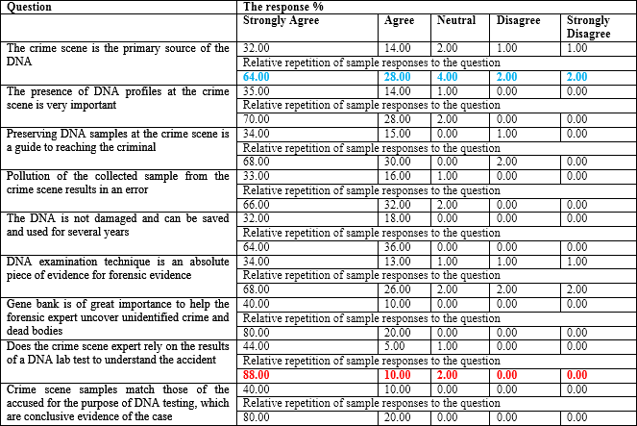

Table 8 : The rate of the respondents’ opinions about the role of DNA in condemning or exonerating the accused.

No. question | Arithmetic medium | Standard deviation | Hypothetical medium | Value  Chi-square | Probability value | Degree of opinion | Opinion leveled
9 | 4.69 | 1.60 | 3 | 46.56 | 0.001** | 92.65 | High
Source:-preparing the researcher from the applied study 2019
Table 9 : The arithmetic mean for all questions.

Question | Weighted arithmetic medium | Standard deviation | Freedom degree (df) | Value  Chi-square | Probability value
Genetic fingerprint has a critical role to play in convicting or acquitting suspects of a crime | 4.68 | 1.554 | 2 | 54.78 | 0.001^{xx}
Determining the source of the samples collected from the crime scene plays a role in changing the course of cases, especially rape | 4.56 | 1.457 | 4 | 82.80 | 0.001^{xx}
The results of the genetic fingerprint examination are considered evidence for accepting doubt and suspicion | 4.56 | 1.360 | 2 | 24.17 | 0.001^{xx}
DNA scans are used in the Iraqi judiciary to demonstrate yield and affiliation for individuals | 4.88 | 1.925 | 1 | 28.88 | 0.001^{xx}
DNA results may be judged in criminal cases | 4.72 | 1.594 | 2 | 40.86 | 0.001^{xx}
It is possible to rely on the results of DNA tests with cases of investigating missing and unidentified bodies | 4.62 | 1.462 | 3 | 75.40 | 0.001^{xx}
Iraqi legislation adopts the results of DNA tests as conclusive evidence to convict or acquit the accused | 4.54 | 1.336 | 3 | 62.20 | 0.001^{xx}
The testimony of experts involved in DNA testing is necessary before the courts | 4.80 | 1.734 | 1 | 18.00 | 0.001^{xx}
Genetic fingerprint analysis is an effective method in terms of proving or denying the crime with complete accuracy. | 4.90 | 1.975 | 1 | 32.00 | 0.001^{xx}

respondents are strongly agree about Crime scene is the primary source of nuclear collection samples, 28% Agree, 4% Neural, 2% Disagree, 2% Strongly Disagree.
The second axis the role of DNA in condemning or exonerating the accused
From Table 8, the average respondents’ opinions on the role of DNA in condemning or exonerating the accused amounted to 4.69 a high level compared to the hypothetical level (3) and the percentage of Chi-square reached 46.56 with a probability value of 0.001%, which is statistically significant at the level of 5% and the degree of opinion reached 92.65%, which is also very high.
These results confirm that the DNA has a significant and important role in the field of convicting or acquitting the accused and helped in achieving justice in society.
We noted from Table 9, that the arithmetic mean for all questions is greater than the hypothetical mean (3) and this indicates that the respondents’ answers to the questions of this axis were their agreement to them.
As for the standard deviation, it ranges between (1.336-1.975). This indicates the homogeneity of the respondents’ answers.
Given the probability value of all the questions, we find that it is less than 0.05 and this indicates that there are statistically significant differences that is, the respondents’ answers are biased to answer without the other. Through this we confirm the consistency of the hypothesis of the second axis hypothesis: The role of DNA in condemning or exonerating the accused.
From Table 10, we find that 90% respondents are strongly agree about Iraqi legislation adopts the results of DNA tests as conclusive evidence to convict or acquit the accused, while 10% Agee. While, we find that 62% respondents are strongly agree about DNA scans are used to detect all crimes, 32% Agee, 4% Neural, 2% Disagree, 2% Strongly Disagree.
The third axis the use of the DNA in Iraqi forensic evidence
From Table 11, the average respondents ’opinions on the rate of the respondents’ opinions about the use of the DNA in Iraqi forensic evidence amounted to 4.78 a high level compared to the hypothetical level (3) and the percentage of Chi-square reached 44.36 with a probability value of 0.001% which is statistically significant at the

Table 10 : Trends of respondents’ opinions about the role of DNA in condemning or exonerating the accused.
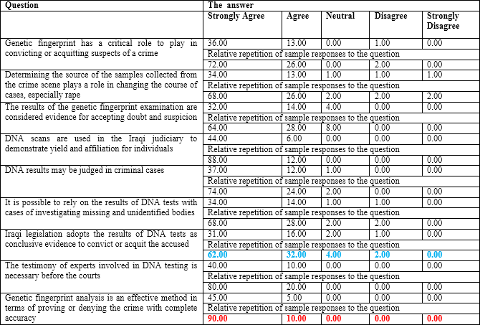

Source: preparing the researcher from the applied study 2019.
Table 11 : The rate of the respondents’ opinions about the use of the DNA in Iraqi forensic evidence.

No. question | Arithmetic medium | Standard deviation | Hypothetical medium | Value  Chi-square | Probability value | Degree of opinion | Opinion leveled
9 | 4.78 | 1.75 | 3 | 44.36 | 0.001** | 93.90 | High

Source:-preparing the researcher from the applied study 2019.
level of 5% and the degree of opinion reached 93.90 which is also very high.
The results indicated that the genetic fingerprint is one of the modern scientific methods used in laboratories of forensic medicine and Iraqi forensic evidence, which contributed effectively to the identification of unidentified bodies and the identification of the remains of the unknown.
We noted Table 12 that the arithmetic mean for all questions is greater than the hypothetical mean (3) and this indicates that the respondents’ answers to the questions of this axis were their agreement to them.
As for the standard deviation, it ranges between (1.462-2.026). This indicates the homogeneity of the respondents’ answers.
Given the probability value of all the questions, we

find that it is less than 0.05 and this indicates that there are statistically significant differences that is, the respondents’ answers are biased to answer without the other. Through this we confirm the consistency of the hypothesis of the third axis hypothesis:
The using of the DNA in Iraqi forensic evidence.
From Table 13, we find that 92% respondents are strongly agree about Genetic fingerprinting tests are used forensic medicine and the Directorate of Criminal Evidence, while 8% Agee. While, we find that 68% respondents are strongly agree about Is there a link between criminal excreta crime scene and the suspect by examining DNA samples, 28% Agee, 2% Neural, 2% Disagree.
DISCUSSION
The study showed that there are high significant

Table 12 : Different opinion levels of the respondents about the use of the DNA in Iraqi forensic evidence.

Question | Arithmetic medium | Standard deviation | Freedom degree (df) | Value Chi- square | Probability value
The use of the genetic fingerprint has led to scientific progress in the field of forensic science | 4.78 | 1.729 | 2 | 50.94 | 0.001^{xx}
The Criminal Evidence Directorate has contributed to resolving many Iraqi criminal cases by way of DNA | 4.90 | 1.975 | 1 | 32.00 | 0.001^{xx}
Genetic fingerprint checks are a modern scientific method for resolving criminal cases | 4.78 | 1.729 | 2 | 50.94 | 0.001^{xx}
Is there a link between criminal excreta crime scene and the suspect by examining DNA samples | 4.78 | 1.729 | 2 | 50.94 | 0.001^{xx}
Are DNA fingerprint examinations important to Iraqi society | 4.74 | 1.637 | 2 | 43.98 | 0.001^{xx}
Are genetic fingerprinting tests have contributed to solving many of the crimes quickly | 4.82 | 1.781 | 1 | 20.48 | 0.001^{xx}
Genetic fingerprint checks contributed significantly to resolving issues because of their association with different bodily fluids | 4.62 | 1.462 | 3 | 58.32 | 0.001^{xx}
Genetic fingerprinting tests are used forensic medicine and the Directorate of Criminal Evidence | 4.76 | 1.682 | 2 | 47.34 | 0.001^{xx}
DNA tests provided in support of the Iraqi forensic experts | 4.92 | 2.026 | 1 | 35.28 | 0.001^{xx}
Table 13 : Trends of respondents’ opinions about the use of the DNA in Iraqi forensic evidence.
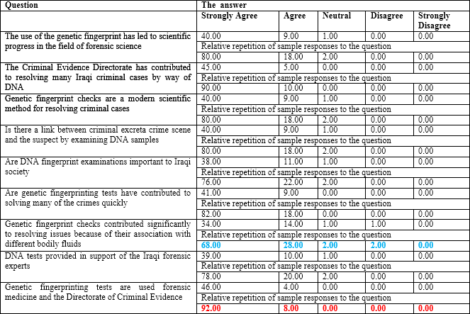

Source: preparing the researcher from the applied study 2019.

differences among the studied classification of demographical characteristics aspects at P<0.05. Through the results of the first axis, in which the researcher believes
that the presence of a genetic fingerprint at the crime scene is a guideline evidence in forensic evidence, from Table 5, which explains trends of respondents’ opinions

on the presence of a crime scene DNA is a scientific evidence in forensic evidence and Table 6 that explains the different opinion levels of the respondents about the presence of a crime scene DNA is a scientific evidence in forensic evidence. We found that the result was positive with the hypothesis and this indicates that the DNA fingerprint samples present in the crime scene are important as scientific evidence is based on in forensic evidence. and this result is consistent with Nisreen (2015) found, the DNA is of criminal significance in the crime scene as a forensic evidence (Nisreen, 2015) and this result also supported the study of Al-Taher (2014), which showed that one of the most important obstacles to using the genetic fingerprint of the crime scene is the occurrence of an error during the collection of samples or the exposure of the sample to pollution. Also study by Fisher (2004), the collection of forensic evidence and the application of forensic sciences have become essential to criminal investigations and prosecutions; Forensic evidence fulfills several roles in criminal investigations. As for the analysis of the second axis in which the researcher assumed that there is a role for the DNA in condemning and exonerating the accused, the result was identical to the hypothesis and this is evident from Table 8 that explains the rate of the respondents’ opinions about the role of DNA in condemning or exonerating the accused. This result supports many studies, including one Helena and Susan (2019) that I concluded Forensic DNA testing is a powerful tool used to identify, convict and exonerate individuals charged of criminal offenses (Helena and Susan, 2019) and Nirpat et al (2013). DNA profiling is a technique by which an individual can be identified at molecular level. The use of DNA testing in criminal investigations in recent years has helped law enforcement in particular to identify criminals and solve difficult crimes such as rape, murder and murder using rape.
As for the results of the third axis, in which the researcher believes that the use of the DNA in the Iraqi forensic evidence was effective in speeding up the detection of crimes, it came in accordance with the assumption through the results of Table 11, which shows the rate of the respondents’ opinions about the use of the DNA in Iraqi forensic evidence.
This finding supported the study of both Nasr (2017), which concluded that the largest percentage of judges in their various degrees confirms that the genetic footprint is clear and understandable and serves the required purpose before the courts. Hodge (2018), who deduced the discovery of DNA evidence has dramatically changed the criminal justice landscape and offers objective
evidence that can either convict or exonerate a suspect.
CONCLUSION AND RECOMMENDATION
These results confirm the need for continued DNA testing and taking results, due to their accuracy, in order to quickly detect unknown crimes and corpses. With regard to DNA tests and their use on the criminal side, more health and justice education programs and more research are needed to increase knowledge about the importance of DNA at the crime scene and to take its results even, if laws do not provide for it.
REFERENCES
Ahmed F (2002) The DNA its role in forensic evidence between sharia and law. Naïf Academy for Security Sciences.
AL-Tahr N (2014) Obstacies to applying the DNA in Sudanese criminal laboratory. University of Rabat, College of Graduate Studies and Research.
Daniel A (2019) Fingerprints and paternity testing, a study of genetics and probability in pre- DNA forensic science. Law, probability and Risk 18, 117-129. 2-3.
Fisher A (2004) Techniques of crime scene investigation. 7th ed. New York.
Grahan A Lancook (2014) Dictionary of statistic. Oxford University Press.
Hadge S (2018) Current controversies in the use of DNA in forensic investigation. University of Baltimore law Review, 48.
Helena M and Susan S (2019) What influences public view on forensic DNA testing in the criminal field. Human Genetics 13(1), 205- 209.
Karthavya S and Nithya J (2014) Role of DNA in forensic identification. Indian J. Forensic Med. Toxicol. 8(2), 43.
Magalhães T, Dinis-Oliveira R J, Silva B, Corte-Real F and Nuno Vieira D (2015) Biological Evidence Management for DNA analysis in cases of sexual assault. Scientific World J. 2015, 365674. doi: 10.1155/2015/365674
Nasr (2017) The DNA and the court’s authority to introduce it with criminal proof. J. Legal Sci. 32(2).
Nirpat P et al (2013) The role of DNA in criminal investigation Admissibility in India legal system and future perspectives. Int.
J. Humanities 2, 15-21.
Nisreen A (2015). The criminal significance of a genetic fingerprint at the crime scene. University of Rabat, College of Graduate Studies and Research.
Panneerch S and Norazmi M (2003) Forensic DNA profiling and database. Malays. J. Med. Sci. 10(2), 20-26.
Postconviction DNA testing, National institute of justice (2018) Rana S (2005) Discovery, development, and current application of
DNA identity testing. Bayl Univ. Med. Cent. 18(2), 130-133.
Rasmus N, Akey J M, Jakobsson M, Pritchard J K, Tishkoff S, and Willerslev E (2017) Tracing the peopling of the world through genomics. Nature 541, 302-310.
Subhash C (2011) DNA profiling and the forensic use of DNA evidence in criminal processing. J. India Law Institute 53, 2, 195-226.
Zanati M S (2018) The importance of DNA in forensic evidence. J. Univ. faculty of Law pp 34- 49.

