**Effect of Gamma Radiation on the Structural, Morphological, and Optical Characteristics of SnO2 Nano Film**

Ola Mohammed firas*, Basim Khalaf Rejah*

*Department of Physics, College of Science for Women, University of Baghdad, Baghdad, Iraq.*

*Ula.Abdullah1604@csw.uobaghdad.edu.iq*

*basimkr_phys@csw.uobaghdad.edu.iq*

|  |
| --- |
| **Article Info.**  **Keywords**:  *SnO2, gamma, radiation, pulsed, laser deposition.* |

**Abstract**

In this study, the fabrication of tin oxide thin film using pulsed laser deposition technique is reported in detail. Further, the effect of 60Co gamma radiation on the structural, morphological, and optical features is systematically demonstrated using x-ray diffraction (XRD), field emission scanning electron microscopy (FE-SEM), atomic force microscopy (AFM), and ultraviolet visible light analysis (UV-Vis). Particularly, the attained crystallite size was found to be decreased from 45.5 to 40.8 nm for pristine and sample irradiated using 1200 Gy 60Co gamma source, respectively. The particle diameter, using FESEM analysis, revealed similar trend to that attained using XRD; in particular, the average diameters were perceived as 93.8 and 79.9 nm for the aforementioned samples. Contrariwise, the calculated optical band gap demonstrated a decreasing profile where optical band gaps of 3.08 and 3.24 eV were acquired for pristine and sample irradiated with 1200 Gy.

**1. Introduction**

Owing to the great potential applications of metal oxide nanoparticles in various fields, the alteration of their physical characteristics is being considered of pronounced importance within research society. Metal oxide semiconductors, particularly, are well-known for their attractive magnetic, electrical, and optical characteristics [1-4]. Furthermore, these physical characteristics of metal oxide semiconductors, structural, optical, electrical, etc., are significantly altered upon the exposure to ionizing radiation, gamma radiation in particular [5-7]. Herein, it is noteworthy to mention that gamma radiation has excessive influence on the addressed characteristics. These changes depend on the irradiation dosage as well as sensibility of the solid-thin film towards specific radiation [8, 9]. In detail, when gamma radiations with adequate level of energy interact with metal oxide semiconductor, ionization as well as atomic disorientation is occurred. Continuously, gamma irradiation of metal oxide semiconductor results in lattice defects production; for example, dislocation loops and defects clusters near the metal/oxide interface [10-14]. These drawbacks may, in turn, lead to low device performance in the target application such as optical communication devices, solar cells, photodetectors, light emitting diodes, and optical dosimeters [15, 16]. Therefore, a sound investigation of the addressed damages and their effects on the physical characteristics is being well-inspected on a number of metal oxide semiconductors. Among different metal oxide semiconductors, tin oxide (SnO2) nanoparticle is well-thought-out n-type semiconductor with wide energy band gap (3.6 eV) and high chemical and mechanical stability [17]. Such properties allow SnO2 to be of great interest in many applications such as liquid crystal displays, far-infrared detectors, heat-reflecting mirrors, solid-state gas sensors, optoelectronic devices [18-21].

In this attempt, this study reports the effect of 60Co gamma irradiation (300, 900, and 1200 Gy) on the structural, morphological, and optical characteristics of SnO2 nano film deposited using pulsed laser deposition technique. Further, the stated characteristics are examined as a function of the utilized dose range. It was found that higher dose of the applied gamma radiation resulted in reduction in the crystallite and particle size; inversely, an increment behavior was observed in the optical band gap profile.

**2. Methodology**

Deposition of SnO2 nano film was achieved via the well-established pulsed laser deposition technique on glass substrate under high-vacuum environment; the glass substrate/s was subject to multi-cycle washing process using soppy water, ethanol, and acetone, respectively. The SnO2 powder was mechanically pressed under 5 tons for 20 minutes to obtain the deposition target. Prior to each deposition processes, the chamber, within which the deposition took place, was evacuated and heated to remove any possible water vapor and/or contaminants. Subsequently, the glass substrate/s was placed in a vertical alignment at 10cm distance to the utilized SnO2 target. Herein, the SnO2 target was exposed to Nd:YAG laser with wavelength of 1064 nm and energy of 300 mJ, while the number of pulses and repetition rate were 60 pulses and 6 Hz, respectively. Hereinafter, the attained SnO2 nano films were exposed to 60Co gamma radiation source with dose rate of 12 Gy/hr using different doses (300, 900, and 1200 Gy) under air atmosphere and room temperature (27 ± 1 °C).

X-ray diffractometer with Cu-Kα radiation and wavelength λ = 1.541A° (XRD, Shimadzu 6000) was employed to examine the effect of gamma radiation on the structural characteristics on the deposited SnO2 nano films. While the morphological and surface roughness alterations were obtained using atomic force microscopy (AFM, SPM AA3000) and field emission scanning electron microscopy (FE-SEM, SU8030). In the meanwhile, the optical properties were characterized using ultraviolet-visible light spectroscopy (UV-Vis).

**3. Results and discussion**

The XRD patterns of the deposited pristine and 60Co irradiated (300, 900, and 1200 Gy) SnO2 are illustrated in Figure 1. Specifically, diffraction peaks attained at around 26.6°, 33.9°, 37.8°, 39.0°, 51.8°, 54.8°, 54.8°, 57.8°, 61.9°, 64.8° and 66.0° are corresponded to the SnO2 crystal formation planes (110), (101), (200), (111), (221), (220), (002), (310), (112), and (301), respectively; such crystal orientations were found to be in accordance with JCPDS data report (85-0712). The acquired results were found to be in a good agreement with previously published reports [22-24]. It should be mentioned that the resultant peak intensity of (110) increased at higher gamma dose. Interestingly, the calculated crystallite size at (110) using Debye–Scherrer equation indicated smaller size as a function of dose increment (Table 1) [25]. Particularly, pristine sample (control) exhibited crystallite size of 45.5 nm, while samples irradiated at 300, 900, and 1200 Gy demonstrated sizes of 44.5, 41.2, 40.8 nm, respectively. In the meanwhile, the full-width at half maximum (FWHM) showed an inverse profile wherein higher gamma dose resulted in lower crystallinity [26].

Figure 2 (a-d) elucidates the FE-SEM topographies of the deposited pristine and 60Co irradiated (300, 900, and 1200 Gy) SnO2 films, wherein all deposited samples, with respect to the radiation statues, revealed well-compacted surfaces. It can be clearly observed that the deposited particles have an obvious agglomeration conduct. However, such a singularity was less noticed at higher irradiation dose, 900 Gy and above. Further, the estimated average nanoparticle diameters showed a decreasing behavior as the irradiation dose increased. In detail, pristine SnO2 demonstrated an average diameter of 93.8 nm (Figure 2, a); thereafter, the attained nanoparticle diameters were found to be 86.9, 82.4, and 79.7 nm for irradiation doses of 300, 900, and 1200 Gy, respectively.



**Figure 1**: XRD patterns of pristine and 60Co irradiated SnO2 films.

**Table 1**: In-depth XRD parameters of the deposited SnO2 films at 26.6° (110).

|  |  |  |  |
| --- | --- | --- | --- |
| **Sample** | **2-theta (deg.)** | **FWHM** | **Crystallite size (nm)** |
| **Control** | 26.68 | 0.180 | 45.5 |
| **300 Gy** | 26.58 | 0.184 | 44.5 |
| **900 Gy** | 26.62 | 0.198 | 41.2 |
| **1200 Gy** | 26.64 | 0.200 | 40.8 |

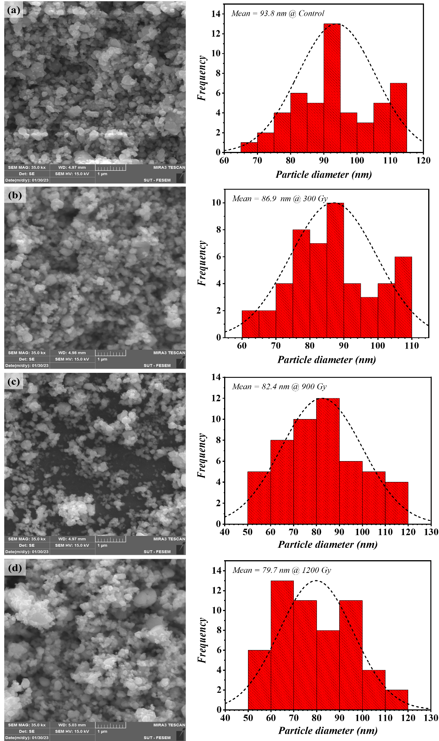

**Figure 2**: FE-SEM topographies of (a) control, (b) 300 Gy, (c) 900 Gy, and (d) 1200 Gy.

The surface roughness and morphology of the deposited samples as well as the effect of gamma radiation were also investigated using AFM technique. The AFM images are presented in Figure 3 (a-d). The surface roughness of pristine SnO2 was found to be 52.6 nm; while exposing SnO2 film to 300 Gy resulted in an increase of the surface roughness (60.9 nm). This was followed by an enhanced surface roughness of 64.2 nm at 900 Gy before being further decreased to 17.9 nm at 1200 Gy. The root mean square of the deposited films was found to be 61.9, 74.6, 87.82, and 32.25 nm for pristine and irradiated (300, 900, and 1200 Gy) SnO2, respectively.

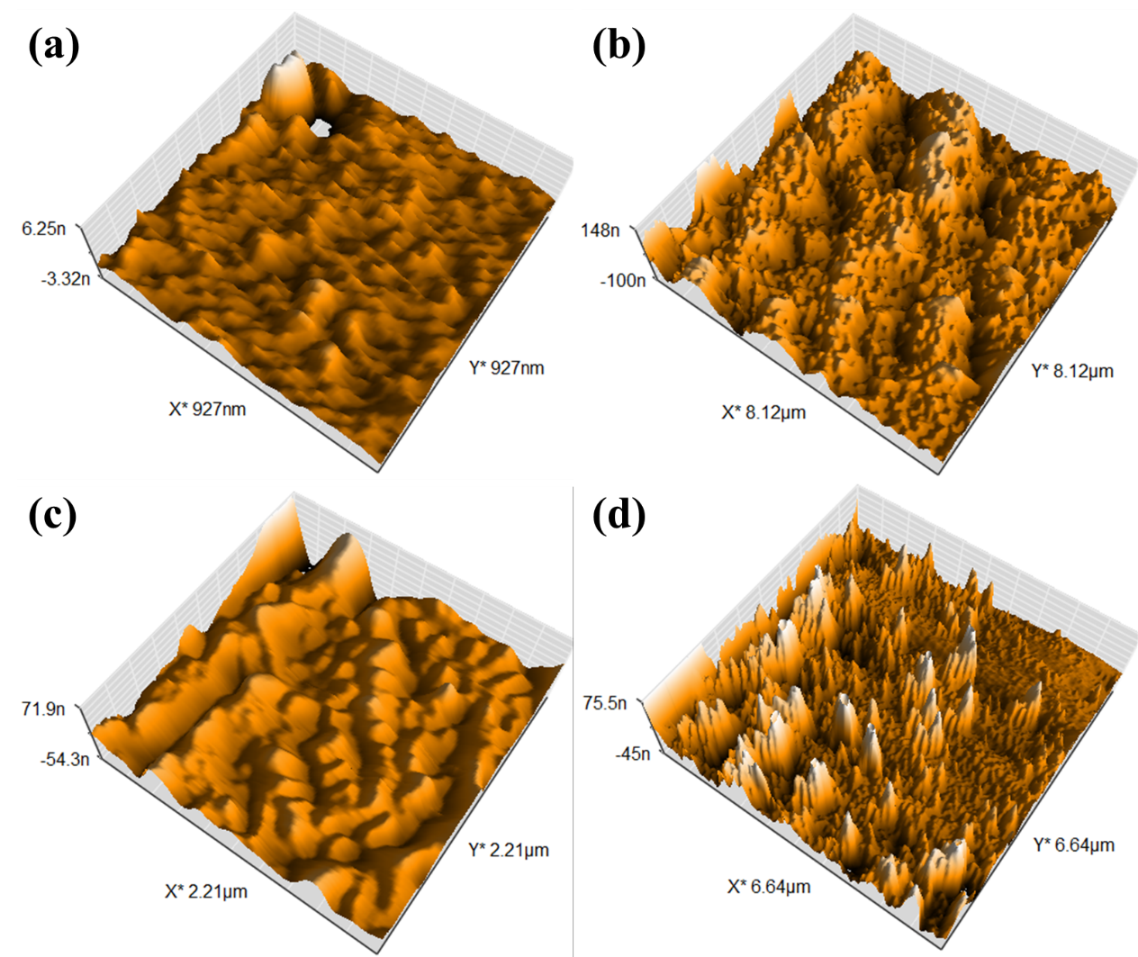

**Figure 3**: AFM images of (a) pristine SnO2, (b) 300 Gy, (c) 900 Gy, and (d) 1200 Gy.

Figure 4 elucidates the absorbance spectra of pristine as well as 60Co irradiated (300, 900, and 1200 Gy) SnO2 films, wherein a clear cut-off phenomenon is attained at around 330 nm. This in turn is corresponded to the crystal formation of SnO2 nanoparticles. Further, a slight blue shift towards higher wavelength is attained at higher 60Co irradiation dose. The optical band gap, obtained using Tauc relation [27], is demonstrated in Figure 5. Pristine sample revealed the occurrence of 3.08 eV optical band gap whereas higher optical band gaps of 3.17 and 3.24 eV were noticed at higher gamma irradiation doses. The obtained results were found to be in good agreement with previously published data [28, 29].



**Figure 4**: Absorbance spectra of pristine and 60Co irradiated SnO2 films.

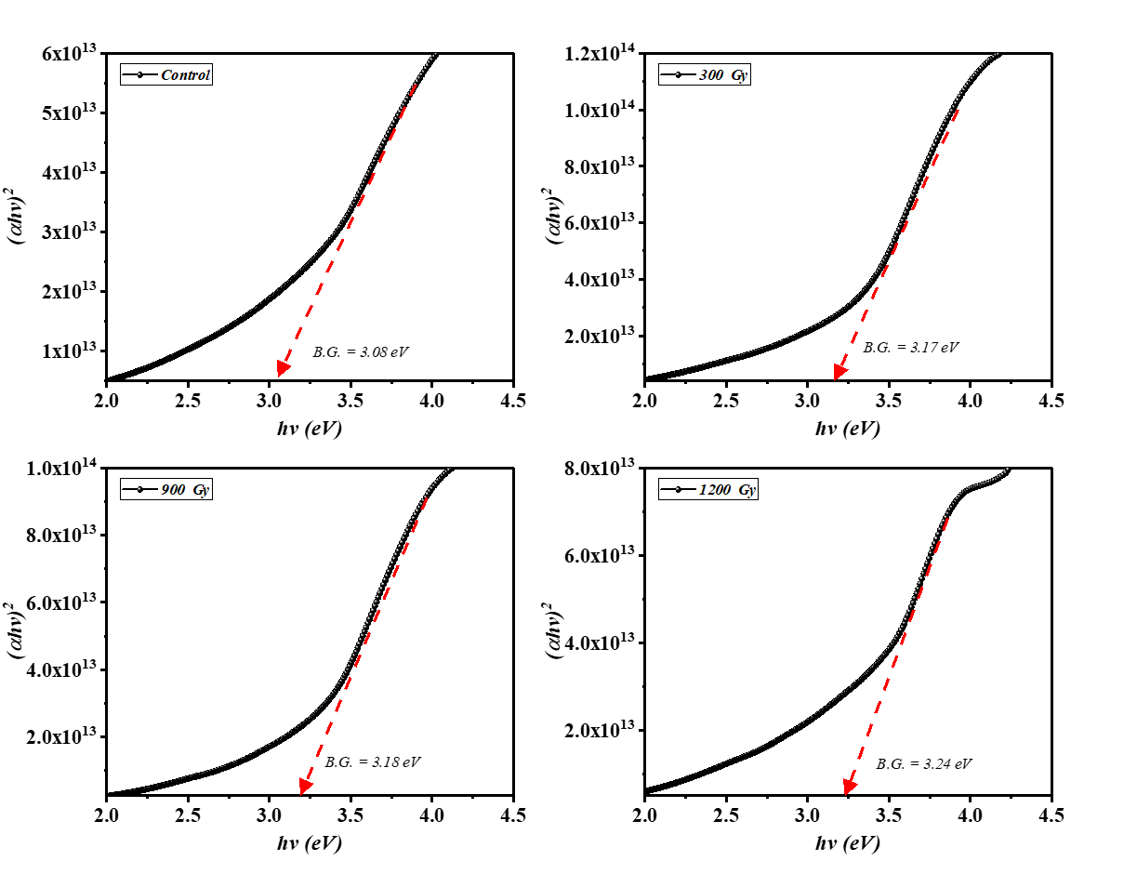

**Figure 5**: Optical bang gap of pristine and 60Co irradiated SnO2 films.

**4. Conclusion**

SnO2 was successfully prepared using pulsed laser deposition technique. The influence of 60Co gamma radiation using different doses (300, 900, and 1200 Gy) on the structural, morphological, and optical characteristics is comprehensively illustrated using (XRD), (FE-SEM), (AFM), and (UV-Vis) techniques .In detail, it was found that the obtained crystallite size was reduced from 45.5 to 40.8 nm for pristine sample and sample treated using irradiation dose of 1200 Gy, respectively, FE-SEM analysis of particle diameter indicated a similar tendency to that obtained using XRD technique ; in particular, the average diameters were perceived as 93.8 and 79.9 nm for the aforementioned samples. In contrast, the estimated optical band gap showed a decreasing profile, with optical band gaps of 3.08 , 3.17 and 3.24 eV obtained for pristine and sample irradiated with 300 and1200 Gy, respectively.

**Data availability statement**

All data that support the findings of this study are included within the article (and any supplementary files).

**Funding statement**

There is no funding source for this study.

**Ethical compliance**

I will continue to learn, observe, read, connect, listen, and search for knowledge.

**Conflict of interest declaration**

The authors declare that they have no affiliations with or involvement in any organization or entity with any financial interest in the subject matter or materials discussed in this manuscript.

**ORCID iDs https://orcid.org/0009-0001-5793-6884**

**References**

1. Salih, E. Y., Bashir, M. B. A., Rajpar, A. H., Badruddin, I. A., and Bahmanrokh, G., *Rapid fabrication of NiO/porous Si film for ultra-violate photodetector: The effect of laser energy.* Microelectronic Engineering, 2022. **258**: p. 111758.

2. Salleh, F., Usop, R., Saugi, N. S., Salih, E. Y., Mohamad, M., Ikeda, H., et al., *Influence of TiO2 layer's nanostructure on its thermoelectric power factor.* Applied Surface Science, 2019. **497**: p. 143736.

3. Sun, C., Yang, J., Xu, M., Cui, Y., Ren, W., Zhang, J., et al., *Recent intensification strategies of SnO2-based photocatalysts: A review.* Chemical Engineering Journal, 2022. **427**: p. 131564.

4. Iltaif, A.-H. K., Jabor, A. A., Mukalaf, R. H., Abood, M. A., and Khalad, F. G., *Study the effective of annealing on the structural and sensitivity properties for SnO2 thin films to CO2 Gas.* Baghdad Science Journal, 2011. **8**(2عدد خاص بمؤتمر الفيزياء).

5. Sen, S. K., Noor, M., Al Mamun, M., Manir, M., Matin, M., Hakim, M., et al., *An investigation of 60Co gamma radiation-induced effects on the properties of nanostructured α-MoO3 for the application in optoelectronic and photonic devices.* Optical and Quantum Electronics, 2019. **51**(3): p. 1-15.

6. Ali, S. M., AlGarawi, M., Khan, S. U.-D., and Aldawood, S., *Nanostructure, optical and electrical response of gamma ray radiated PdS/p-Si heterojunction.* Materials Science in Semiconductor Processing, 2021. **122**: p. 105474.

7. Yasmin, S. and Sayyed, M., *Enhancing the radiation absorption ability of the glass system with the contamination of Heavy Metal Oxide (PbO, CuO, and Bi2O3)‏.* Optik, 2023. **272**: p. 170218.

8. Darwish, A., Issa, S. A., and El-Nahass, M., *Effect of gamma irradiation on structural, electrical and optical properties of nanostructure thin films of nickel phthalocyanine.* Synthetic Metals, 2016. **215**: p. 200-206.

9. Holmes-Siedle, A. and Adams, L., *Handbook of Radiation Effects, Oxford University Press*. 2002, USA.

10. Selçuk, A. B., Ocak, S. B., and Yüksel, Ö. F., *Effects of gamma irradiation on dielectric characteristics of SnO2 thin films.* Nuclear Instruments and Methods in Physics Research Section A: Accelerators, Spectrometers, Detectors and Associated Equipment, 2008. **594**(3): p. 395-399.

11. Lavanya, N., Sekar, C., Anithaa, A., Sudhan, N., Asokan, K., Bonavita, A., et al., *Investigations on the effect of gamma-ray irradiation on the gas sensing properties of SnO2 nanoparticles.* Nanotechnology, 2016. **27**(38): p. 385502.

12. Abhirami, K., Sathyamoorthy, R., and Asokan, K., *Structural, optical and electrical properties of gamma irradiated SnO thin films.* Radiation physics and chemistry, 2013. **91**: p. 35-39.

13. Wasly, H., El-Sadek, A., Elnobi, S., and Abuelwafa, A. A., *Morphological, structural, and optical properties of flexible Tin Oxide (II) thin film via thermal evaporation technique.* The European Physical Journal Plus, 2022. **137**(1): p. 1-10.

14. Khalil, S. G., Ameen, M. A., and Jubier, N. J., *Effect of laser irradiation on the optical properties of SnO2 films deposited by post oxidation of metal films.* Baghdad Science Journal, 2011. **8**(4).

15. Souli, M., Nefzi, C., Seboui, Z., Mejri, A., Vidu, R., and Kamoun-Turki, N., *Improved structural properties, morphological and optical behaviors of sprayed Cu2ZnSnS4 thin films induced by high gamma radiations for solar cells.* Materials Science in Semiconductor Processing, 2018. **83**: p. 50-57.

16. Bashir, M. B. A., Salih, E. Y., Rajpar, A. H., Bahmanrokh, G., and Sabri, M. F. M., *The impact of laser energy on the photoresponsive characteristics of CdO/Si visible light photodetector.* Journal of Micromechanics and Microengineering, 2022. **32**(8): p. 085006.

17. Abdullah, H., Al-Taay, H., Khalaf, M., Oleiwi, H., and Rahma, A. *Structure, Morphology and Optical Properties of SnO2 Nanoparticle Synthesized via Ultrasonic Spray Pyrolysis Technique: Effect of CuO Doping Concentration*. in *Journal of Physics: Conference Series*. 2021. IOP Publishing.

18. Hadi, N. M. and Ammar, K. A. *Effect of polysiloxane Liquid Crystal Polymer on tin Oxide (SnO2) Nanoparticles Properties for Humidity and Climate Components Sensors*. in *IOP Conference Series: Materials Science and Engineering*. 2020. IOP Publishing.

19. Zhang, Z., Xu, M., Ruan, X., Yan, J., Yun, J., Zhao, W., et al., *Enhanced radar and infrared compatible stealth properties in hierarchical SnO2@ ZnO nanostructures.* Ceramics International, 2017. **43**(3): p. 3443-3447.

20. Alhuthali, A., El-Nahass, M., Atta, A., Abd El-Raheem, M., Elsabawy, K. M., and Hassanien, A., *Study of topological morphology and optical properties of SnO2 thin films deposited by RF sputtering technique.* Journal of Luminescence, 2015. **158**: p. 165-171.

21. Salih, E. Y., Bashir, M. B. A., Rajpar, A. H., and Badruddin, I. A., *Fabrication and characterization of porous Si/CuO film for visible light MSM photodetector: The effect of post-processing temperature.* Ceramics International, 2022. **48**(7): p. 9965-9972.

22. Kumar, S., *Exploration of structural, morphological and magnetic properties of transition metal doped SnO2 films grown using pulsed laser deposition.* Vacuum, 2020. **182**: p. 109725.

23. Ke, C., Zhu, W., Pan, J., and Yang, Z., *Annealing temperature dependent oxygen vacancy behavior in SnO2 thin films fabricated by pulsed laser deposition.* Current Applied Physics, 2011. **11**(3): p. S306-S309.

24. Hassan, J. *Hydrothermal Synthesis and Characterization of SnO2 Nanosheets*. in *Advanced Materials Research*. 2023. Trans Tech Publ.

25. Holzwarth, U. and Gibson, N., *The Scherrer equation versus the'Debye-Scherrer equation'.* Nature nanotechnology, 2011. **6**(9): p. 534-534.

26. Salih, E. Y., Ramizy, A., Aldaghri, O., Sabri, M. F. M., Madkhali, N., Alinad, T., et al., *Rapid Synthesis of Hexagonal-Shaped Zn (Al) O-MMO Nanorods for Dye-Sensitized Solar Cell Using Zn/Al-LDH as Precursor.* Nanomaterials, 2022. **12**(9): p. 1477.

27. Bashir, M. B. A., Rajpar, A. H., Salih, E. Y., and Ahmed, E. M., *Preparation and Photovoltaic Evaluation of CuO@ Zn (Al) O-Mixed Metal Oxides for Dye Sensitized Solar Cell.* Nanomaterials, 2023. **13**(5): p. 802.

28. Abdalameer, N. K., *Effects of cold atmospheric plasma on the optical properties of SnO2 thin film.* Advances in Natural and Applied Sciences, 2017. **11**(9): p. 357-364.

29. Aadim, K. A. and Essa, M. A., *Structural and Optical properties of SnO2 doped ZnOthin films prepared by Pulsed Nd: YAG Laser Deposition.* Journal of College of Education, 2019. **3**(3).