**Acinetobacter baumanni in Ciconia ciconia as Potential Host for Coronavirus Strains**

**Mosab Nouraldein Mohammed Hamad**

**Affiliation:**

phylum of Medical Parasitology, Department of Medical Laboratory Sciences, Faculty of Health Science, Elsheikh Abdallah Elbadri University, Berber, Sudan.

**Corresponding author:** Mosab Nouraldein Mohammed Hamad

**Corresponding Email:** [**musab.noor13@gmail.com**](mailto:musab.noor13@gmail.com)

**Mobile number: 00249929194137**

**ORCID id: https://orcid.org/0000-0002-7819-3258.**

**Abstract**

Acinetobacter baumanni in white storks (Ciconia ciconia) is the main host of coronavirus strains, and have ability to convert coronavirus from each strain to another, occurrence of outbreaks of SARS-CoV-2 VUI 202012/01, in a year of reappearance of white storks in England, concentration of new variant strain of coronavirus in south-east part of the Britain, huge amount of visitors to hatched white storks and presence of Acinetobacter baumanni in nesting of this endangered migratory bird , power the linkage between bacteria, virus and bird.

Furthermore outbreaks of Middle East respiratory syndrome in Saudi Arabia after death of huge amount of white storks in southern area to Jeddah city, certainly Wadi Al-Dawasir Province, and later outbreak of MERS in Saudi Arabia with more concentration in Wadi Al-Dawasir. Also artificial nesting of white storks in The Honghe Nature Reserve in northeast China's Heilongjiang province and Acinetobacter baumanni outbreaks in China predisposing factors for SARS COV-1 and SARS COV-2. Overlapping coding sequencing required to follow-up the potential relation between coronavirus strains, Acinetobacter baumanni and the white storks.

**Keywords:** SARS COV-1, SARS COV-2, SARS-CoV-2 VUI 202012/01, MERS, Acinetobacter baumanni, white storks

**Introduction:**

The White Stork (Ciconia ciconia) is recognized as a public and well-known anthropophilic bird in Europe. Though, the entire population has dropped for several causes since the 1950s but has become constant in latest eras at an inferior level, because of synthetic nest places and numerous preservation methods [1].

From 2003 to 2008, over 600 Ciconia ciconia nestlings in the German federal state of Brandenburg were ringed and inspected for influenza A viruses. Through the feast of highly pathogenic avian influenza virus of subtype H5N1 amongst wild birds in Germany in spring 2006, dead wild birds, counting 88 white storks, were examined for infection with HPAIV. Also, fresh fecal specimens were inspected by RT-PCR to screen the existence of HPAIV in mature storks. Though the observing of nestlings and grownup white storks unsuccessful to yield indication of influenza A virus infections in these birds, two storks found dead in April 2006 in the identical site examined positive for HPAIV H5N1. Sequence analysis discovered that the virus isolated from one of the storks belonged to clade 2.2, which was frequently found in wild birds in the north of Germany and other European countries throughout the epidemic in 2006. In spite of these two incidents, Ciconia ciconia looked to function as neither a vector nor as a reservoir for HPAIV in Germany. The jeopardy of white storks transmitting HPAIV to domestic poultry and humans is low [2].

No one distinguishes for certain why storks missing from Britain, though their presence on the menus of feudal banquets proposes that they may simply have been targeted for food. In spite of their 600-year absence, though, white storks have continued a significant sign, containing in traditional stories, and floodlit documents, on pub and hotel signs, and in family designations and names down the centuries. The White Stork Scheme expectations that enthusiasm about the reappearance of these magnetic birds will stimulus better public attention in environment retrieval in the U.K. and, maybe, cover the way for more species restorations.

In current months, the strangers at Knepp certainly have been a reason for festivity—an interruption from the depressed figures of COVID-19 and an emphasis of community understanding, their activities even apparent to reflect those of persons under lockdown. At the end of March as persons squatted at home, the white storks instigated hatching their eggs. In mid-May with travel limits to nature parts in the U.K. lifted, the two sets of eggs hatched, letting hundreds of visitors to see the chicks for themselves, and this may be the starting point of new strain of COVID-19 in UK.

In the previous few days, the primarily set of hatchlings have fledged the nest, flying down to the earth to feed on grasshoppers under the watchful eye of their parents and settling in close plants at dark. Throughout the coming weeks, just as airline flights initiate opening up and people take to the skies once more, the daring young storks will fly farther afield, maybe even subsequent their parents and exploding over to Europe for an incantation [3].

The globe has been viewing with alarm meanwhile the United Kingdom recognized a novel variant of the coronavirus on December 14, which has led to a surge in new contagions through the South East of the republic. It has been stated that the transformed strain in the South East has doubled the number of cases in a week, with additional 36,804 new infections documented. The frequency of infection in East Sussex now stands at 1,862 cases per 100,000 persons [4].

The variant can currently be found ubiquitously in the UK, excluding for Northern Ireland. But it is definitely the most intense in London and the South East, where it is mainly accountable for the rising number of incidents [5].

Since then, two additional novel strains of the virus have been [recognized](https://www.aljazeera.com/news/2020/12/26/which-countries-have-reported-new-variants-of-covid-19) in South Africa and Nigeria, with incidents of all three collecting up in at least 13 countries up to now [6]. Acinetobacter baumannii is a global happening nosocomial pathogen, the normal residings of which continue to be distinct. Lately, white stork nestlings have been defined as a frequent home of A. baumanni [7].

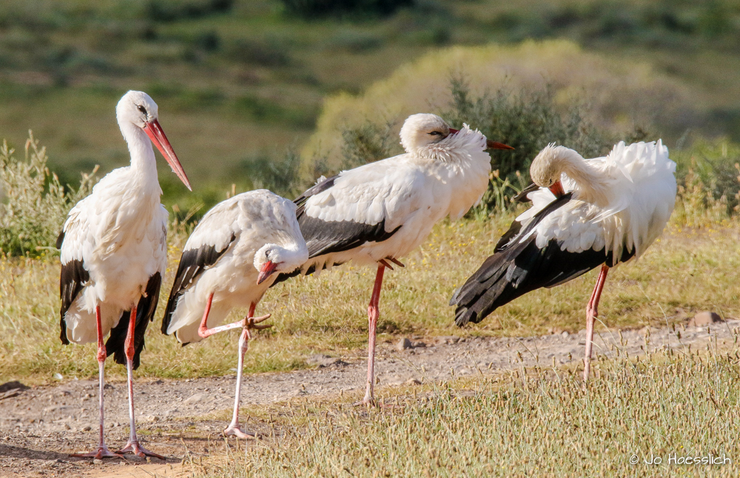

**Figure 1: Migrant White storks in South Africa** [8]

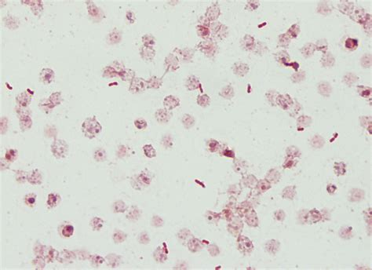

**Figure 2:** Acinetobacter baumanni gram stain morphology [9].

We hypothesize that SARS COV-2 and SARS-CoV-2 VUI 202012/01 is a natural not synthetic viruses and their natural host is a bacterial species inhabit storks, named Acinetobacter baumanni. The virus converted from SARS COV-2 to SARS-CoV-2 VUI 202012/01 and others newly observed strains , through the complete nucleotide sequence of ssRNA phage AP205 proliferating in Acinetobacter species. The RNA has big overlapping reading frame, which code for coat and replicase proteins. Their gene order as that in RNA coliphages into the genus alloleviviruses, like Q (beta), which have a coat read-through protein [10].

The East Lake environmental beautiful part is located in the east of Wuhan City. The entire picturesque zone covers 82 square kilometers, of which the water part is 33 square kilometers. It is the main city lake in China. It is popular and catches a million visitors a year, in winter, it is very entertaining to go out and enjoy the snow, the attractiveness of the desirable flowers and the flying migratory birds [11].

After breeding, the storks travel to eastern China in September and reoccurrence in March. The Oriental stork is a lonely bird excluding throughout the breeding period. Its food consists mostly of fish, frogs, insects, small birds and reptiles, in addition to rodents [12].

Sharifipour et al said that; of nineteen COVID-19 patients, 11 (58%) patients were male and 8 (42%) were female, with a mean age of ~ 67 years old. The normal ICU length of stay was ~ 15 days and at the end of the study, 18 cases (95%) died and only was 1 case (5%) discharged. In whole, all patients were found positive for bacterial infections, counting seventeen Acinetobacter baumannii (90%) and two Staphylococcus aureus (10%) strains [13].

Study done by Mohammed Shobrak in which A power line positioned 100 km south of Jeddah was observed from2008 to 2011 and the conclusions show that collision and electrocution of migratory birds by power lines are of conservation concern in Saudi Arabia, The White Stork (Ciconia ciconia), Common Quail (Coturnix coturnix), Corncrake (Crex crex) and Willow Warbler (Phylloscopus trochilus) were the most influenced species in the study zone, Amongst these large species was the White Stork, which signifies the uppermost percentage of persons of one species influenced by electrocution or collision documented in this study [14]. The Saudi Arabia Ministry of Health, has stated an upsurge in the Middle East Respiratory Syndrome Coronavirus (MERS-CoV) incidents in Wadi Al-Dawasir Province, in combination with the breeding period. In a media announcement, MOH has observed a notable rise in MERS incidents throughout the previous three weeks in the province and across Kingdom's regions, pointing out that such rise often occurs through the same era every year and is related to human direct interaction with camel, mainly through the reproducing term and camel movements [15].

Prior to over one year, a pneumonia related with the 2019 novel Covid showed up in Wuhan, China. 99 established incidents were involved. Analysis was centered on clinical and radiological features and obviously established by a real time RT-PCR. For all the cases variables linked to epidemiological, laboratory, clinical and radiological features were stated.

From the 99 incidents of with 2019-nCoV pneumonia, 49 (49%) had a history of contact to the Huanan seafood marketplace. No further respiratory viruses were visible in any of the patients. Acinetobacter baumannii, Aspergillus flavus and Klebsiella pneumoniae were isolated from single patient, with A. baumannii to be extremely resistant to antibiotics [16].

The Honghe Nature Reserve in northeast China's Heilongjiang Area is home to the Ciconia ciconia [17]. The firstly documented [COVID-19](https://en.wikipedia.org/wiki/COVID-19) incident in the Heilongjiang region happened in [Mudanjiang](https://en.wikipedia.org/wiki/Mudanjiang) on 21 January 2020 [18].

Reuters agency announced that the northeastern Chinese border province of Heilongjiang stated 79 new introduced coronavirus incidents on 13th April. The new incidents were Chinese people who toured back from Russia, the document stated that said, of the entire number of patients, 65 were originally documented as asymptomatic cases [19].

**Conclusion:**

Of all 25 epidemic strains ofAcinetobacter, 23 were recognized as A. baumanni [20], so difference of its strains cause emergence of different strains of coronaviruses as seen in China, Britain, Nigeria and South Africa. We suggest that the COVID-19 epidemic occurred in province of Heilongjiang and then transferred to Wuhan seafood market with asymptomatic patients from northeastern Chinese border province of Heilongjiang.

**Recommendations:**

We recommended that, using Overlapping coding sequencing to assess the potential relationship between Acinetobacter baumanni strains, white storks and coronavirus strains and to know the actual starting point of the pandemic.

**Funding:**

None

**References:**

1. Kaleta EF, Kummerfeld N. Isolation of herpesvirus and Newcastle disease virus from White Storks (Ciconia ciconia) maintained at four rehabilitation centres in northern Germany during 1983 to 2001 and failure to detect antibodies against avian influenza A viruses of subtypes H5 and H7 in these birds. Avian Pathol. 2012;41(4):383-9. doi: 10.1080/03079457.2012.696312. PMID: 22834553.
2. Müller T, Hlinak A, Freuling C, Mühle RU, Engelhardt A, Globig A, Schulze C, Starick E, Eggers U, Sass B, Wallschläger D, Teifke J, Harder T, Conraths FJ. Virological monitoring of white storks (Ciconia ciconia) for avian influenza. Avian Dis. 2009 Dec;53(4):578-84. doi: 10.1637/8851-040909-Reg.1. PMID: 20095160.
3. <https://www.nationalgeographic.com/animals/2020/07/white-storks-nesting-britain-after-six-centuries/>.
4. <https://www.theargus.co.uk/news/18965499.sussex-set-tier-4-covid-19-restrictions-reports-say/>
5. https://inews.co.uk/news/health/new-covid-strain-where-uk-locations-cases-mutant-coronavirus-other-countries-travel-ban-802783.
6. Dr. Amir Khan, 31 Dec 2020, <https://www.aljazeera.com/features/2020/12/31/doctors-note-what-we-know-about-the-new-strain-of-covid-19>.
7. Łopińska A, Indykiewicz P, Skiebe E, et al. Low Occurrence of *Acinetobacter baumannii* in Gulls and Songbirds. *Pol J Microbiol*. 2020;69(1):1-6. doi:10.33073/pjm-2020-011.
8. <https://www.kariega.co.za/blog/migratory-birds-south-african-summer-safari>.
9. https://www.google.com/search?q=acinetobacter+baumannii+gram+stain+morphology&tbm=isch&ved=2ahUKEwiItYixvv_tAhXkgM4BHXyCCuYQ2-cCegQIABAA&oq=acinetobacter+baumannii+gram+stain&gs_lcp=CgNpbWcQARgBMgIIADICCAA6BAgAEEM6BggAEAgQHjoECAAQGDoECAAQHlCO8gVY0pQGYJ2lBmgAcAB4AIABvgOIAcYakgEJMC4xLjQuMy4zmAEAoAEBqgELZ3dzLXdpei1pbWfAAQE&sclient=img&ei=UZPxX8jIDeSBur4P_ISqsA4&bih=657&biw=1366#imgrc=FlUM80NBnXjFnM.
10. Klovins J, Overbeek GP, van den Worm SHE, Ackermann HW, van Duin J. Nucleotide sequence of a ssRNA phage from Acinetobacter: kinship to coliphages. J Gen Virol. 2002 Jun;83(Pt 6):1523-1533. doi: 10.1099/0022-1317-83-6-1523. PMID: 12029168.
11. <https://www.chinahighlights.com/wuhan/attraction/east-lake-park.htm>.
12. <https://en.wikipedia.org/wiki/Oriental_stork#:~:text=After%20breeding%2C%20the%20storks%20migrate,between%20two%20and%20six%20eggs>.
13. R. Nawrot, J. Barylski , Ł. Tomaszewski , L. Jerzak , A. Goździcka-Józefiak , Sz. Jędrzejewski , P. Tryjanowski, Identification of Bacterial Species in White Stork Chicks in Poland Using PCR Method and Sequencing of Bacterial 16SrRNA, Polish J. of Environ. Stud. Vol. 18, No. 2 (2009), 301-304.
14. Sharifipour, E., Shams, S., Esmkhani, M. *et al.* Evaluation of bacterial co-infections of the respiratory tract in COVID-19 patients admitted to ICU. *BMC Infect Dis* **20,**646 (2020). <https://doi.org/10.1186/s12879-020-05374-z>.
15. Mohammed Shobrak (2012) Electrocution and collision of birds with power lines in Saudi Arabia, Zoology in the Middle East, 57:1, 45-52, DOI: [10.1080/09397140.2012.10648962](https://doi.org/10.1080/09397140.2012.10648962)
16. <https://www.moh.gov.sa/en/Ministry/MediaCenter/News/Pages/News-2019-02-12-001.aspx>.
17. Chen N, Zhou M, Dong X, Qu J, Gong F, Han Y, Qiu Y, Wang J, Liu Y, Wei Y, Xia J, Yu T, Zhang X, Zhang L. Epidemiological and clinical characteristics of 99 cases of 2019 novel coronavirus pneumonia in Wuhan, China: a descriptive study. Lancet. 2020 Feb 15;395(10223):507-513. doi: 10.1016/S0140-6736(20)30211-7. Epub 2020 Jan 30. PMID: 32007143; PMCID: PMC7135076.
18. <https://news.cgtn.com/news/3d3d414e7855544f7a457a6333566d54/share_p.html>.
19. <https://en.wikipedia.org/wiki/COVID-19_pandemic_in_Heilongjiang>.
20. https://fr.reuters.com/article/uk-health-coronavirus-china-heilongjiang-idUKKCN21W01G.
21. Koeleman JG, Stoof J, Van Der Bijl MW, Vandenbroucke-Grauls CM, Savelkoul PH. Identification of epidemic strains of Acinetobacter baumannii by integrase gene PCR. *J Clin Microbiol*. 2001;39(1):8-13. doi:10.1128/JCM.39.1.8-13.2001.