IMAGE COMPERASSION
Reem Majed Adwan

Technical college of management
Department/information technology
Middle Technical University / Administrative Technical College. Zaafaraniyah
Email / reem1993maged@gmail.com
Master of Information Technology

Introduction: Nowadays, the size of storage media increases day by day. Although the largest capacity of hard disk is about two Terabytes, it is not enough large if we storage a video file without compressing it. For example, if we have a color video file stream, that is, with three 720x480 sized layer, 30 frames per second and 8 bits for each pixel. Then we need 720x480x3x8x30$≅$249Mbit/s! This equals to about 31.1MB per second. For a 650MB CD-ROM, we can only storage a video about 20 seconds long. That is why we want to do image and video compression though the capacity of storage media is quite large now.
Image compression: is a type of data compression applied to digital images, to reduce their cost for storage or transmission. Algorithms may take advantage of visual perception and the statistical properties of image data to provide superior results compared with generic compression methods
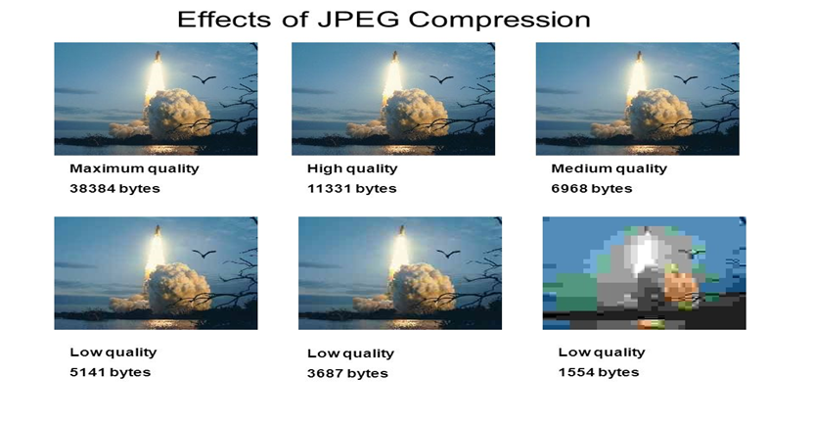

Types of compression:
- Lossless compression: image compression is a compression algorithm that allows the original image to be perfectly reconstructed from the original data.
- Lossy compression: image compression is a type of compression where a certain amount of information is discarded which means that some data are lost and hence the image cannot be decompressed with 100% originality.

Jpeg compression
JPEG is a commonly used method of lossy compression for digital images. The degree of compression can be adjusted, allowing a tradeoff between storage size and image quality with a compression ratio 10:1; but with little perceptible loss in image quality. Why JPEG? JPEG uses transform coding, it is largely based on the following observations: – A large majority of useful image contents change relatively slowly across images, i.e., it is unusual for intensity values to alter up and down several times in a small area, for example, within an 8 x 8 image block, Experiments suggest that humans are more immune to loss of higher spatial frequency components than loss of lower frequency components

Step 1 The input image is divided into smaller blocks having 8 x 8 dimensions, summing up to 64 units in total. Each of these units is called a pixel, which is the smallest unit of any image.
Step 2 - RGB to YCbCr conversion
• JPEG makes use of [Y, Cb, Cr] model instead of [R,G,B] model.
• The precision of colors suffer less (for a human eye) than the precision of contours (based on luminance)
Step 3: subtracting 128 for each pixel
Step 4: DCT (Discrete Cosine Transformation)
Step 5: QUANTAZATION
Step 6: Zig Zag Recording and run length encode

Result: Image compression is an extremely important part of modern computing. by having the ability to compress images to fraction of their original size valuable and expensive disk space can be saved. In addition, transportation of images from one computer to another becomes easier and (which is why image compression has played such as important role in the development of the internet). The JPEG image compression algorithm provides a very effective way to compress images with minimal loss in quality.
References
- Image Compression /Mark Handley
- https://www.youtube.com/user/Computerphile
- JPEG Image Compression /- K. M. Aishwarya

