The calculation of optimum tilt angle of the fixed street lighting solar panel system in Baghdad city Using PV systems Program

Baha'a A.M.Al-Hilli*, Asma'a H.Muslim*, Emad J.Mehdi*
*Al-Mustansiriyah Univ., College of Education, Phys. Dept.
**Ministry of Science & Technology, Renewable Energy directorate, Solar Cell Research centre.

E-mail: bahahilli@yahoo.com
تحديد زاوية الميل المثلى للوح الشمسي الثابت لإنارة الشوارع لمدينة بغداد باستخدام برنامج "PV Systems"

بهاء عبدالرسول مجيد*، اسماء حسن مسلم** , عماد جليل مهدي**
*الجامعة المستنصرية، كلية التربية، قسم الفيزياء
**وزارة العلوم والتكنولوجيا / دائرة الطاقات المتجددة / مركز بحوث الطاقة الشمسية
E-mail: bahahilli@yahoo.com
The calculation of optimum tilt angle of the fixed street lighting solar panel system in Baghdad city Using PV systems Program

ABSTRACT
The tilt angle for fixed solar panel is the most important affecting factors on the amount of incident solar radiation intensity on the fixed solar panel yearly. The characterized solar street light change in working hours, relative to g on the change in daylight and night hours. By using PV systems Program to determine the optimum tilt angle of fixed solar panel solar street light to all the year in Baghdad city, and it is found that the optimum tilt angle values are ranging from 45 degrees to 65 degrees of average solar radiation that incident during a year period.
Keywords: Fe₂O₃, tilt angle, fixed solar cell, stand alone

الملخص
تعتبر زاوية الميل عن الافق للوح الشمسي الثابت من اهم العوامل المؤثرة على مقدار شدة الاشعاع الشمسي الساقط على اللوح الشمسي على مدار السنة . وتتميز انارة الشوارع العاملة بالطاقة الشمسية بتغير ساعات عملها نسبة الى ساعات استلامها لشدة الاشعاع الشمسي على مدار السنة حسب تغير ساعات النهار والليل. تم استخدام برنامج pv systems لتعيين زاوية الميل المثلى للوح الشمسي الثابت لانارة الشوارع على مدار السنة لمدينة بغداد , وكانت زاوية الميل المثلى تتراوح مابين قيمتي 45 درجة الى 65 درجة في معدلات الاشعاع الشمسي الساقط على مدار السنة وتعتبر الافضل ايضا في كمية الغبار المتراكم على اللوح الشمسي
الكلمات المفتاحية: زاوية الميل، الالواح الشمسية الثابتة، التشغيل المستقل

Introduction
In a photovoltaic (PV) lighting system, solar radiation replaces the burning of fossil fuels such as coal or natural gas or the harnessing of water power to generate the electricity necessary to power the lighting. A PV lighting system consists of a PV panel, battery, electronic circuits, light source (lamp), and luminaries (optics). Figure 1 illustrates the components in a typical PV lighting system. PV panels transform solar energy into electrical energy. A PV panel is made up of many PV cells, which are created by semiconductor positive-negative (pn) junctions [1]
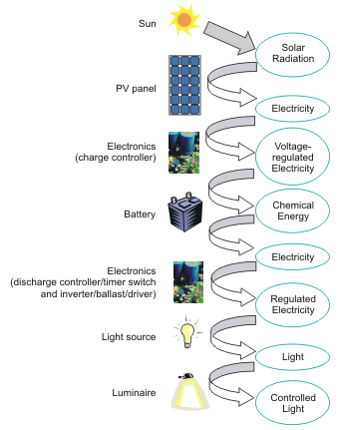 Figure (1): PV lighting system components and energy flow diagram

The electrical energy created by the PV cells can energize light sources (lamps) directly or be stored in a battery for later use. The dc current generated by the PV cell or the battery can be regulated and stabilized using an electronic circuit to energize dc light sources like incandescent, light-emitting diodes (LED), or fluorescent lamps operated on dc ballasts; or they can be converted into 220 volts, 50 hertz AC to energize ac light sources such as fluorescent lamps operated on AC ballasts. AC ballasts are more commonly available [1,2]
Electronic components, including charge controllers, timer switches, and ballasts for fluorescent lighting (or drivers for LEDs or inverters for AC lamps) provide regulation and control to the electric energy. The light source provides the light, and the luminaries that houses these components provides protection for the elements and optics to direct the light.
The light output of a PV lighting system depends on the amount of solar energy received and the efficiency or efficacy of its components, including the PV panel, battery, electronics, light source, and luminal [1,3]
Solar irradiance for photovoltaic (PV) power is affected by location, weather, time of year, and surrounding structures. The solar radiation received by the earth's atmosphere is 1367 watts per square meter (Messenger and Ventre 2004), but this amount is reduced when the solar radiation passes through the air mass. Solar radiation is the radiant energy emitted by the sun. The term "solar irradiance" refers to the amount of radiant flux incident on any surface, including buildings. The solar irradiance is lower at sea level, for example, than it is on a mountain top. It is also generally true that the farther away a location is from the equator, the lower the solar irradiance will be available at ground level. In summer, solar irradiance is available longer than in winter. Weather also affects the amount of solar irradiance. Cloud cover, for example, will reduce solar irradiance. Finally, solar irradiance may be blocked by buildings, trees, or snow and dirt on the PV panels [2,4]
The amount of solar radiation is affected by the geographic location, the season, and the climate conditions of the location. For example, the amount of available solar radiation in Phoenix, Basra is greater than that in Baghdad city. If we install two lighting systems located in these two cities with the same components, the system in Baghdad city will require a larger solar panel to power the system reliably. The data on daily total solar radiation for different months in various Iraqi cities [1,4]
All locations need larger PV panels in December than they do in June because daylight hours are shorter in winter, giving the system less time to recharge. The sun's energy is also less intense in the winter. This decreased solar irradiance affects the ability of the PV panel to collect sufficient energy to power the lighting throughout the night, thus necessitating a larger panel size.[3.,4,5]
The solar panel size estimated is based upon average solar radiation for the various months listed. When calculating the size requirements for a solar panel, using average solar radiation data for the month with the least sunshine will ensure that the panel will provide the power required to operate the lighting system, even during the winter months. However, this does not cover arias in which a location might receive little or no sunlight for a higher than average number of consecutive days. If a PV lighting system is installed in a location where it is critical that the system operate fully every night of the year, a system specified may want to "over design" the size of the PV panels to help to ensure that it will provide the required power under all possible sky and weather conditions. [1,3,6]
Photovoltaic (PV) panels collect solar radiation directly from the sun, from the sky, and from sunlight reflected off the ground or area surrounding the PV panel. Orienting the PV panel in a direction and tilt to maximize its exposure to direct sunlight will optimize the collection efficiency. The panel will collect solar radiation most efficiently when the sun's rays are perpendicular to the panel's surface. The angle of the sun varies throughout the year, as illustrated in Figure 2. Therefore, the optimal tilt angle for a PV panel in the winter will differ from the optimal tilt angle for the summer. This angle will also vary by latitude.[3,4,6,7].
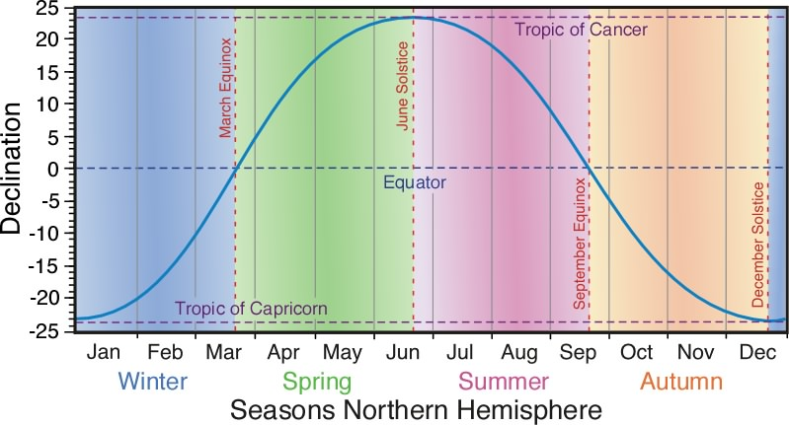
Figure (2): The solar declination angle variation through one year period

The first step in determining optimal PV panel orientation and tilt angle is to review the site where the PV lighting system will be installed. Trees, large buildings, or other structures or obstructions surrounding the site might cast shadows onto a tilted PV panel at various times of day or during winter months when the sun is at a low angle in the sky. Therefore, it may be best to orient the PV panels horizontally to face the sky directly. This may allow the panels to collect the maximum amount of solar radiation with the least obstruction. However, a horizontal panel will get dirty faster [3,4,5]
However, if the site surrounding the PV lighting system is relatively free of obstructions, a lighting specifier can orient the system's PV panel in a particular direction and update at a selected angle. In this case, the PV panel should always face toward the equator. In the Northern Hemisphere the panel should face south and tilt from horizon at an angle approximately equal to the site's latitude. For example, if the system were located in Baghdad, the PV panel should face south and tilt up at an angle of approximately 33.[2.5.7,8]
Instrument:
By using PV SYSTEM program to calculate the tilt angle of solar panel which feeds solar street light in Baghdad city ,there is some steps to use PV SYSTEM :-
- Open program window fig. (3)
- Chose Preliminary Design option
- Chose Stand Alone option
- Chose location option (to enter the latitude and longitude for Baghdad city)
- Chose system specification option ( to enter the tilt angel (vary angels) and azimuth angel (zero angle (south direction ))
- Chose results option
- Final step (record data )
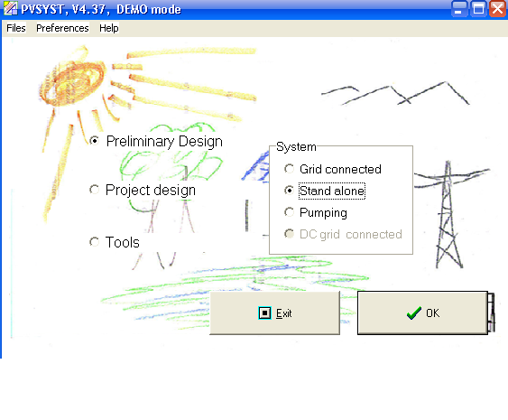
Figure (3): PV SYSTEMS program main window

Results and Discussion
Program data has been adopted for several tilt angles from 30º to 65º, which is the angles that solar panels can be installed in Iraq as a fixed panel, as shown in the table (1), so that it shows the average solar radiation for each tilt angle to all months.
In January, the highest average solar radiation at angle between (45º and 65º) and in February between (40º and 60º), In March it was at 35º ,and in April , May, June, July and August at 30º tilt angle, but for the September, the highest average solar radiation were achieved at 30º to 35º tilt angle , and in October, ranging between 35º and 55º, for the November, the tilt angles ranging between 45º and 65º,and in December tilt angles ranging between 50º and 65º.
Table (1): The average of solar radiation to multi tilt angles in year
Months | Average of solar radiation kW /m²/year
 | 30° | 35° | 40° | 45° | 50° | 55° | 60° | 65°
Jan. | 3.5 | 3.6 | 3.7 | 3.8 | 3.8 | 3.8 | 3.8 | 3.8
Feb. | 4.4 | 4.5 | 4.6 | 4.6 | 4.6 | 4.6 | 4.5 | 4.4
Mar. | 5.4 | 5.5 | 5.4 | 5.4 | 5.3 | 5.2 | 5 | 4.9
Aprl. | 6 | 5.9 | 5.7 | 5.5 | 5.3 | 5.1 | 4.9 | 4.6
May | 6.6 | 6.4 | 6.1 | 5.8 | 5.5 | 5.1 | 4.7 | 4.3
Jun. | 6.7 | 6.4 | 6.1 | 5.7 | 5.4 | 4.9 | 4.5 | 4
July | 6.8 | 6.5 | 6.2 | 5.8 | 5.5 | 5.1 | 4.6 | 4.2
Aug. | 6.9 | 6.7 | 6.5 | 6.2 | 5.9 | 5.6 | 5.2 | 4.9
Sept. | 6.5 | 6.5 | 6.4 | 6.3 | 6.1 | 5.9 | 5.7 | 5.5
Oct. | 5.7 | 5.8 | 5.8 | 5.8 | 5.8 | 5.8 | 5.7 | 5.5
Nov. | 4.6 | 4.8 | 4.9 | 5 | 5 | 5 | 5 | 5
Dec. | 3.6 | 3.7 | 3.8 | 3.9 | 4 | 4 | 4 | 4
Average/ year | 5.5 | 5.5 | 5.4 | 5.3 | 5.2 | 5 | 4.8 | 4.6

The changing of sunshine hours throughout the year, and vary from month to another, related to the change in earth location relative to the sun, and change the elevation angle of the sun relative to the earth and thus change the average of solar radiation that incident on the surface for every tilt Angle for solar panel .
There is a difference between the sunshine hours and operation hours of solar streetlight. In winter hours are running solar street light longest hours of sunrise, and in the summer the operation hours of street light to be shorter than the sunshine hours therefore van in winter, the solar street light needs a large amount of solar radiation in order to cover the long operation hours in the night of winter, as shown in the table (2).
Table (2): The relation between sun shine hours and average of solar radiation
Months | Sun shine hours | Average of solar radiation kW.h /m²/year
 |  | 30 | 35° | 40° | 45° | 50° | 55° | 60° | 65°
Jan. | 6.5 | 22.75 | 23.4 | 24.05 | 24.7 | 24.7 | 24.7 | 24.7 | 24.7
Feb. | 7.5 | 33 | 33.75 | 34.5 | 34.5 | 34.5 | 34.5 | 33.75 | 33
Mar. | 7.5 | 40.5 | 41.25 | 40.5 | 40.5 | 39.75 | 39 | 37.5 | 36.75
Apr. | 8.5 | 51 | 50.15 | 48.45 | 46.75 | 45.05 | 43.35 | 41.65 | 39.1
May | 9.5 | 62.7 | 60.8 | 57.95 | 55.1 | 52.25 | 48.45 | 44.65 | 40.85
Jun. | 13.5 | 90.45 | 86.4 | 82.35 | 76.95 | 72.9 | 66.15 | 60.75 | 54
July | 13.5 | 91.8 | 87.75 | 83.7 | 78.3 | 74.25 | 68.85 | 62.1 | 56.7
Aug | 13.5 | 93.15 | 90.45 | 87.75 | 83.7 | 79.65 | 75.6 | 70.2 | 66.15
Sept | 10.5 | 68.25 | 68.25 | 67.2 | 66.15 | 64.05 | 61.95 | 59.85 | 57.75
Oct | 9 | 51.3 | 52.2 | 52.2 | 52.2 | 52.2 | 52.2 | 51.3 | 49.5
Nov. | 7.5 | 34.5 | 36 | 36.75 | 37.5 | 37.5 | 37.5 | 37.5 | 37.5
Dec. | 5.5 | 19.8 | 20.35 | 20.9 | 21.45 | 22 | 22 | 22 | 22

For example, if we assume that we have a lamp of 50 watts power and it must work during the darkness hours of night , especially in the darkness hours in winter it will be long, the amount of power that is required will be greater in winter more than in summer and that the length of the night hours in winter as shown in the table (3) , where the best average of solar radiation amount it will be achieved at 45º to 65º tilt angles and that can cover operation hours in the winter , while in summer the long sun shine hours and the average solar radiation amount are large and can be sufficient to cover the requirements of the working hours of the lamp, which are operating hours shorter in summer night, in addition to that there is another advantage to large tilt angles , it provides an opportunity to be the as clean as solar panel due to prevention of dust accumulation at small tilt angles, and this could be a self-cleaning solar panel in all the year period. In addition to that, the higher tilt angles prevent increasing the temperature of the solar panel especially in summer because it may not be perpendicular with incident solar radiation which are high, and the solar panel temperatures increase in the case of small tilt angles.
Table (3): The relation between darkens hours and lamp energy and the best angles to average of solar radiation
Months | Darkens hours | Lamp 50 w (load) | Average of solar radiation kW.h /m²/year to Best tilt angels
 |  | Energy (W.h) | 45° | 50° | 55° | 60° | 65°
Jan | 15 | 750 | 24.7 | 24.7 | 24.7 | 24.7 | 24.7
Feb | 14 | 700 | 34.5 | 34.5 | 34.5 | 33.75 | 33
Mar | 14 | 700 | 40.5 | 39.75 | 39 | 37.5 | 36.75
Aprl. | 13 | 650 | 46.75 | 45.05 | 43.35 | 41.65 | 39.1
May | 12 | 600 | 55.1 | 52.25 | 48.45 | 44.65 | 40.85
Jun. | 9 | 450 | 76.95 | 72.9 | 66.15 | 60.75 | 54
July | 9 | 450 | 78.3 | 74.25 | 68.85 | 62.1 | 56.7
Aug. | 9 | 450 | 83.7 | 79.65 | 75.6 | 70.2 | 66.15
Sept. | 12 | 600 | 66.15 | 64.05 | 61.95 | 59.85 | 57.75
Oct. | 13 | 650 | 52.2 | 52.2 | 52.2 | 51.3 | 49.5
Nov. | 14 | 700 | 37.5 | 37.5 | 37.5 | 37.5 | 37.5
Dec | 15 | 750 | 21.45 | 22 | 22 | 22 | 22

Conclusion
optimal tilt angles of solar panel utilized for solar street light are ranging between 45º and 65º ,where the average of solar radiation be large and therefore be sufficient to cover the operation hours for the solar street lighting in winter and either in summer the average of solar radiation be large and sunshine be longer and enough to provide energy average to operate the lamp in short hours in this season.

References
- Diaz, P. and E. Lorenzo. 2001. Solar home system battery and charge regulator testing. Prog. Photovolt: Res. Appl. 2001: 9:363-377.
- Diaz, P. and M. A. Egido. 2003. Experimental analysis of battery charge regulation in photovoltaic systems. Prog. Photovolt: Res. Appl. 2003; 11:481-493.
- DOE Energy Efficiency and Renewable Energy program. 2003. A consumer's guide-Get your power from the sun. DOE/GO-102003-1844. Dunlop, J. P. 1997. Batteries and charge control in stand-alone photovoltaic systems-fundamentals and application. Prepared for Sandia National Laboratories by Florida Solar Energy Centre
- Landau, C. R. 2002. Optimum orientation of solar panels. http://www.macslab.com/optsolar.html (accessed June 30, 2006).
- Messenger, R. A. and J. Ventre. 2004. Photovoltaic Systems Engineering. 2nd edition. CRC Press LLC
- Zhou, Y. and N. Narendran. 2005. Photovoltaic-powered light-emitting diode lighting systems. Optical Engineering. Vol. 44(11), paper 111311.
- Ministry of New and Renewable Energy Government of India Solar Lighting Systems Module Trainers Textbook . Study materials in Renewable Energy Areas for ITI students E-mail: communication@newconceptinfosys.com , www.newconceptinfo.com
- Shara Kamal ,Mohammed ¹and Assistant Prof. Rizgar Bakir Waly² ,Street and House Lighting Using Photovoltaic Panels , College of Engineering, University of Salahaddin International Journal of Engineering & Technology IJET - IJENS Vol: 11 No: 06 , December 2011

