**مَجلةُ أُريد الدَّوليةُ للعُلومِ والتِّكنولوجيا**

العدد x ، المجلد x ، الشهر xxxx م

**FULL RESEARCH TITLE (SIZE 14, BOLD, CAPITAL LETTERS)**

Researcher name*

*College name, University, city, country*

**عنوان البحث باللغة العربية حجم الخط 14 غامق**

اسم الباحث*

الكلية – الجامعة – المدينة – الدولة

[email@email.com](mailto:email@email.com)

arid.my/xxxx-xxxx

|  |
| --- |
| **ARTICLE INFO** |
| ***Article history:***  Received xx/xx/xxxx  Received in revised form xx/xx/xxxx  Accepted xx/xx/xxxx  Available online xx/xx/xxxx |

**ABSTRACT**

English abstract text must be in this page, font size: 12 , single line spacing, font type L Times New Roman. Maximum words: 250.

**Keywords:** Keyword 1, Keyword 2, Keyword 3, Keyword 4, Keyword 5

**الملخص**

يجب أن يكون الملخص قصيرًا لا يتعدى 250 كلمة حول المعلومات المهمة للبحث . يجب أن يكون الملخص معبر عن محتوى البحث ويشمل اهم النتائج والاستنتاجات التي تم التوصل اليها. يجب ان يحتوي كل بحث على ملخص باللغة العربية واللغة الانجليزية ويكون كلاهما بصفحة جديدة. ينبغي أن تدرج قائمة من 5 كلمات رئيسية من البحث وتوضع بعد الملخص.

الكلمات المفتاحية : كلمة 1، كلمة 2 ، كلمة 3 ، كلمة 4 ، كلمة 5

1. **Introduction:**

Below text is a sample text for demonstration only, the proper way to reference a figure is like this : as shown in figures (1) and (2).

Equations can be written like this : Efficiency **ԑ** (Eᵧ) is a measure of the percentage of radiation that a given detector detects from the overall yield that is emitted from the source into a solid angle of usually 4*π* in the photo-peak .The detector efficiency is calculated as in the following equation.

$ԑ ( Eᵧ ) =Nt*100/Nᵧ$

Where: -

**N**t = Net area per unit of time over the whole recorded spectrum (minus the background rate).

**N**γ = Absolute activity per unit of time.

Spectrum of full energy for range of discrete gamma-ray energies chosen from standard sources is illustrated in Figure (3). Each sample was analyzed by using high resolution Gamma spectrometry system. It consists of high pure germanium detector having 40% relative efficiency, its energy resolution measured in terms of Full With Half Maximum (FWHM) is 2.1 keV at 1332 keV of Co-60 Gamma energy. The pulse amplitude is converted to a discrete number using the 4096 channel in a multi-channel analyzer (MCA (. Gamma ray spectrometry measurements were analyzed using genie 2000 software [8,9].



789

C

PS

1112

964

1408

411

344

244

121

Energy (Kev)

Figure (1): Calibration spectrum energy for rang of discrete gamma-ray for Eu-152.

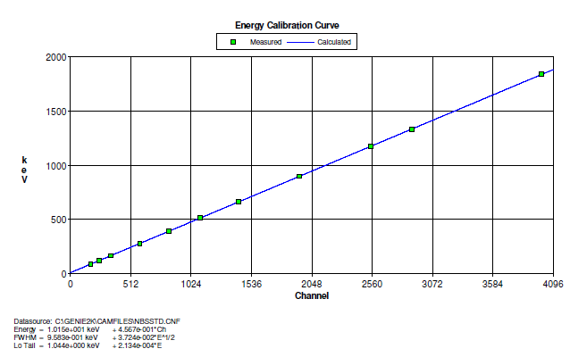

Figure (2): Energy calibration using Eu-152 radioactive standard

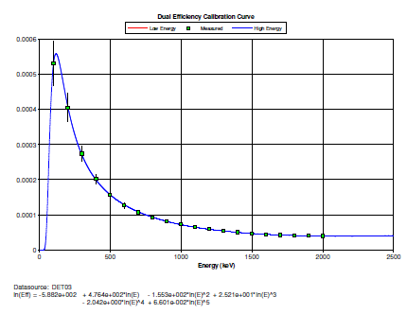

Figure (3): Efficiency calibration curve of (HPGe) detector using Eu-152

Energy (Kev)

1. **Results and Discussion:**

This section holds the result and discussion context, tables can referenced like this : as presented in Table (1).

The specific activity spectrum of cement sample is shows in Fig (4) the specific activity for Ra-226, Th-232 and K-40 was calculated using the following relation:

$$A( Bq.kg-1 )= N/ ԑ ( Eᵧ ) I( Eᵧ ) tcm$$

where: -

**A**: - Is the specific activity in (Bq. kg-1).

**N** :- Is the corrected net peak area of the (N = Ns - Nb).

Ns :- Is the net peak area in the sample spectrum .

Nb :- Is the corresponding net peak area in the background spectrum.

**ԑ** ( Eᵧ ) :- Is the efficiency of the detector .

**I** (Eᵧ):-Is the intensity of gamma energy [E]

**t**c ;- Is the counting time.

**m** :- The mass ( kg ) of the sample.

The results in the present study for cement have also been compared with values of the worldwide specific activity of Ra-226, Th-232 and K-40 (in Bq.kg-1) for other countries of the world are shown in Table (2). Therefore, the cement product of a Mass plant has characteristics and radiation properties that are safe when using these materials as building materials [3, 8, 10, 11, 12, and 13].

Table (1): Results of cement plants Mass samples

|  |  |  |  |
| --- | --- | --- | --- |
| Samples No.North Iraqi/cement Mass | Ra-226  Bq.kg-1 | Th-232  Bq.kg-1 | K-40  Bq.kg-1 |
| M1 | 60.32 | 35.37 | 130.11 |
| M2 | 55.54 | 37.45 | 135.21 |
| M3 | 58.62 | 37.88 | 128.5 |
| M4 | 65.34 | 36.23 | 140.12 |
| M5 | 50.68 | 36.61 | 125.33 |
| M6 | 56.12 | 37.51 | 136.21 |
| Average | 50.27 | 36.841 | 132.58 |

1. **Conclusions**

We believe all construction materials are important and the most important is the cement material because it contains several primary materials collected from mines from different countries. Therefore, you need continuous monitoring, especially radiological monitoring. As we have previously said, humans live for long periods of time in contact with cement. From the observation of the results, Mass cement is widely used in Iraqi markets. It was found that natural radionuclide in these studies were within permissible limits compared with global research publications.

**List of Abbreviations:**

1. International Atomic Energy Agency (IAEA).
2. Hyper-Purity Germanium (HPGe).
3. Full of Half Maximum (FWHM).
4. Multi-channel analyzer (MCA).

**Acknowledgement**:

Dedicate to colleagues who are competent to benefit. For general knowledge and special thanks to the journal and its editor**. If there is a research grant mention its name and number in this section.**

**References**

